Myocardial infarction with cardiogenic shock and unilateral pulmonary oedema – A rare presentation

Background: Unilateral pulmonary oedema is a rare condition which is often misdiagnosed at the first presentation. It most commonly occurs in the upper lobe of the right lung. Due to its rare presentation, a high index of suspicion is required, and correct, timely management is required to reduce the morbidity and mortality.
Case presentation: We present a case of right-sided unilateral pulmonary oedema in a 62-year-old Caucasian man who presented with chest pain and shortness of breath. Initially he was treated for pneumonia and sepsis in the emergency department because of the xray findings of right sided infiltrates and raised inflammatory markers meeting sepsis criteria. He was found to have myocardial infarction and cardiogenic shock by the clerking medical team. On examination, the patient had features of heart failure and mitral regurgitation. Subsequently, a diagnosis of myocardial infarction with unilateral pulmonary oedema and mitral regurgitation was made. The patient was resuscitated accordingly and was discussed with the interventional cardiology team for primary PCI with intensive care support. But unfortunately the patient went into cardiorespiratory arrest in the resuscitation area of the emergency department and did not survive.

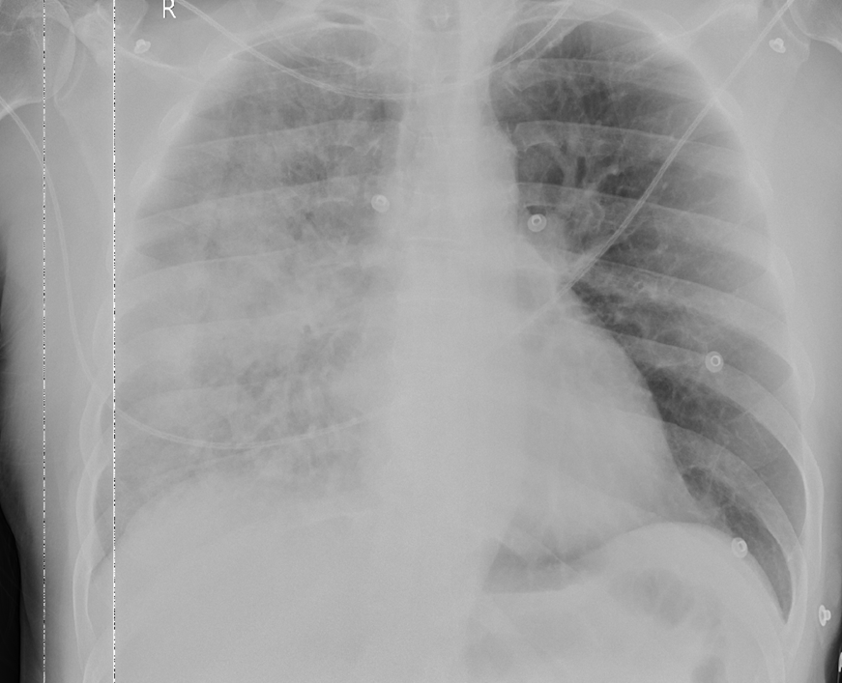

Conclusions: Unilateral pulmonary oedema is a very rare but reversible condition with good patient outcome if it is suspected early and treated early. It can be misguiding to the treating team and masquerade as sepsis secondary to pneumonia, losing crucial life-saving time.

