Pain: More than Meets the Eye
Jasmin Hundal MD, Madiha Ali MD, Kyle Ferguson MD, Norman Saffra MD, Benson A. Babu MD MBA

Eye pain is common and initially managed by primary care physicians. Questions to consider when examining patients: 1) Are there any alarming eye findings that need an urgent ophthalmology referral? 2) Is this particular eye condition part of a larger systemic disorder or one of a primary eye disease? 3) Is there a need for additional testing such as HIV or HPV screening? 4) Should a biopsy be performed? Meticulous patient history and risk factor analysis combined with a clinical examination will help formulate a differential diagnosis and inform further management. By doing so, it obviates the need for unwanted testing, early specialist referral, and improves patient outcome. Familiarization with the typical presentation and appearance of a pterygium will portend an opportunity for the comprehensive practitioner to treat with conservative therapy, thus saving the patient time and discomfort. In the rare refractory case or atypical appearance, consultation with ophthalmology is needed.

A 35-year-old Hispanic male patient with a history of pterygium presented with complaints of worsening left eye pain for months. Prior to these symptoms, the patient had been treated for pterygium for years without eye pain. Over the past two weeks, the patient had also noticed more redness and soreness that occured all day. He noticed darkening in the medial vision of his left eye, persistence of left eye pain and visual changes. An excisional biopsy of the lesion was performed. The final biopsy reports revealed an ocular surface squamous cell carcinoma in situ causing pterygium.

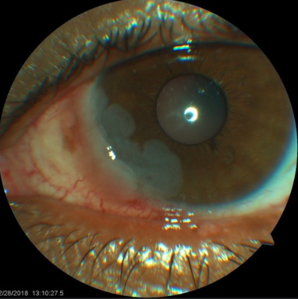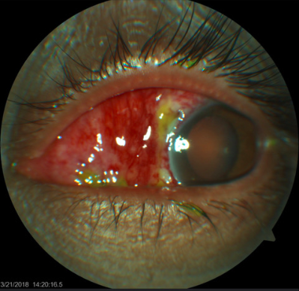

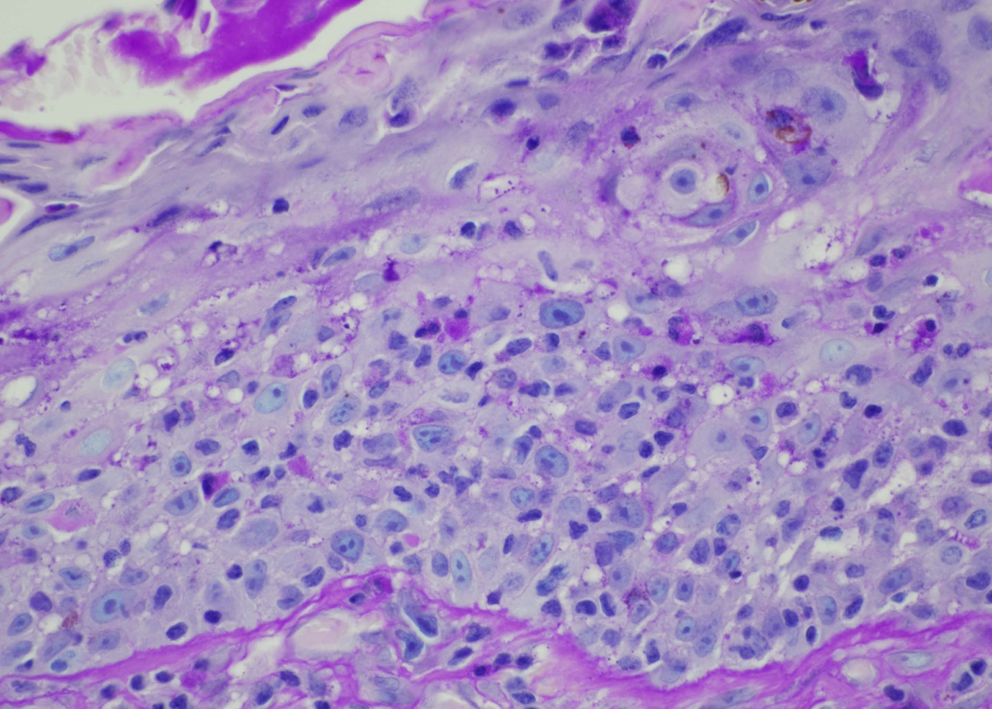
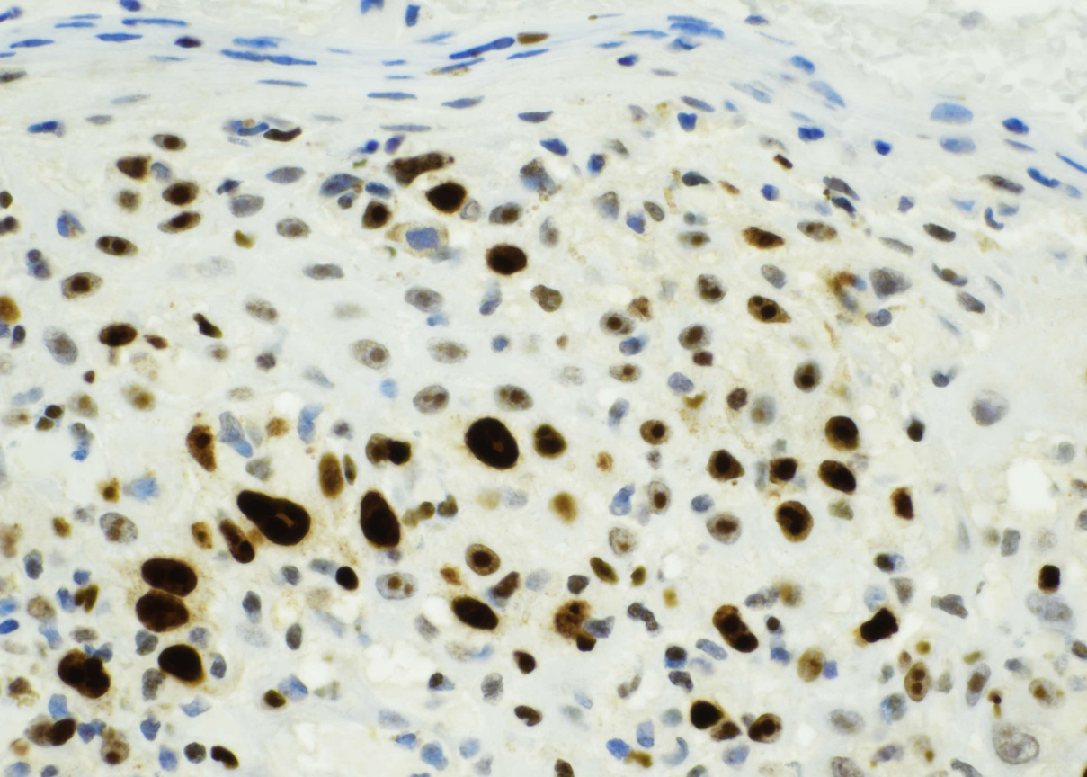
Squamous Cell Carcinoma in situ. Left eye conjunctival lesion showed considerable acanthosis with full thickness dysplasia and surface keratin accumulation. PAS and Ki-67 staining.

Presenter Correspondence to:
Benson A. Babu MD MBA
Internal Medicine Hospital Medicine
New York Presbyterian Hospital
Lower Manhattan
170 Williams Street
New York New York 10038
bensonbabumd@gmail.com
(516) 491-3713

