
A rare case of Intramedullary spinal ependymoma presenting as isolated neck pain

Khushali Jhaveri, MD
PGY-1, Internal Medicine
Georgetown University, Washington Hospital Center, Washington DC.

A previously healthy 26 year old female presented with initial symptom of isolated neck pain. She denied any headache, nausea, vomiting, blurry vision, numbness, tingling, muscle weakness or radiating pain. She denied fever, fatigue, joint pain, recent trauma, travel, sick contacts or changes in weight or appetite. No risk factors for HIV were identified.

Patient was afebrile with normal vital signs. On physical examination, isolated neck tenderness was noted without any redness or swelling. Range of motion was preserved. Nuchal rigidity, Kernig and Brudzinki’s sign were negative. Neuro exam revealed 5/5 motor strength in all extremities and intact sensation in all dermatomes. Normal reflexes were noted except left elbow and knee hyperreflexia. Chest, cardiovascular, abdominal and extremities examination were unremarkable.

Initial laboratory examination including CBC with differential, inflammatory markers, renal and liver function were within normal limits. X-ray was done and was unremarkable. A trial of muscle relaxants was given. On non-resolution of symptoms, An MRI of the cervical spine was offered which revealed a heterogenous intramedullary lesion raising suspicion for an intramedullary neoplastic lesion. Screening of entire CNS was otherwise unremarkable.

To establish a specific diagnosis, patient underwent a posterior cervical laminectomy for tumor resection. Gross-total resection was not achieved due to drop in sensory potentials during intraoperative monitoring. Histopathological examination showed WHO grade 2 ependymoma.

Patient had no significant motor neurological impairment after surgery. However, significant sensory and proprioceptive loss was observed due to posterior spinal approach. She remains progression free at 9 months with MRI with stable residual tumor.

Word count : 252 words.
Figures:
Figure 1A Figure 1B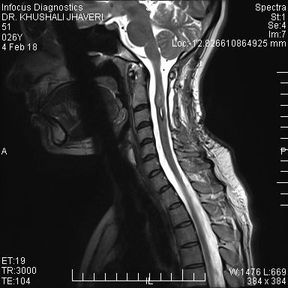 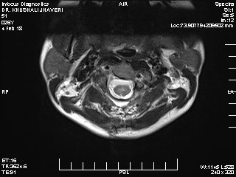Figure 2A Figure 2B

Figure Legends:
Figure 1 A&B : Heterogenous intramedullary lesion having enhancing solid-cystic component from mid body of C2 to upper body of C4 vertebral levels measuring 36mm X 15mm X 13mm with solid enhancing component of the lesion measuring 13mm X 11mm X 13mm(CC X AP X Transverse). Perilesional edema and two tiny hemorrhagic foci, one at the cranial and one at the caudal aspect of the lesion.

Figure 2 A&B : Residual tumor of 13mm X 11mm X 7mm (CC X AP X Transverse) with resolution of cystic component. Intervertebral disc appeared unremarkable with vertebral bodies being normal in size, shape, alignment and signal intensity.

Biography:

Dr. Khushali Jhaveri is doing her Internal medicine Residency from Georgetown University. She has done around 5 abstract/poster presentations in reputed international conferences. This case report is unique because the patient is Dr. Jhaveri herself.

Full name: Khushali Jhaveri
Contact number: +1 202-839-2364
Email id: khushali.jhaveri@gmail.com
Category: (Oral presentation/ Poster presentation)
Session name: Diagnosis and case reports.
Research interest: Internal medicine, Gastroenterology.

