
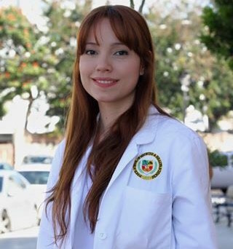

Title: Fever, hemoconcentration, and shock: Dengue or Chikungunya Infection?
Author: Janet M. Colón-Castellano, Walter Morales-Borrero, Jose Gutierrez
VA Caribbean Healthcare system, Puerto Rico

Case of a 68-year-old man with past medical history of dengue hemorrhagic fever who was admitted to the medical intensive care unit (MICU) with the diagnosis of Septic shock. His symptoms started the prior week with sudden onset of fever, polyarthralgia and skin rash over the abdomen extending to the back, buttocks and extremities. The patient visited a community primary care physician who recommended acetaminophen for symptom relief. After 2 days of no improvement and development of abdominal pain, nausea, non-bloody vomiting and dark-colored stools, the patient visited the emergency department. Physical examination was remarkable for hypotension, tachycardia, tachypnea and oxygen desaturation, and a non-blanching maculopapular rash over the abdomen, back, buttocks, and extremities. No evidence of acute neurological deficits or cardiopulmonary involvement. Laboratory workup showed hemoconcentration, thrombocytopenia, hepatic transaminitis, and acute renal injury, findings suggestive of circulatory compromise due to systemic capillary leak syndrome. Patient developed cardiorespiratory arrest requiring advanced cardiac support measures and mechanical ventilation for which he was admitted to MICU. While on MICU, he was initiated on broad spectrum antibiotics, aggressive fluid resuscitation, and vasopressors. He persisted with profound shock and died 7 hours after admission to MICU. Final laboratory reports were remarkable for RNA-PCR positive for Chikungunya virus and negative for Dengue virus. Chikungunya infection is usually a self-limited disease and only required supportive therapy. This case highlights an unusual presentation of chikungunya fever with systemic capillary leak syndrome, a well-known complication of Dengue hemorrhagic fever.

Biography:
Janet M. Colón-Castellano completed her Baccalaureate’s degree in Natural Sciences with a minor on Biotechnology from the University of Puerto Rico in Ponce. Following her growing research interests in Human Immunodeficiency Virus (HIV), she worked as a laboratory technician at one of the few HIV research centers of Puerto Rico. Afterwards, Dr. Colón-Castellano decided to pursue a doctorate in Medicine from the Ponce Health Sciences University which she completed on 2016. She is currently completing her Internal Medicine residency at the Veteran’s Affairs Caribbean Healthcare System located in San Juan, Puerto Rico.

Presenting author details:
Full name: Janet M. Colón-Castellano
Contact number: 939-217-7978
Email: jmcolon@stu.psm.edu
Category: Poster presentation
Session name: Infectious Disease, Viral Infections
Research interest: Infectious disease, Endocrinology

