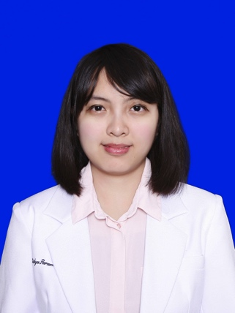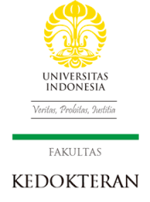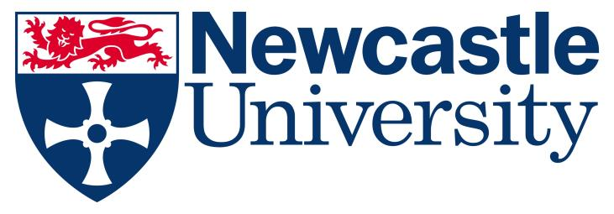

Title: Effectiveness of Magnetic Resonance Imaging in Diagnosis of Liver Iron Overload in Thalassemia-β Major Patients with Regular Blood Transfusion
Author (s) Name: Maria Satya Paramitha, Tri Juli Edi Tarigan
Departement of Internal Medicine, Faculty of Medicine, Universitas Indonesia, Jakarta, Indonesia

Introduction: Transfusion-dependent iron overload is a determinant of further complications in patients with conditions requiring regular blood transfusion; such as thalassemia-β major. Currently, liver biopsy is used as a gold standard for measuring liver iron concentration. Magnetic Resonance Imaging (MRI) has been proposed as a non-invasive diagnostic method for measuring liver iron concentration.
Methods: Literature searching was conducted from Pubmed®, Embase®, and SCOPUS®. One systematic review and meta-analysis article was selected from twelve chosen studies. The article was critically appraised afterwards, using standard criteria for diagnostic research.
Results: Twenty eligible studies (cohort and case-control) that utilized 1.5-T or higher scanner system as the index test, and liver biopsy as the reference standard were analyzed. In the analysis of T2 SE and T2* GRE, the results obtained were positive predictive values (0.81 and 0.74), negative predictive values (0.83 and 0.88), likelihood ratio positive (8.85 and 4.86), and likelihood ratio negative (0.10 and 0.05); respectively. Meta-regression analysis was conducted to explore heterogeneity between studies.
Discussion: In comparison to liver biopsy, MRI is proven to be poorly invasive with the amount of possible sampling errors similar to the gold standard. Although MRI is not considered cannot be used for depicting histological stages, it has been validated as a sensitive and non-invasive diagnostic technique to evaluate tissue iron content.
Conclusion: MRI has been proven to be moderately sufficient for ruling in definite diagnosis of liver iron overload and highly sufficient for ruling out diagnosis of the same condition.

Biography

The writer is a medical doctor who has completed her undergraduate study in Faculty of Medicine, Universitas Indonesia. She also has completed her postgraduate study with the degree of Master by Research in Cancer from Newcastle University Medical School, the United Kingdom. In this Evidence-Based Case Report, she was supervised by dr. Tri Juli Edi Tarigan, SpPD-KEMD from Department of Internal Medicine, Metabolic Endocrine Division, Faculty of Medicine, Universitas Indonesia.

Presenting author details
Full name: Maria Satya Paramitha
Contact number: +6281290926890
Email id: maria.satya85@gmail.com
Category: (Oral presentation/Poster presentation)
Session name: Internal Medicine and Patient Care
Research interest: Hematology in Internal Medicine

