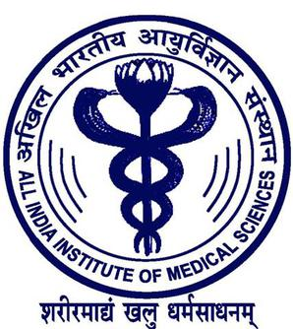

Initial Antibiotic Prescribing Pattern Amongst Physicians, for Patients of Pneumonia, at Medical Wards and ICU – An Observational Study from India

Divya M Radhakrishnan MD¹, Naveet Wig MD¹, Anant Mohan MD¹,
Arti Kapil MD¹, Randeep Guleria MD DM¹
¹All india Institute of Medical Sciences, New Delhi -110029
Introduction: The growing body of evidence shows a strong linkage between inappropriate antibiotic use and antimicrobial resistance.
Objective: To analyze the initial antibiotic prescribing pattern among physicians for pneumonia at medical wards and ICU of a tertiary care institute in northern India.
Methods: The initial antibiotic regimen is defined as the antibiotics prescribed during the first day of therapy. One hundred and twelve prescription were analyzed, one from each patients with pneumonia over a period of 6 months.
Results: Amoxicilllin-Clavulanic acid (38.39) was the commonest antibiotic prescribed followed by azithromycin (34.82%) either as mono or combination therapy. Cefaperazone-sulbactum (35.71%), levofloxacin (32.14%), and Piperacillin-Tazobactum (22.32%) were among the commonly prescribed antibiotics for pneumonia, either alone or in combination. Seventy-five percentage of prescription contained 2 or more antibiotics. The prescription was considered appropriate if antibiotics were prescribed in correct dose and duration, according to patient characteristics and local sensitivity profile. Only 44.79% initial prescriptions were found appropriate and adhering to Institute’s antibiotic protocol.
Conclusion: Our study throws light into the prevailing irrational antibiotic prescribing patterns in developing countries like India. Formulation of local antibiotic protocol and adherence to the same can improve prescribing pattern and thereby antimicrobial sensitivity.

Presenting author details
Full name: Dr Divya Madathiparambil Radhakrishnan
Contact number: 9958034273
Email id: dr.divyamr@gmail.com
Category: Poster presentation
Session name: Internal Medicine and Patient care

