Abstract Template

War on Terror Cells: Novel sources of antimicrobials
Naveed Ahmed Khan,¹ Salwa Mansur Ali,¹ Ayaz Anwar,² Muhammad Raza Shah,² Peter Heard,¹ and Ruqaiyyah Siddiqui¹

¹Department of Biological Sciences, School of Science and Technology, Sunway University, Malaysia; ²HEJ Research Institute, University of Karachi, Pakistan; Tel: 60-(0)3-7491-8622. Ext: 7176. Fax: 60-(0)3-5635-8630. E-mail: naveed5438@gmail.com

With the worsening trends of drug resistance, there is a need for newer and more powerful antimicrobial agents. The search for new compounds originating from natural resources is a promising research area. We hypothesized that animals living in polluted environments are potential source of novel antimicrobial molecules. Under polluted milieus, organisms such as cockroaches encounter different types of microbes, including superbugs. Such creatures survive the onslaught of superbugs and are able to ward off disease by producing antimicrobial substances. Here, we characterized antibacterial properties in extracts of various body organs of cockroaches (Periplaneta americana) and showed potent antibacterial activity in crude brain extract against methicillin-resistant Staphylococcus aureus and neuropathogenic E. coli K1. The size-exclusion spin columns revealed that the active compound(s) are less than 10 kDa in molecular mass. Using cytotoxicity assays, it was observed that pre-treatment of bacteria with lysates inhibited bacteria-mediated host cell cytotoxicity. Using spectra obtained with LC-MS on Agilent 1290 infinity liquid chromatograph, coupled with an Agilent 6460 triple quadruple mass spectrometer, tissues lysates were analyzed. Among hundreds of compounds, only a few homologous compounds were identified that contained isoquinoline group, chromene derivatives, thiazine groups, imidazoles, pyrrole containing analogs, sulfonamides, furanones, flavanones, and known to possess broad-spectrum antimicrobial properties, and possess anti-inflammatory, anti-tumour, and analgesic properties. Further identification, characterization and functional studies using individual compounds can act as a breakthrough in developing novel therapeutics against various pathogens including superbugs.

Keywords—Infectious diseases, novel antimicrobials, insects.

Professional Biography (100-150 words)

Following my BSc in Pakistan, I moved to the UK. I completed my MSc and PhD in England and then moved to the USA. After several years of research experience at the Tufts University School of Medicine, Boston, and then at the Johns Hopkins University School of Medicine, Baltimore, I moved back to the UK and joined University of London in 2002 as a faculty member. For the next several years, I worked enthusiastically to pursue research, and became a Senior Lecturer; and then joined the University of Nottingham, UK as an Associate Professor of Molecular Microbiology. In 2010, I joined the Aga Khan University as Professor and Chair of the Department of Biological and Biomedical Sciences, and in 2015, I joined the Sunway University as Professor and Head of Biological Sciences, School of Science and Technology, Malaysia campus. Based on academic performance and accomplishments, I was awarded the title of “Distinguished Professor” of the University in 2016.
I maintain a broad interest in all aspects of infectious diseases. I am Editor of several journals and an active reviewer of more than 80 journals and several national and international funding agencies, and review modules and programmes for several Universities as well as developing new programmes. I have published 7 books. My research findings have been published in over 193 peer-reviewed publications and secured significant grant income (>$2 million). I have supervised 40 graduate research students (11 PhDs) to completion and 60 UG research students. Based on high research productivity, I received the prestigious ‘Schwentker Research Award’ by the Johns Hopkins University, USA, Hull Royal Infirmary Fellowship Award, UK, Kut Foundation Award, UK, Best research award by Medical Research Society, Royal College of Physicians, UK, Best Speaker’s Award by the Aga Khan University, Pakistan, and the ‘Best Young Research Scholar Award” by the Government of Pakistan, Higher Education Commission in 2013. Additionally, I have been awarded the A R Shakoori Gold Medal Award by the Zoological Society of Pakistan in 2014 for best contributions in Biological Sciences. In 2014, I was selected among the top 10 productive scientists in Pakistan in the field of Biological Sciences (selected from 2,728 productive Scientists of Pakistan). In 2015, I received the prestigious ‘Pakistan Academy of Sciences’ Gold Medal Award in Biological Sciences. In 2016, I received Silver Medal Awards by the International Invention & Innovation Exhibition, Ministry of Science, Technology & Innovation, Malaysia. Recently, I received Gold Medal in Bio-Innovation award, as well as Research Excellence Award in Pharma-Innovation at the Pharma+Bio Asia 2016 convention. Based on research accomplishments, I was awarded the title of “Distinguished Professor” of the University in 2016. Recently, I received the “Order of Merit” award at the 5th Korea Inventor Award Festival – 2016 held in Seol, Korea. In 2017, I received silver medals at the 28th International Invention, Innovation and Technology Exhibition (ITEX), Malaysia. My work on “animals living in polluted environments could be rich stores of new antibiotics” caught worldwide attention. Several documentaries were made and shown on leading news channels/websites and peer-reviewed journals. Google search of "Naveed Khan and Cockroach" yields thousands of web pages.

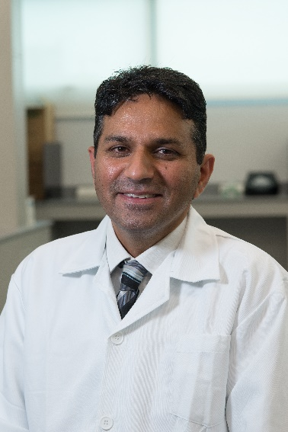
Paste your Photograph here

Email Id:

Any Comments:

