Abstract Title: The Achilles' Heel Targeted by TB47 Is Protected in Select Mycobacteria
Tianyu Zhang ¹ , Yang Liu ^{1,2} and Yamin Gao¹

¹ Guangzhou Institutes of Biomedicine and Health (GIBH),Chinese Academy of Sciences (CAS),China
²Anhui University ,China

Abstract
Existing treatments for mycobacterial infections are lengthy or losing effectiveness due to resistance/toxicity. New powerful drugs with new mechanisms of action could address the current need for novel regimens. TB47 is a new agent with activity against M. tuberculosis, the bacteria that causes tuberculosis. Using various in vitro, in macrophage and in vivo approaches, we found that TB47 is bacteriostatic against M. tuberculosis.
We also assessed the activity of TB47 against M. ulcerans, the causative agent of Buruli ulcer (BU), using in vitro assays and an established mouse model. BU is a disease that manifests as skin ulcer resulting from destruction of skin and dermal tissue in response to a toxin secreted by M. ulcerans. When using TB47 to treat the autoluminescent M. ulcerans reporter strain infected mice, we found that TB47 was bactericidal against M. ulcerans and prevented footpad swelling and pathology that are characteristic in untreated mice.
We failed to obtain TB47-resistant M. tuberculosis mutants though we tried a lot. M. ulcerans and Mycobacterium marinum are closely related in evolution. We selected TB47-resistant ​M. marinum​and M. ulcerans mutants. We identified mutations by sequencing the whole genomes of the mutants. A common mutation was a single nucleotide mutation resulting in an amino acid replacement in the gene encoding QrcB, a protein of the electron transport chain. We also hypothesize that CycAB protein complex confers protection from the poisoning effect of TB47 of the Qrc complex, as shown below.
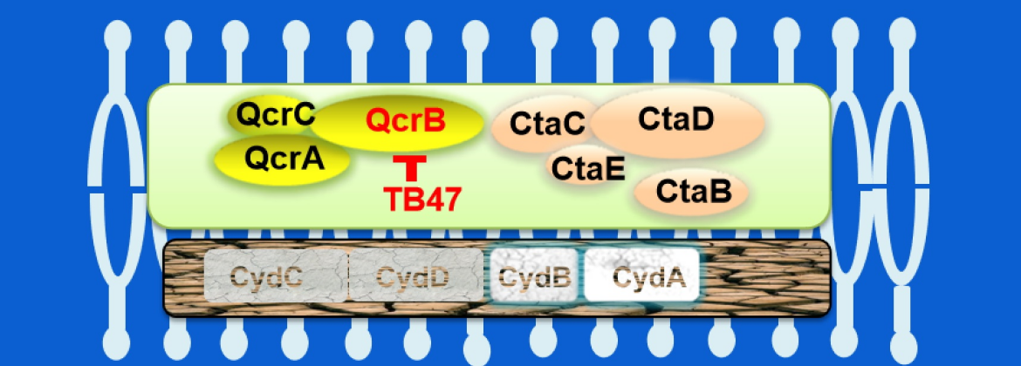
We propose that QrcB is the Achilles’ Heel of mycobacteria that is targeted by TB47. Different species of mycobacteria exhibit varying levels of sensitivity to TB47. We hypothesize that molecular differences in the QrcB orthologs in different mycobacteria determine the level of inhibition by TB47. Likely equally important is how robust the CydAB complex is in each mycobacterium.
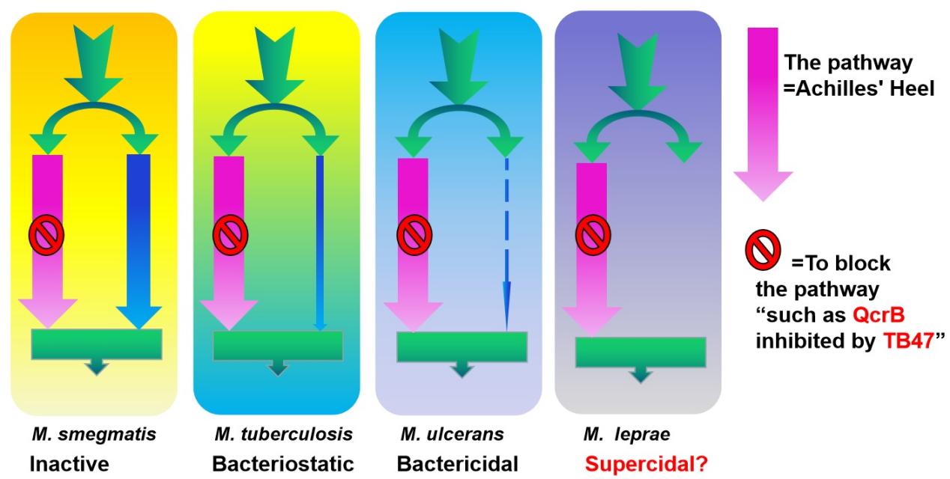

Keywords—mycobacterium, Buruli ulcer, tuberculosis, electron transport chain

Professional Biography
Tianyu Zhang has completed his PhD at the age of 30 years from The Chinese Academy of Medical Sciences &The Peking Union Medical College (PUMC), China and postdoctoral studies from Johns Hopkins University School of Medicine. He is the director of Tuberculosis Research Laboratory, State Key Laboratory of Respiratory Disease, China. He has published more than 56 SCI papers in reputed journals such as Am J Respir Crit Care Med, Nat Commun, Clin Microbiol Infect, PLoS Negl Trop Dis, Antimicrob Agents Chemother, ACS Infectious Diseases, E J Med Chem, J Genet Genomics, J Proteome Res, Front Microbiol, Front Cell Infect Microbiol, J Clin Microbiol, ACS Med Chem Lett, Infect Drug Resist. and has been serving as an editorial board member of Frontiers in Medicine, Frontiers in Public Health and Frontiers in Microbiology.
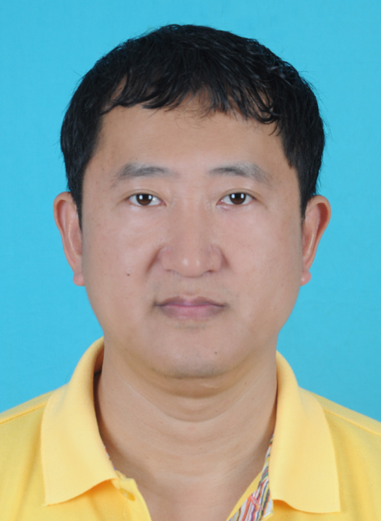

Email: zhang_tianyu@gibh.ac.cn

Any Comments: Complete List of My Published English Papers Using My ResearcherID (K-4801-2015) in: http://www.researcherid.com/Home.action. My ORCID: 0000-0001-5647-6014.

