Fighting malaria using paratransgenic vectors using Engineered Enterobacter cloacae expressing Defensin
Mohammad Ali Oshaghi, PhD, Tehran University of Medical Sciences, Iran
Hossein Dehghan, PhD, Tehran University of Medical Sciences, Iran
Seyed Hassan Moosa-Kazemi, PhD, Tehran University of Medical Sciences, Iran

Abstract

Enterobacter cloacae bacterium is a known symbiont of most Anopheles gut microflora and nominated as a proper candidate for paratransgenic control of malaria. Here, we describe a strategy that uses symbiotic bacteria to deliver antimalaria effector molecule to the midgut lumen, thus rendering host mosquitoes refractory to malaria infection. Enterobacter cloacae was engineered to secret defensin, a natural plant anti-Plasmodium effector protein. The engineered E. cloacae inhibited oocyst formation of the rodent malaria parasite Plasmodium berghei by up to 92.8% in An. stephensi. Significantly, the proportion of mosquitoes carrying parasites (prevalence) decreased by up to 75%. Interestingly, the wild strain of E.cloacae could inhibited oocyst formation by up to 72%. These findings provide the foundation for the use of either wild or genetically modified E.cloacae bacteria as a powerful tool to combat malaria.

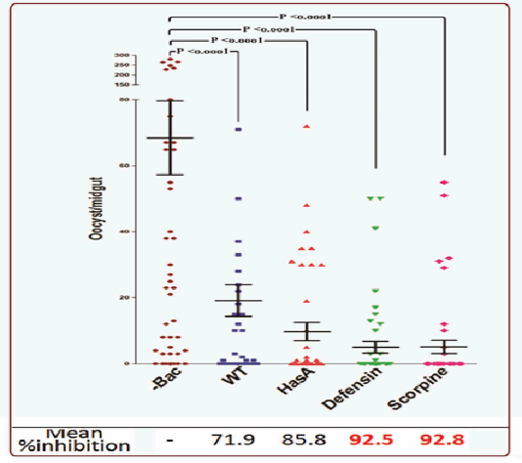
Effect of E.cloacae Wild type (WT), E.cloacae HasA, E.cloacae GFP-Defensin, and E.cloacae HasA-Scorpine on Plasmodium berghei development (oocyst formation) in Anopheles stephensi
Recent publications
- Dehghan H, Oshaghi MA, et al (2017) Dynamics of Transgenic Enterobacter cloacae Expressing Green Fluorescent Protein Defensin (GFP-D) in Anopheles stephensi Under Laboratory Condition. J Arthropod Borne Dis. 11(4):515-532.
- Wang S, Dos-Santos ALA, Huang W, Liu KC, Oshaghi MA, Wei G, Agre P, Jacobs-Lorena M (2017) Driving mosquito refractoriness to Plasmodium falciparum with engineered symbiotic bacteria. Science. 357(6358):1399-1402.
- Soltani A, Vatandoost H, Oshaghi MA, Enayati AA, Chavshin AR (2017) The role of midgut symbiotic bacteria in resistance of Anopheles stephensi (Diptera: Culicidae) to organophosphate insecticides. Pathog Glob Health. 111(6):289-296.
- Maleki-Ravasan N, Oshaghi MA, et al. (2015) Aerobic bacterial flora of biotic and abiotic compartments of a hyperendemic Zoonotic Cutaneous Leishmaniasis (ZCL) focus. Parasit Vectors. 8:63.
- Neafsey DE, et al. (2015) Mosquito genomics. Highly evolvable malaria vectors: the genomes of 16 Anopheles mosquitoes. Science. 347(6217):1258522.

Biography
Mohammad Ali Oshaghi has his expertise in insect microbiota, finding proper bacterial candidate, manipulating them to express antimicrobial molecules, reintroduction the engineered bacteria to midgut of insect vectors inorder to express the effector molecules to kill the parasites. This technique is call paratransgenesis. He has built a few modified bacteria for control of malaria and leishmanial parasites after years of experience in research. He has also several years of in teaching in education institutions.
Email: moshaghi@sina.tums.ac.ir

Notes/Comments

