Determining the misuse / overuse of Antibiotic in Non Viral Sexually Transmitted Infections

Subash Chandra Sonkar^{1,2}, Rekha Bharti², Pratima Mittal², Daman Saluja¹
- Department of Obstetrics & Gynecology Vardhman Mahavir Medical College and Safdarjung Hospital, New Delhi 110029, India
- Medical Biotechnology Laboratory, Dr. B.R. Ambedkar Center for Biomedical Research, University of Delhi, Delhi 110007, India

Abstract
Statement of the Problem: The emergence of multi-drug resistant sexually transmitted infections (STIs) is causing a treatment crisis across the globe. Due to extensive usage of antibiotics in the recent past, infectious agents developed resistance to those antibiotics commonly used for treatment. As results such resistant strains becoming a public health problem in a number of countries including India. NAAT based methods are able to determine multiple misuse and /or overuse of antibiotics from a single DNA sample. By studying the specific infection causing pathogens (Chlaymydia trachomatis, Neisseria gonorrhoeae and Trichomonas vaginalis) that enrolled in the study and recommended treatments using NACO recommended NACP guidelines with Infection treatments with laboratory measures. Findings: Misuse and overuse of antibiotics in 588 syndromically treated women, 46(7.82%) women tested positive whereas 542(92.17%) samples were negative for these three pathogens as determined by PCR based assay. The total estimated percentage of the overuse and misuse of antibiotics in the study were 72.17% and 8.69% respectively. Correct and complete treatment estimated it compared to laboratory measures and NACP was 42/46 (91.30%). The overuse of antibiotics prevalence were estimated Azithromycin and Cifixime (55.90%), combination of Dixycilin, Cefixime and Metrodizonole (31.18%) and combination of Dixycilin, Cifixime, Metrodizonole, Azithromycin (13.65%).
Recommendations clearly demonstrate that the prevalence of infections is still significant among female patients visiting Obstetrics & Gynecology Departments. The study underpins the need to conduct diagnostic assays for identification of causative pathogen before implementing antibiotic treatment to patients with vaginal discharge. It also divulges the need to review the use of syndromic case management for controlling sexually transmitted diseases.

Image

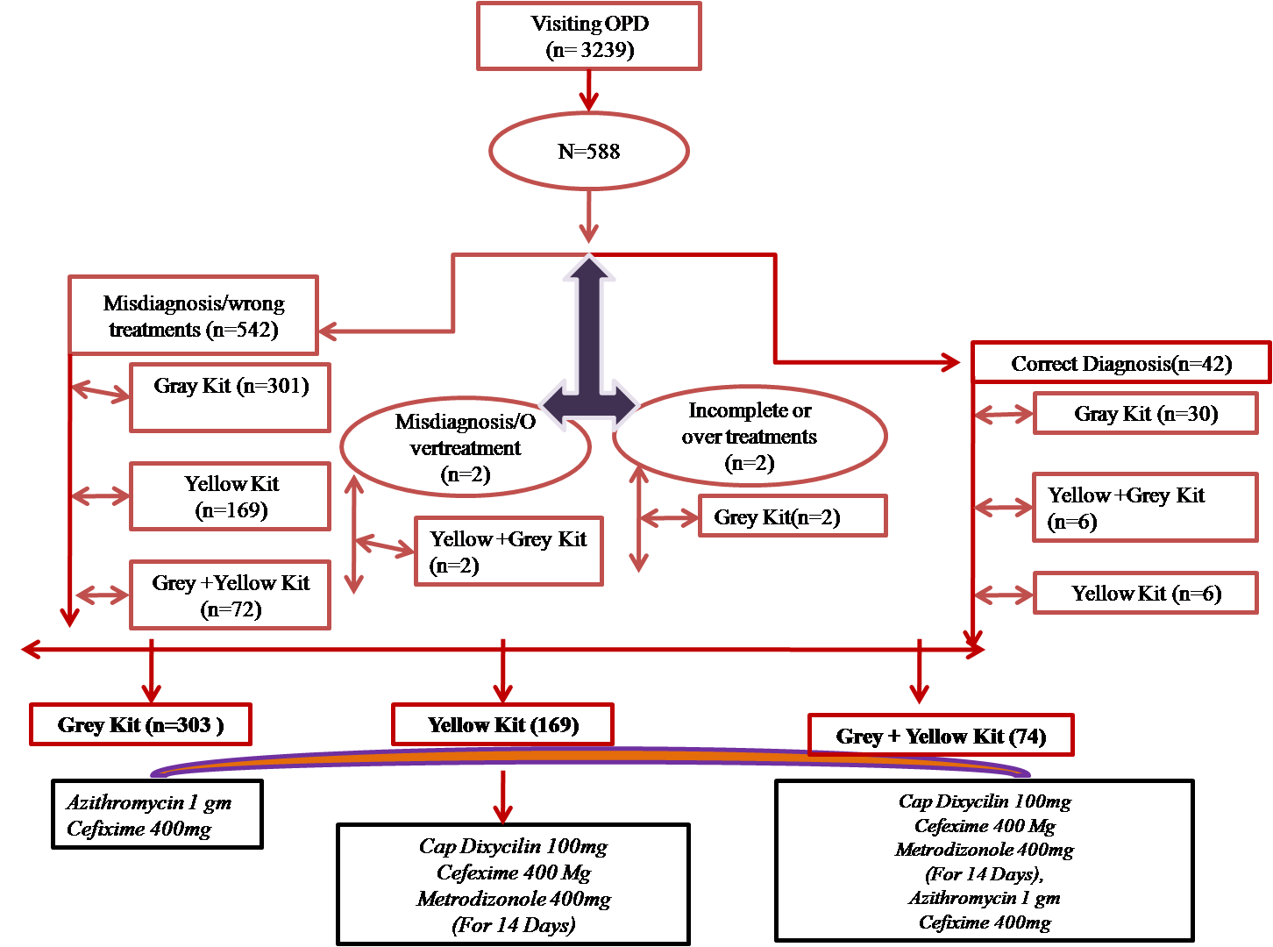

Recent publications (minimum 5)
- Sonkar SC,WasnikK, SharmaV, MishraPK, KumarA, BhardwajM, MittalP SalujaD, (2017). Evaluating the utility of syndromic case management for three sexually transmitted infections in symptomatic women visiting hospitals in Delhi, India. Nature Scientific Reports. 7:1465.
- Sonkar SC, Sachdeva D, Mishra PK, Kumar A, Mittal P Saluja D. (2016). A Molecular-Beacon-Based asymmetric PCR assay for diagnosis of trichomoniasis. Biosensors & Bioelectronics.86:41-7.
- Sonkar SC, Washnik K, Mishra PK, Kumar A, Mittal P, Saluja D (2016). Comparative analysis of syndromic and PCR-based diagnostics assay reveals misdiagnosis/ overtreatment for trichomoniasis based on subjective judgment in symptomatic patients. Inf. Dis. of Poverty; 5; 5; 42.
4. Sonkar SC, Yadav S, Dhanda K, Malla N, Saluja D, Yadav M. (2016). Evaluation of DNA based techniques for the diagnosis of Human Vaginal trichomoniasis in North Indian Population. British Microbiology Research Journal. Vol.: 17, Issue.: 6
5. Jain R, Sonkar SC, Chaudhry U, BalaM, Saluja D. (2016). In-silico hierarchical approach for the Identification of Potential Universal Vaccine Candidates (PUVCs) from Neisseria gonorrhoeae. Journal of Theoretical Biology 410: 36-43


Biography
Dr. Sonkar, National postdoctoral fellow from India and working in area of disease managements. His primary objective to provide knowledge and solid evidence that can improve conditions in low resource settings through impactful research, effective policy change and detailed health programs.
Email: drscsonkar@gmail.com

Notes/Comments:

