Chlamydia pneumoniae infection associated to atherosclerosis in Moroccan patients
Fouzia Radouani, PhD, Institut Pasteur du Maroc, Casablanca, Morocco

Image

Abstract

Atherosclerosis is a multifactorial vascular inflammatory process; vessel wall inflammation is an important mechanism, responsible for initiation, progression, sclerosis, erosion, and rupture of atherosclerotic plaques. Chlamydia pneumoniae has been suggested as a possible etiologic agent for this inflammatory mechanism, it has been shown that C. pneumoniae infects human mononuclear cells, and transmigrate into circulation and infect endothelial cells by cell-to-cell transmission of C. pneumoniae.
The main objective of our study was to evaluate the association between C. pneumoniae and atherosclerosis in Moroccan patients by a case/control approach and strain genotyping.
A total of 137 patients with cardiovascular diseases and 124 controls were recruited. Clinical data were recorded, blood samples were collected and 37 atherosclerotic plaques were obtained from patients subjected to surgery. C. pneumoniae DNA detection in peripheral blood mononuclear cells (PBMCs) and atherosclerotic plaques was performed by nested PCR. For strains molecular characterization, a second nested PCR was carried out to amplify a 366 bp fragment of the ompA variable domain 4 gene. PCR products were sequenced and sequences were processed by Seaview MUSCLE. Statistical analysis was done by SPSS.
The Nested PCR results showed 54% and 18% respectively for positivity in case’s and control’s PBMCs and 86.5% in atheroma plaques, the difference being significant between the two groups (p<0.001, OR_{a}=8,580, CI, 95% [3,273-22,491]).
Sequencing of the detected strains showed more than 98% homology with human C. pneumoniae reference strains. However, the phylogenetic study and polymorphism analysis of C. pneumoniae sequences revealed various genotypes. The comparison between our strains and C. pneumoniae strains retrieved in GenBank showed an identity with human strains and some new genotypes were also detected.
Our case/control study revealed C. pneumoniae involvement in atherosclerosis; the genotyping showed identity between the detected strains and human strains circulating worldwide. However, some new strains were also revealed.
Key words: Chlamydia pneumoniae, molecular characterization, case/control study.

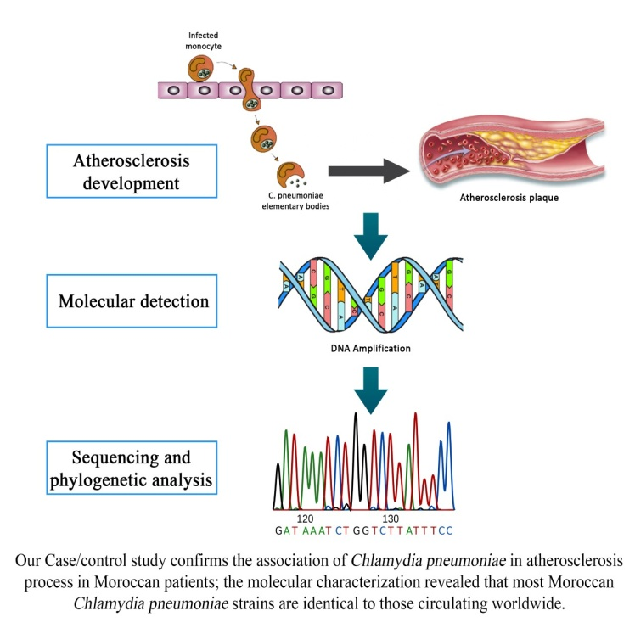
Recent publications
- Elyazghi Z, El Yazouli L, Sadki K, Radouani F. ABI Base Recall: Automatic correction and ends trimming of DNA sequences. IEEE Trans Nanobioscience. 2017 Sep 20. doi: 10.1109/TNB.2017.2755004. [Epub ahead of print]
- El Yazouli L, Hejaji H, Elmdaghri N, Aroussi Alami A, Dakka N, Radouani F. Investigation of Chlamydia pneumoniae infection in Moroccan patients suffering from cardiovascular diseases. Infect Public Health. 2017 Aug 28. pii: S1876-0341(17)30210-1. doi: 10.1016/j.jiph.2017.07.029.
- EL Yazouli L, Criscuolo A, Hejaji H, Bouaaza M, Elmdaghri N, Alami AA, Amraoui A, Dakka N, Radouani F. Molecular characterization of Chlamydia pneumoniae associated to atherosclerosis. Pathog Dis. 2017 Apr 6. doi: 10.1093/femspd/ftx039.
- Mulder NJ, Adebiyi E, Adebiyi M, Adeyemi S, Ahmed A, Ahmed R, Akanle B, Alibi M, Armstrong DL, Aron S, Ashano E, Baichoo S, Benkahla A, Brown DK, Chimusa ER, Fadlelmola FM, Falola D, Fatumo S, Ghedira K, Ghouila A, Hazelhurst S, Isewon I, Jung S, Kassim SK, Kayondo JK, Mbiyavanga M, Meintjes A, Mohammed S, Mosaku A, Moussa A, Muhammd M, Mungloo-Dilmohamud Z, Nashiru O, Odia T, Okafor A, Oladipo O, Osamor V, Oyelade J, Sadki K, Salifu SP, Soyemi J, Panji S, Radouani F, Souiai O, Tastan Bishop Ö; H3ABioNet Consortium, as members of the H3Africa Consortium. Development of Bioinformatics Infrastructure for Genomics Research. Glob Heart. 2017 Jun;12(2):91-98. doi: 10.1016/j.gheart.2017.01.005.
- Mulder NJ, Adebiyi E, Alami R, Benkahla A, Brandful J, Doumbia S, Everett D, Fadlelmola FM, Gaboun F, Gaseitsiwe S, Ghazal H, Hazelhurst S, Hide W, Ibrahimi A, Jaufeerally Fakim Y, Jongeneel CV, Joubert F, Kassim S, Kayondo J, Kumuthini J, Lyantagaye S, Makani J, Mansour Alzohairy A, Masiga D, Moussa A, Nash O, Ouwe Missi Oukem-Boyer O, Owusu-Dabo E, Panji S, Patterton H, Radouani F, Sadki K, Seghrouchni F, Tastan Bishop Ö, Tiffin N, Ulenga N; H3ABioNet Consortium. H3ABioNet, a sustainable pan-African bioinformatics network for human heredity and health in Africa .Genome Res. 2016 Feb;26(2):271-7. doi: 10.1101/gr.196295.115. Epub 2015 Dec 1.



PhD in Immunology, researcher at Institut Pasteur Morocco. Head of Chlamydiae and Mycoplasma laboratory, main research includes diseases associated to Chlamydiae and Mycoplasma infections. Conducting several research projects, author of many publications, presented her work in national and international conferences, active in various associations and organized conferences, meetings. Also interested in bioinformatics discipline. Principal investigator of H3Abionet project, responsible for the Bioinformatics platform implementation in Institut Pasteur du Maroc, supervises MSc and PhD students, develops tools. She works in an African network with objectives to meet the needs in genomics, data analysis and biological mechanisms exploration. Email: radouani@gmail.com/fouzia.radouani@pasteur.ma

Notes/Comments:

