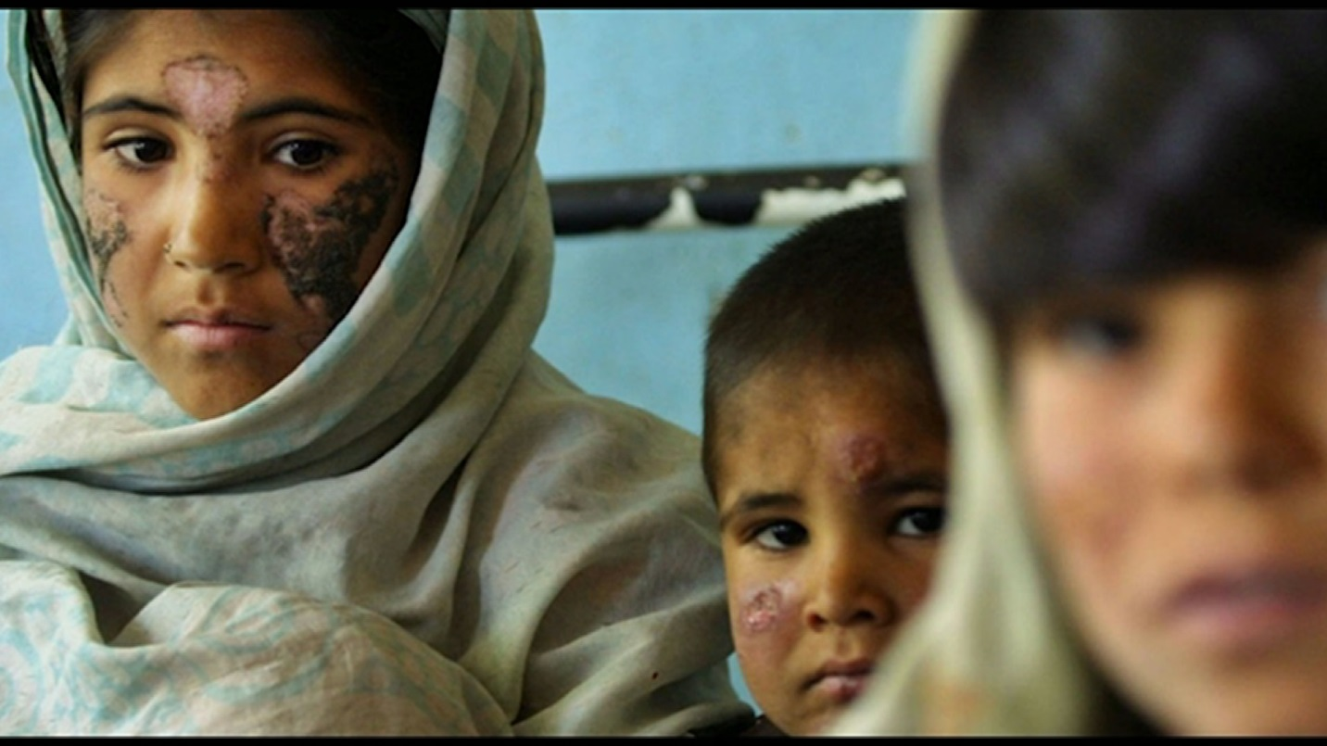

Leishmaniasis as life lasting sore for women in Afghanistan!
Let’s Change Lives…
By: Parwana Hamdam, BSPH - MPH
June 29th, 2019

Background: Leishmaniasis affects 1 to 1.5 million people all around the world and 90 % of this infection happens in developing countries. Afghanistan is one of the developing countries with high burdens of Leishmaniasis, Kabul; the capital of Afghanistan is the largest focus of cutaneous leishmaniasis globally. It is believed that the CL burden has a double nature: epidemiological, but also social: as a matter of fact, people affected by CL suffer from stigma and marginalization; ultimately, this can affect the opportunity to live a healthy life, particularly when the disease causes disfiguration among young girls and women. In Afghanistan almost all female leishmaniasis patients are seeking care.
Objective: The main purpose of this study is to explore the reason behind the delay.
Methodology:
Method: Qualitative method was used as tool for this study. One focus group discussion and three in-depth interviews have conducted.
Participants: HealthCare providers in Leishmaniasis Clinic at National Malaria and Leishmaniasis Control Program.
Analysis: Thematic Analysis method was used.
Finding:
Many factors such as socio-economic status, lack of knowledge about the disease, traditional or local treatment methods, and as well as lack of female health care providers contribute to this delay.
- Socio-economic status
“All patients coming to our clinics are very poor, even some of them cannot afford the money on transportation." A female health care Provider- In-depth Interview
- Lack of knowledge about the disease:
"Most of the time we have women patients with more than 20 lesions on her face, hands or any other parts of the body and they believed it is all because of the touching the lesion" A Female Health Care Provider- In-depth Interview
“One of our female patients said: the day I got this disease I completely stopped going out of the home because people don't behave with me like they used to do before now I feel disable and the ugliest person in the world." A Male health Care provider- Focus Group Discussion
- Local or Traditional Treatment:
“We had and have lots of patients who are using traditional care prior to coming to the clinics; even some of them are using acid to treat leishmaniasis." A Male health Care provider- Focus Group Discussion
- Lack of female health care providers:
“You will be shocked hearing this story, last year one of our female health care providers was on her maternity leave and the other was also absent due to some urgent issues in her family. In that day we lost almost all female patients with very serious conditions just because they have known that our female health care providers are absent” A Female Health Care Provider- Focus group
Conclusion:
Leishmaniasis change to a lifelong scar if not timely diagnosed and treated because it is highly attached to the stigma. Many factors such as low socioeconomic status, lack of knowledge about the disease, lack of female health care providers, and local or tradition treatment affect the treatment status of the disease. The due mentioned factor most people are seeking care very late almost in the last stage of the disease which results worsen of the lesion and make treatment very difficult and affect women social life negatively.

