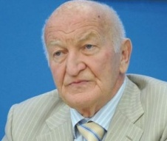

Title: The Selective Effect of NSC-631570 on Women Reproductive Cancers
Name: Dr. Wassil Nowicky
“Nowicky Pharma”/ Ukrainian Anti-Cancer Institute,
Margareten Street 7, A-1040, Vienna, Austria

First indications on the selective effect of NSC‐631570 on the cancer cells were provided in an early study when different oxygen consumption by normal liver cells and Ehrlich’s tumor ascitic cells after the incubation with NSC‐631570 was revealed.

In the tests on the Jurkat lymphoma model, NSC‐631570 has been proven to be a strong apoptosis inductor. Profound research showed NSC‐631570 brought about the depolarisation of mitochondrial membranes and consequently the activation of caspases.

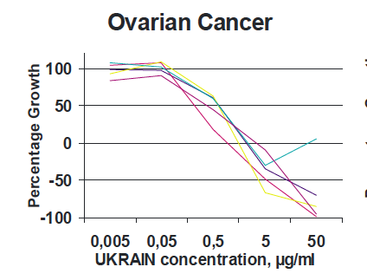
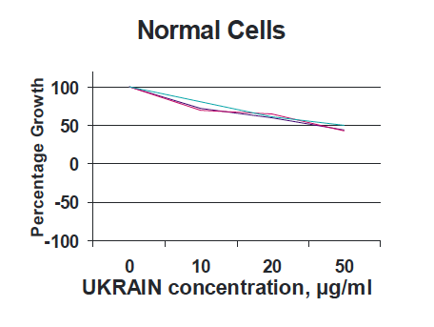
NSC‐631570 induced apoptosis in a panel of cancer cell lines (ovarial and cervical cancer HeLa, HeKB, HeKS32, HeBcl3, HeNFR and HeIKK, human colon cancer SW480, human renal carcinoma HEK293, human osteosarcoma MG‐63) by activating the caspases of the intrinsic cell death pathway.

Interestingly, non‐transformed fibroblasts (hTERT) cell line was insensitive to the drug. In the tests on human ovarian and cervix carcinoma cells HeLa, squamous carcinoma cells WHCO5, normal kidney cell line Graham 293, and transformed kidney cell line Vero from African green monkey, NSC‐631570 inhibited the tubulin polymerisation and caused a metaphase block in cancer cells which is characterised by abnormal chromosomal distribution, and results in the formation of micronuclei and in apoptosis.

Biography
Dr. Wassil Nowicky — Dipl. Ing., Dr. techn., DDDr. h. c., Director of “Nowicky Pharma” and President of the Ukrainian Anti-Cancer Institute (Vienna, Austria). Has finished his study at the Radiotechnical Faculty of the Technical University of Lviv (Ukraine) with the end of 1955 with graduation to “Diplomingeniueur” in 1960 which title was nostrificated in Austria in 1975. Dr. Wassil Nowicky became the very first scientist in the development of the anticancer protonic therapy and is the inventor of the preparation against cancer with a selective effect on basis of celandine alkaloids “NSC-631570”. He used the factor that cancer cells are more negative charged than normal cells and invented the Celandine alkaloid with a positive charge thanks to which it accumulates in cancer cells very fast. Thus, Dr. Nowicky is invited as an Honorable Speaker to take part in many scientific international congresses and conferences in USA, Australia, Japan, UAE, Europe. Author of over 300 scientific articles dedicated to cancer research. Dr. Wassil Nowicky is a real member of the New York Academy of Sciences, member of the European Union for applied immunology and of the American Association for scientific progress, honorary doctor of the Janka Kupala University in Hrodno, doctor “honoris causa” of the Open international university on complex medicine in Colombo, honorary member of the Austrian Society of a name od Albert Schweizer. He has received the award for merits of National guild of pharmasists of America. the award of Austrian Society of sanitary, hygiene and public health services and others.

Presenting author details
Full name: Dr. Wassil Nowicky
E-mail: dr.nowicky@yahoo.de
Website: www.ukrin.com
Contact number: +436644020692
Session name/ number:
Category: Oral presentation

