Butterfly Warrior: An Introspection on the Physical, Mental, Social and Emotional Aspects of Men with Systemic Lupus Erythematosus
Lyanne Iris G. Erlano, Manila Science High School, Philippines
Aldrin Mitchell B. Macatangay, Manila Science High School, Philippines
Lira Kale S. Pajarillo, Manila Science High School, Philippines
Melanie Andrae M. Seno, Manila Science High School, Philippines

Abstract
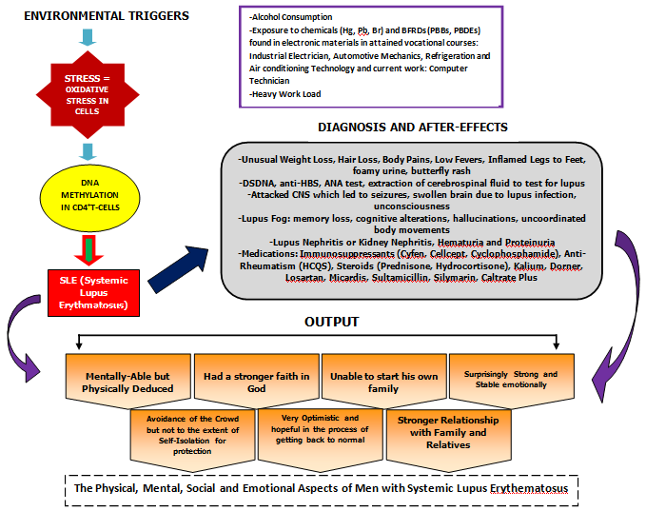
Medicine is a field in science that concerns itself to the improvement of an organism’s well-being by having a catena to the field of Healthcare. It is a branch of science which treats diseases and unriddles illnesses which have no available cure like autoimmune diseases, like Lupus. Lupus or Systemic Lupus Erythematosus (SLE) is a disease where the immune system attacks the body’s own cells mistaking it for a foreign aggregate of a person’s body that usually targets the female population. Due to this, many researches of this disease have focused mainly on female Lupus cases, leaving the affected male population with little knowledge about their case and about themselves. As part of the research enterprise, an introspection among the physical, mental, emotional and social aspects of a male lupus patient was done to promulgate information about the accordant aspects of a person’s self and to see any effects of the disease to the manliness of a male Lupus patient. The research was conducted through In-depth interviews and email interviews of one male lupus patient, having open-ended questions as its cornerstone being a case study. Results of the research were accomplished by sense-making, which furthered the knowledge of male lupus patients being physically deduced, mentally polished, emotionally reliant to God and family, socially selective and still relevantly male.
Keywords: Systemic Lupus Erythematosus (SLE), Male Lupus Patient, Introspection, Case Study

Results and Discussion
Bibliography

Anselm M and Kow, N.Y (2014). The Pathology of T Cells in Systemic Lupus Erythematosus. Hindawi Journal of Immunology Research. Volume 2014. pp: 419029-419037
Anselm M. and Tay, S.H (2014). Environmental Factors, Toxicants and Systemic Lupus Erythematosus. International Journal of Molecular Sciences. Volume 15, Number 9. 2014: pp. 16043-16056
Avery, Anthony, Creswell, Kathrin, Crowe, Sarah, Huby, Guro, Robertson, Ann and Sheikh, Aziz (2011). The Case Study Approach. BioMed Central: BMC Medical Research Methodology. Volume 11. 2011: p. 100
Bogdan, Robert, DeVault, Marjorie And Taylor, Steven (2015). Introduction to Qualitative Research Methods: A Guidebook and Resource. 2015. Retrieved from Wiley Website.
Cho, Judy H. and Gregersen, Peter K (2011). Genomics and the Multifactorial Nature of Human Autoimmune Disease. The New England Journal of Medicine. Volume 365. 2011: pp. 1612-162

Lyanne Iris G. Erlano, Aldrin Mitchell B. Macatangay, Lira Kale S. Pajarillo and Melanie Andrae M. Seno are all Senior High School students of Manila Science High School in the Philippines.
iriserlano@gmail.com, drinmacatangay@gmail.com, lirakalep@gmail.com and melanieaseno@gmail.com

