Abstract Title: HMGB1 released from damaged intestinal epithelia contributes to activation of mucosal DCs and induction of intestinal CTLs and IgA
Ayako Wakabayashi¹, Masumi Shimizu¹, Eiji Shinya¹, Hidemi Takahashi¹

¹ (Department of Microbiology and Immunology, Nippon Medical School, Tokyo, Japan)

Abstract (not more than 300 words)

Cholera toxin (CT) is a potent mucosal adjuvant, and oral administration of antigens plus intact CT but not CTA or CTB subunit induces antigen-specific CD8⁺ CTLs as well as IgA production in intestinal mucosa; however, mechanisms for the induction of these immune responses remain unknown. We attempted to examine whether oral administration of CT induces enhancement of intestinal cell death and release of HMGB1. The number of viable intestinal epithelial cells (IECs) was remarkably reduced and the number of dying AnnexinV⁺ 7-AAD⁺ cells was significantly increased in EpCAM⁺ IECs at 16 h after the oral administration of intact CT, compared to the group with oral CTA or CTB subunit. Then, we observed a significant increase of the fecal HMGB1 levels at 6 and 16 h after the oral CT-stimulation compared to other groups. After that, we tried to examine whether cytoplasmic HMGB1⁺ IECs are increased by the oral CT-stimulation. The cytoplasmic HMGB1⁺ IECs were significantly increased by the oral CT-stimulation and they were EpCAM⁺CD45⁻ IECs. HMGB1 dose-dependently enhanced the expression of CD80 and CD86 on DCs in vitro, and intravenous or oral administration of glycyrrhizin, an HMGB1 inhibitor, significantly suppressed activation of mucosal DCs, induction of intestinal CTLs and IgA, and DTH responses by oral CT-stimulation. Taken together, these results suggest that oral administration of intact CT but not CTA or CTB subunit triggers epithelial cell death in the gut and the release of HMGB1 from damaged IECs and that the released HMGB1 may mediate activation of mucosal DCs and induction of CTLs and IgA in the intestine.

Keywords—HMGB1, Cholera toxin, Epithelia, CTLs

Professional Biography (100-150 words)

Ayako Wakabayashi is a Senior Assistant Professor in Department of Microbiology and Immunology at Nippon Medical School, Tokyo Japan since 2016. She has completed her PhD and postdoctoral studies as a research resident from Tokyo Medical and Dental University. Her research interests lie in the area of mucosal immunology in the digestive tract, sensitization to food allergy, and gastrointestinal infectious diseases. She is the instructor for immunology, allergology, food hygienics, and nutrition.

Recent Publications (up to 5)

- Wakabayashi A, Shimizu M, Shinya E, Takahashi H (2018) HMGB1 released from intestinal epithelia damaged by cholera toxin adjuvant contributes to activation of mucosal dendritic cells and induction of intestinal cytotoxic T lymphocytes and IgA. Cell Death and Disease. 9(6) 631.
- Murakami R, Nakagawa Y, Shimizu M, Wakabayashi A, Negishi Y, Hiroi T, Okubo K, Takahashi H (2015) Effects of dendritic cell subset manipulation on airway allergy in a mouse model. International Archives of Allergy and Immunology. 168(4) 219-232.
- Negishi Y, Wakabayashi A, Shimizu M, Ichikawa T, Kumagai Y, Takeshita T, Takahashi H (2012) Disruption of maternal immune balance maintained by innate DC subsets results in spontaneous pregnancy loss in mice. Immunobiology. 217(10) 951-961.
- Moriya K, Wakabayashi A (equally contributed), Shimizu M, Tamura H, Dan K, Takahashi H (2010) Induction of tumor-specific acquired immunity against already established tumors by selective stimulation of innate DEC-205⁺ dendritic cells. Cancer Immunology, Immunotherapy. 59(7) 1083-1095.
- Wakabayashi A, Nakagawa Y, Shimizu M, Moriya K, Nishiyama Y, Takahashi H (2008) Suppression of an already established tumor growing through activated mucosal CTLs induced by oral administration of tumor antigen with cholera toxin. The Journal of Immunology 180(6) 4000-4010.

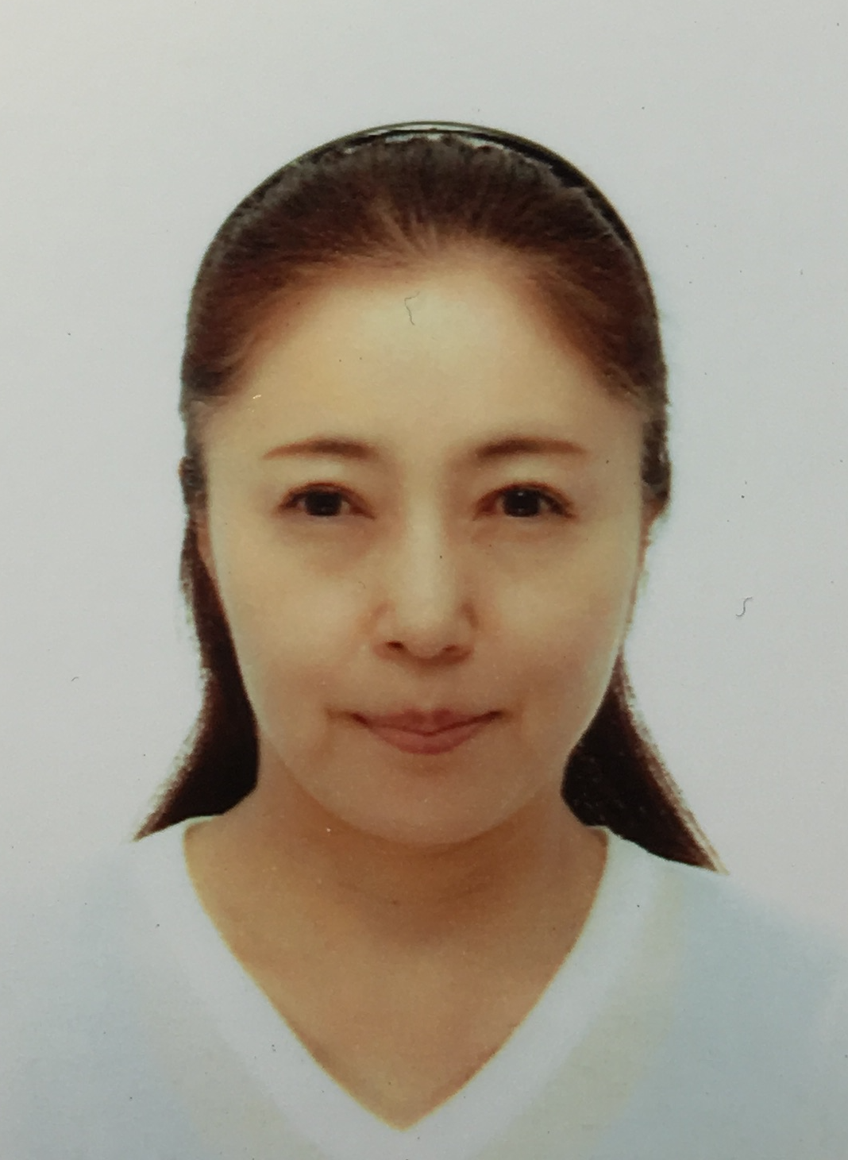

Email Id: awaka@nms.ac.jp

