Oncology, Primary Healthcare and the High Mortality Rate among People with Cancer in Nigeria and Sub – Saharan Africa – A Survivor’s Cry for Global Intervention. 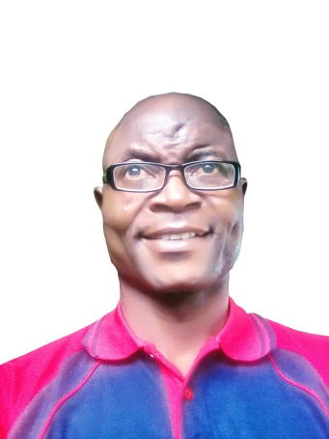
Lanre Jacob
Cancer Survivor, Oncology Researcher and Cancer Advocate, Nigeria.
Abstract
Problem Statement:
In Nigeria and most part of Africa, oncology services are not integrated into the general public healthcare system, especially at the Primary Healthcare level. This has helped to cut off most part of the populations from access to the few oncology facilities that are capable of cancer diagnosis and treatment. Couple with other factors such as very low awareness about cancer among the people, deaths from diverse cancers in Nigeria and in Sub-Saharan are increasing at alarming rate.
Purpose
The purpose of this study is to bring the attention of the world to the high death rates from cancer going on in Nigeria and the Sub-Saharan Africa. It is a survivor’s cry for global intervention to save the millions of helpless cancer victims in Nigeria and Africa.
Methodology
Critical and in depth review of the studies was done with the aim of identifying the status of oncological services in Nigeria and its integration into the general public health system, especially at the primary healthcare level.
Finding
A Study of a 2015 report on Radiation and oncology services available in Nigeria revealed that there were 5 Linear Machines and 3 Cobalt-60 Machines with only four of them functional. The population of Nigerians served by a megavoltage cancer therapy machine is over 33 million. In a population of about 180 million, there were just 30 radiation oncologists, 8 medical physicists, 18 Radiotherapy Technologists and 28 oncology nurses. These facilities and personnel were found in few private hospitals and in some public tertiary health centers. While the situation has not improved at all, thousands of patients still queue for six months or above to go through a course of radiotherapy service. Majority die in the process.
Conclusion
Nigeria, and indeed Africa is under the bondage of cancer. The trend present opportunities for both African governments and international agencies to rise now to tackle the high mortality rate from cancer in the continent.

References
- Professor Tajudeen Ajekigbe (2015): Cancer, Unwanted Guest that may Visit: Inaugural Lecture at the University of Lagos, Nigeria
- Nofisat Ismaila, Omotola Salako, Jimoh Mutiu and Oladeji Adebayo (2016): Oncology Guidelines Usage in a Low- and Middle-Income Country: Journal of Global Oncology
- World Health Organization (2014) Cancer Country Profile (Nigeria)
- Nigeria National Cancer plan - 2018 -2022
- Njaka SRN (2016): A systemic Review of incidence of cancer and challenges to its Treatment in Nigeria: Journal of Cancer Science & Therapy
Biography
Name: Lanre Jacob
University of Lagos, Nigeria
Lanre Jacob, Playwright, Novelist, graduated from the University of Lagos in 1999 with a B.A. degree in Linguistics. Jacob came in contact with Dermato-fibro-sarcoma protuberance in his scalp at the age of ten, leading to several dangerous surgeries. His 30 year cancer experience led him into oncology research and vigorous cancer advocacy and in 2016, he established the Lanre Jacob Sarcoma Cancer Foundation, a non-profit working to support people with cancer and which also collaborates with governments in Nigeria to carry out sustained national cancer awareness among community groups across country.
Presenting author’s details
Full name: Lanre Jacob
Contact number: +2348130133902
Twitter account: @LJSCancerfoundation
Linked In account: Lanre Jacob:
Category: Oral presentation

