The utility of concordant trend analyses in a Phase 2 study in Congenital and Childhood Onset Myotonic Dystrophy Type 1: a case example
Joseph Horrigan, MD, AMO Pharma Ltd, UK
Alison McMorn, PhD, AMO Pharma Ltd, UK
Alex Yaroshinsky, PhD, Vital Systems, Inc, USA.
Madison Stoms, Vital Systems, Inc., USA
Mike Snape, PhD, Amo Pharma Ltd, UK

Abstract
Statement of the Problem: Proof-of-concept clinical trials in rare diseases such as congenital and childhood onset myotonic dystrophy Type 1 are often hampered by a lack of knowledge concerning optimal outcome measures to detect efficacy. The concordant trends analysis offers a solution in which efficacy is assessed by evaluating the trends on several within-study assessments, provided the assessments are quasi- or wholly-independent. Positive findings using this analytical technique are unlikely to arise due to chance alone. Methodology & Theoretical Orientation: AMO-02/tideglusib is a novel, orally administered GSK-3β enzyme inhibitor. Overactivity of GSK3β has been identified as a key pathophysiological feature of congenital and childhood onset myotonic dystrophy. Accordingly, this Phase 2a clinical trial explored the utility of AMO-02 in 16 adolescents and adult subjects with this form of myotonic dystrophy across a 12-week treatment period. Outcome measures included disease-specific rating scales, functional/performance-based assessments, and biomarkers. Findings: AMO-02 rendered clinical benefit to the majority of subjects after 12 weeks of treatment. The concordant trend analysis revealed a clear dose-response relationship that favored the 1000 mg over 400 mg dose. Four of the 10 efficacy variables (i.e. grip strength, Clinician VAS rating scale, Caregiver Top 3 Concerns rating scale, and OSU CGI-I rating scale) differed in favor of 1000 mg over 400 mg dose and there was no worsening in the remaining six variables. Conclusion & Significance: The concordant trend analysis provides reiterative confidence about the study findings. This is important since this novel therapeutic area lacks gold standard outcome measures and this study was the first clinical trial conducted in this specific population. Accordingly, AMO-02 merits further progression in clinical development in this population of individuals affected by early-onset myotonic dystrophy, and the 1000 mg dose may have the best prospect of establishing a consistent efficacy signal.

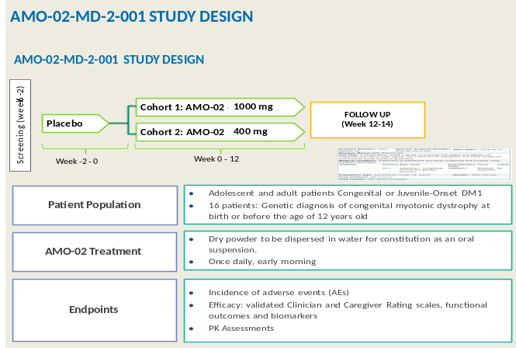

Recent Publications
- Reardon W, Newcombe R, Fenton I, Sibert J, Harper PS. The natural history of congenital myotonic dystrophy: mortality and long term clinical aspects. Arch Dis Child. 1993; 68:177-181
- Ratan V, Bhat RV, Haeberlein SLB, Avila J. Glycogen synthase kinase 3: a drug target for CNS therapies. Journal of Neurochem. 2004; 89:1313–1317
- Jones K, Wei C, Iakova P, Bugiardini E, Schneider-Gold C, Meola G, Woodgett J, Killian J, Timchenko NA, Timchenko LT. GSK3β mediates muscle pathology in myotonic dystrophy. J Clin Invest. 2012; 122:4461-4472
- Wei C, Jones K, Timchenko NA, Timchenko L., GSK3β is a new therapeutic target for myotonic dystrophy type 1. Rare Dis. 2013; 1:e26555
- Ho G, Cardamone M, Farrar M1. Congenital and childhood myotonic dystrophy: Current aspects of disease and future directions. World J Clin Pediatr. 2015; 4:66-80

Biography
AMO Pharma is a privately held emerging biopharmaceutical company, based in the United Kingdom, that is developing new treatments for serious and debilitating diseases including rare genetic disorders. The company’s goal is to identify and advance promising therapies for patient populations with significant areas of unmet need. The company is led by seasoned professionals with extensive experience in all phases of preclinical and clinical development. The AMO Pharma portfolio currently includes clinical stage investigational drugs to treat neuromuscular or CNS symptoms of rare diseases. AMO Pharma’s investigational drugs currently include AMO-01 for the treatment of Phelan-McDermid syndrome, AMO-02 for the treatment of congenital myotonic dystrophy, and AMO-04 for the treatment of Rett syndrome.
Email: mike. snape@amo-pharma.com

