Not All Thiazides Are Created Equal: Comparing Cardiovascular Outcomes Among Commonly Prescribed Antihypertensives
Rachel Boysen, PA-S3, Lance Hansen, PA-S3, Meredith Mihalick, PA-S3, Julie Kutac, PhD
University of Texas Medical Branch Galveston, TX 77555, USA

Abstract (300 word limit)
Thiazide-like and thiazide-type diuretics are both recommended, without discrimination, by the Joint National Committee as first line treatments for hypertension.1 However, despite similar mechanisms for blood pressure reduction, there is mounting evidence that these two distinct classes of medication confer variable protection against adverse cardiovascular events. The purpose of this analysis is to determine whether thiazide-like diuretics are associated with fewer cardiovascular events than thiazide-type diuretics, in the absence of head-to-head trials in the literature. A systematic review using PubMed with the inclusion criteria of subjects taking either thiazide-type diuretics or thiazide-like diuretics, excluding meta-analyses and systematic reviews. Most studies reviewed concluded thiazide-like diuretics showed a higher reduction in mortality rates secondary to cardiovascular events such as myocardial infarction, stroke, heart failure, and left ventricular hypertrophy than thiazide-type diuretics such as HCTZ or bendroflumethiazide. Many studies reviewed also showed that thiazide-like diuretics showed greater decrease in systolic and diastolic ambulatory blood pressures than thiazide-type diuretics. Additionally, most studies revealed higher risk of electrolyte imbalance due to therapy with thiazide-like diuretics in comparison with thiazide-type diuretics at similar doses. The majority of studies conclude thiazide-like diuretics are superior to thiazide-type diuretics on the contingency that the patient’s bloodwork reflects stable electrolyte counts and the patients are able to be monitored throughout the course of their treatment. Chlorthalidone or indapamide should be considered the standard of care if prescribing a thiazide diuretic for HTN due to their overall improvement of cardiovascular outcomes.

Image
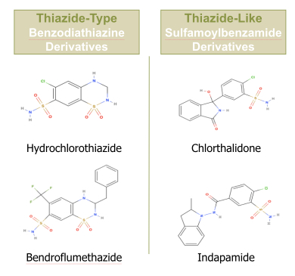
Recent Publications (minimum 5)

Photograph


Biography
Rachel, Lance, and Meredith are 3rd year Physician Assistant students graduating in August 2020. They have a diverse background of experiences leading them to PA school including a prior career in biomedical engineering, background in emergency medicine, and child development. They will be pursuing careers in Texas after graduation.
Email: raboysen@utmb.edu, lshansen@utmb.edu, memehali@utmb.edu

