Clinical and genetic investigation of ichthyosis in familial and sporadic cases in south of Tunisia: genotype–phenotype correlation

Dr.Mariem Ennouri, PhD, University of Sfax, Tunisia; Dr.Andreas D. Zimmer, PhD, University of Freiburg,Germany; Dr. Emna Bahloul, Doctor, University of Sfax, Tunisia; Dr. Rim Chaabouni, Doctor, University of Sfax, Tunisia; Dr. Slaheddine Marrakchi, Doctor, University of Sfax, Tunisia; Dr. Hamida Turki, Doctor, University of Sfax, Tunisia; Pr. Faiza Fakhfakh, Professor, University of Sfax, Tunisia;; Pr. Judith Fischer, Professor, University of Freiburg,Germany; Pr. Noura Bougacha‑Elleuch, Professor, University of Sfax, Tunisia

Abstract (300 word limit)

Background: Ichthyosis is a heterogeneous group of Mendelian cornification disorders that includes syndromic and non-syndromic forms. Autosomal Recessive Congenital Ichthyosis (ARCI) and Ichthyosis Linearis Circumflexa (ILC) belong to non-syndromic forms. Syndromic ichthyosis is rather a large group of heterogeneous diseases. Overlapping phenotypes and genotypes between these disorders is a major characteristic. Therefore, determining the specific genetic background for each form would be necessary.

Methods: A total of 11 Tunisian patients with non-syndromic (8 with ARCI and 2 with ILC) and autosomal syndromic ichthyosis (1 patient) were screened by a custom Agilent HaloPlex multi-gene panel and the segregation of causative mutations were analyzed in available family members.

Results: Clinical and molecular characterization, leading to genotype–phenotype correlation in 11 Tunisian patients was carried out. Overall, we identified 8 mutations in 5 genes. Thus, in patients with ARCI, we identified a novel (c.118T > C in NIPAL4) and 4 already reported mutations (c.534A > C in NIPAL4; c.788G > A and c.1042C > T in TGM1 and c.844C > T in CYP4F22). Yellowish severe keratoderma was found to be associated with NIPAL4 variations and brachydactyly to TGM1 mutations. Two novel variations (c.5898G > C and c.2855A> G in ABCA12) seemed to be features of ILC. Delexon13 in CERS3 was reported in a patient with syndromic ichthyosis.

Conclusions: Our study further extends the spectrum of mutations involved in ichthyosis as well as clinical features that could help directing genetic investigation.

Image
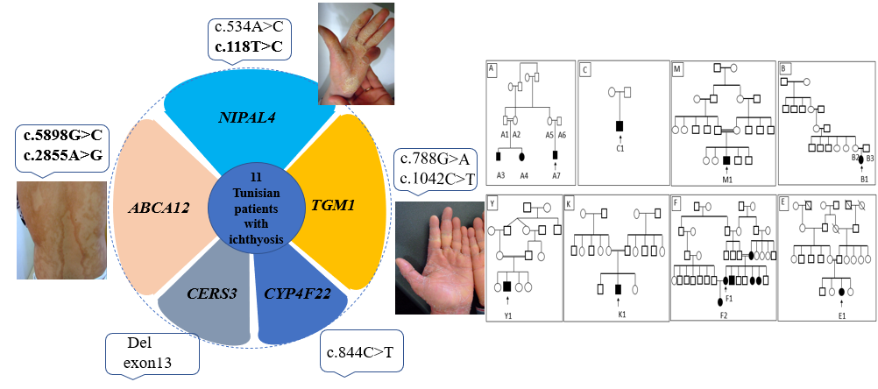
Recent Publications (minimum 5)
- Ballin N, Hotz A, Bourrat E, Küsel J, Oji V, Bouadjar B, et al. Genetical, clinical and functional analysis of a large international cohort of patients with autosomal recessive congenital ichthyosis due to mutations in NIPAL4.Hum Mutat. 2019..
- van Leersum FS, Seyger MMB, Theunissen TEJ, Bongers EMHF, Steijlen PM, van Geel M. Recessive mosaicism in ABCA12 causes blaschkoid congenital ichthyosiform erythroderma. Br J Dermatol. 2020;182:208–11..
- Autosomal recessive congenital ichthyoses in the Czech Republic. Br J Dermatol. 2016;174:405–7..
- Simpson JK, Martinez-Queipo M, Onoufriadis A, Tso S, Glass E, Liu L, et al. Genotype-phenotype correlation in a large English cohort of patientswith autosomal recessive ichthyosis. Br J Dermatol. 2020;182:729–37
- Louhichi N, Hadjsalem I, Marrakchi S, Trabelsi F, Masmoudi A, Turki H, et al. Congenital lamellar ichthyosis in Tunisia is caused by a founder nonsense mutation in the TGM1 gene. Mol Biol Rep. 2013;40:2527–32.
Photograph

 Biography (150 word limit)
Mariem Ennouri, PhD in biologic sciences at University of Sfax Tunisia. Her research was focused in Human Genetics and Genetic disorders of Dermatology. Her first goal was to identify the genetic mutations responsible for a rare disease such Psoriasis and Ichthyosis, to improve the health and the wellbeing for Humanity. She has published four articles after years of experience in research. She collaborates with national and international laboratories like National Institute of Health and Medical Research "INSERM" (Paris-France) and Human Genetic (Freiburg-Germany).
Email: mariamnouri1992@gmail.com

Notes/Comment

