How single-molecule real-time sequencing can improve the prognosis and genetic counselling in Myotonic dystrophy type 1

Antoine Mangin, Dementia Research Institute, Cardiff University, BRITAIN
Laure de Pontual, Sorbonne Université, Inserm, Institut de Myologie, Centre de Recherche en Myologie, FRANCE
Dr Yu-Chih Tsai, Pacific Biosciences, USA
Dr Laetitia Monteil, Genetics Department of the Hospital of Toulouse, FRANCE
Dr Mathilde Nizon, Dr Pierre Boisseau and Dr Sandra Mercier, CHU de Nantes, FRANCE
Dr Janet Ziegle, Dr John Harting and Dr Cheryl Heiner, Pacific Biosciences, USA
Dr Gourdon Geneviève, PhD, Sorbonne Université, Inserm, Institut de Myologie, Centre de Recherche en Myologie, FRANCE
Dr Stéphanie Tomé, PhD, Sorbonne Université, Inserm, Institut de Myologie, Centre de Recherche en Myologie, FRANCE

Abstract

Myotonic dystrophy type 1 (DM1) results from the expansion of an unstable CTG repeat that usually increases across generations and over time in somatic tissues. CTG repeat instability and DM1 clinical manifestations depend on the length of the repeat itself and the purity of the repeated sequence. The genetic counseling in DM1 is very complex, due to the highly variable clinical presentation and technical difficulties in determining the size and purity of the CTG expansion. We used PacBio Single-Molecule Real-Time sequencing (SMRT) to precisely measure large CTG repeat size and identify sequence interruptions of expanded allele to understand clinical and genetic variability in DM1 patients. We sequenced several DM1 patients with CTG repeat expansions ranging from 130 to > 1000 CTG repeats on the Sequel I and II systems from purified amplicons. We obtained more than 77% full DM1 reads per sample, with >70% of the reads from expanded alleles. The data includes long reads in the expected size range for all samples, including DM1 patients with more than 1000 CTG repeats (Table1and Ref1). SMRT sequencing is very promising to sequence large triplet repeat expansions, to identify CTG repeat interruptions and to estimate somatic mosaicism in DM1 patients. This method can significantly improve the prognosis and counseling offered to patients.

Recent Publications
- Mangin, Antoine, Laure de Pontual, Yu-Chih Tsai, Laetitia Monteil, Mathilde Nizon, et al. (2021). « Robust Detection of Somatic Mosaicism and Repeat Interruptions by Long-Read Targeted Sequencing in Myotonic Dystrophy Type 1 ». International Journal of Molecular Sciences 22 (5): 2616.

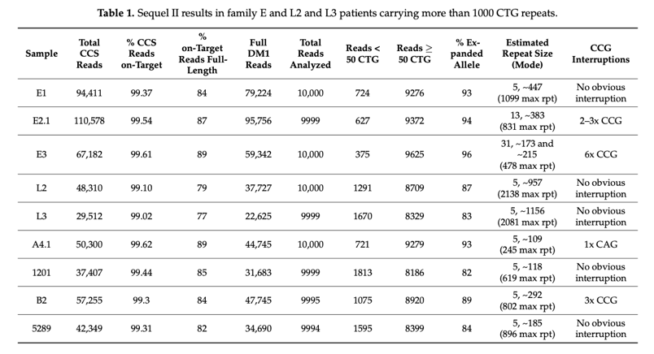
- Tomé, Stéphanie, et Geneviève Gourdon. (2020a). « Fast Assays to Detect Interruptions in CTG.CAG Repeat Expansions ». 2056:11‑23. Methods in Molecular Biology.

- Tomé, Stéphanie, et Geneviève Gourdon. (2020b). « DM1 Phenotype Variability and Triplet Repeat Instability: Challenges in the Development of New Therapies ». International Journal of Molecular Sciences 21 (2): 457.

- Lo Scrudato, Mirella, Karine Poulard, Célia Sourd, Stéphanie Tomé, Arnaud F. Klein, Guillaume Corre, Aline Huguet, Denis Furling, Geneviève Gourdon, et Ana Buj-Bello. (2019). « Genome Editing of Expanded CTG Repeats within the Human DMPK Gene Reduces Nuclear RNA Foci in the Muscle of DM1 Mice ». Molecular Therapy 27 (8): 1372‑88.

- Tomé, Stéphanie, Elodie Dandelot, Céline Dogan, Alexis Bertrand, David Geneviève, Yann Péréon, Marie Simon, Jean-Paul Bonnefont, Guillaume Bassez, et Geneviève Gourdon. 2018. « Unusual Association of a Unique CAG Interruption in 5′ of DM1 CTG Repeats with Intergenerational Contractions and Low Somatic Mosaicism ». Human Mutation 39 (7): 970‑82.

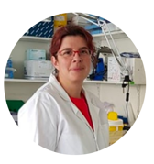
Biography
Dr. Tomé has been working for more than 15 years on trinucleotide repeats instability observed in several neurological and neuromuscular disorders such as Huntington's disease and myotonic dystrophies. Dr Tomé is focusing her research on myotonic dystrophy type 1 (DM1) and the mechanisms of CTG repeat instability, in particular CTG contractions in the research group led by Dr. Gourdon (Paris, FRANCE). Dr. Tomé has acquired a solid expertise in Single-molecule real-time (SMRT) sequencing developed by Pacific Biosciences. Recently, she applied this method to precisely measure and characterize the sequence of large CTG repeats in DM1 patients to better understand the high clinical and genetic variability observed in the DM1 population. Dr Tomé and her colleagues wish to introduce SMRT sequencing as an alternative molecular diagnostic method that could improve the prognosis and counseling offered to DM1 patients, but also use it routinely in research.
Email: stephanie.tome@inserm.fr

Notes/Comments:

