Affordable & Low Cost Hospital model across the Globe: Strategic management and exclusive case study.

Prof. R. K. Yadav, Chairman - Hospimed International Healthcare Foundation & Managing Director – Hospimed Group

Abstract –

Statement of the Problem: Establishing a hospital in India requires tremendous amount of planning, architectural drawings, large finances, approvals, certifications, licenses and medical guidelines & ethics to be followed, hence designing health facilities without thorough thinking and norms mostly result in serious fanatical loss.
Case Study - The similar condition was faced recently last year by the Medical Director of Burdwan Institute of Medical Sciences (BIMS), Burdwan, West Bengal, India while constructing multi & super specialty hospital by a local Architect without any knowledge & experience how to build, design and architectural plan of a new Hospital. Later, he on-boarded Prof. R. K. Yadav of Hospimed Group which he decided to demolished the entire old construction and revised all Architectural Drawing, Designing, Facility Plan, Space Management, Optimal Medical Equipments, Hospital Beds, OT’s ICU, ITU, Dialysis, Emergency and utilize all the services at standard International norms and built the hospital as per Indian Standards - NABL, NABH, State and Central Government of India norms. “We must keep support and educate our clients/Investor as a learner, give them 200 percent support on long-term basis and showcase positive commitment in every aspect of our interactions to earn their confidence.
Prof. Yadav identified and recommend to establish Multi or Super Specialty Hospital with all International standard norms – Best Architecture drawing & Designing, Engineering, construction, interior designing, management consulting, infrastructures and turnkey project management services for configuring corporate standards at affordable & Low cost model across the globe. Its variety of proven benchmarks (Trade Marks, Copyright, ISO, CRISIL, NSIC and MSME of India), tools and frameworks enable healthcare players to develop efficient & ethical business operations and deliver value-based services to the patients. Prof. R. K. Yadav of Hospimed is recognized for providing few options for each project based on the latest know-how and new generation technologies along with medico legal support that further help patients, Nursing Team, Technicians, Para Medicals and Doctors to boost better patient management services as per One International / Universally norms.
Prof. Yadav also feels to focus on single window service under the ease of specialized management team comprising of senior advocates (high & supreme court), CAs, Doctors, HRs, Bio-medical Engineers and Business developers to augment the productivity and efficiency of the hospital. It ensures that all systems, protocols, services and structure are in place, the hospital has obtained all required regulatory approvals and licenses, operational policies are well laid out and most importantly the marketing campaign is rolled out. There should be mandatory statutory issues (health, drug, insurance & fire license, pollution, and waste management) and financial accounting including Tally Entry and purchase & inventory guidelines, billing (individual & corporate), recovery/auditing/income tax filing, assets and pricing assessment & revision management, vendor payment bill assessment and other financial issues including patient procedure consent, medicine dose, treatment guidelines, drug chart which should be one SOPs Internationally.
Research Methodology – Prof. Yadav has done various strategic exercises by detail Questioners to Employees, Doctors, Patient, Patient Relatives, Visitors to take their review including In-house Employee feedback and questioners by giving them various exercises, Data to Analyze and many patient treatment methodology should be one International / Universally norms.

Conclusion & Significance – Prof. Yadav strongly recommend by implementing “ONE WORLD – ONE HOSPITAL – ONE NORMS” internationally /universally with an ambition to follow “HEALTH FOR ALL”.

Recent Publications –
Published in Silicon India, Healthcare Consultants Special, March 06 – 2018, India & USA, “Building Certified Healthcare Projects at affordable Cost”, Volume 01, issue 10-2, March 06, 2018.

Biography
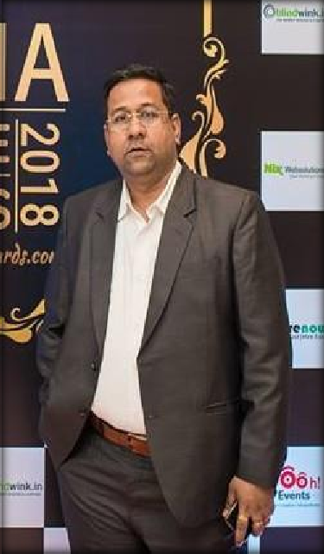

M. Phil in Hospital & Health Systems Management – CMC Vellore under Tulane Medical University, USA (2001-2003) Collaboration Program at BITS, Pilani, Christian Medical College, CMC Vellore, Tamil Nadu, India, Bombay Hospital, Mumbai, India under Tulane Medical University, New Orleans, United States of America.

MHA (PGDHM) in Hospital Management (Two Years ,1994-1996) Full Time from Indian Institute of Social Welfare & Business Management (IISWBM), Kolkata, India under All India Council for Technical Education,(AICTE), New Delhi, India, Government of India.

Post Graduate Diploma in Hospital Personnel Management (1996) from Institute of Healthcare Administration, Chennai, India.

B.Sc. in Bio-Science (1993) from The Scottish Church College, Kolkata, India, under University of Calcutta, West Bengal, India.

24 years wide experience in Healthcare industry for setting-up various Healthcare Projects in India & abroad also working as a visiting Lecturer/Professor for Mgmt. Institute & Colleges.

Today, Prof. Yadav is a one of the leading & reputed Consultant in Healthcare Industry and developing various kinds of projects in Healthcare. He has earned his reputation & goodwill in Healthcare Industry within very short period of time for his hard work, dedication & positive commitments.
He had started his Healthcare career journey since 1996 from the level of a “Management Trainee” at Apollo Hospitals, Chennai and today he is running his Companies name a “HOSPIMED” brand which is specialized in Hospital Architectural, Drawing, Designing, Planning, Construction, Interior Designing, Medical Equipment and Setting-up a Healthcare Projects on a Turnkey basis and he is still attached with many Organization like DR.S.K.SEN HEALTHCARE UNIT as a Technical Consultants and Research Scholar Team Head to provide unique treatment methodology of “AYUSH” as per International Standard.
Prof. R. K. Yadav has 24 years wide experience in Healthcare Industry with strong vision to create professional environment & bring World Class Medical facility in a small set-up Hospital at a bare minimum and low cost for every individual.
Moreover, he strongly believes to give more thrust to Under Graduate & Post Graduate Programs, Research work on Hospital Management, Para Medical Programs, Nursing Programs, Health Safety Programs, AYUSH Program & many other professional programs where students can get complete theoretically knowledge, Practical knowledge, Workshops, Seminars along with all required Case Studies and allied Research work which will help them to handle the situation/decision independently in future. He has implemented SOP’s of Hospital in a very simple and easy manner so that employee of the Hospital can understand and do their best in a professional and ethical Service in a any Hospital.
After completion of M. Phil in Hospital & Health Systems Management in the year 2001-2003 he had worked for Corporate Hospital for more than 22 years and started working as a freelancer Hospital Consultant and later on he develop the Group which is well known as a Hospimed Group and working as a Managing Director and become Top Ten Hospital Consultants in India in the year 2018. He is also attached with many Hospitals, Colleges, Medical Trust to do philanthropic social work for the society. He is still giving lectures for many Institute, Management Colleges including Research Work on many New Hospital Management Project issues. There are many Abstract, Research Work, Presentation and Review in leading Magazines.

Presenting author details
Full Name: Prof. Rajesh Kumar Yadav MHA, M. Phil in Hospital & Health Systems Management.
Calling Number: +91-9830094625, WhatsApp Number - +917001144674
Email ID – hospimedfoundation@gmail.com or hospimedgroup@gmail.com
Session name/ number: Hospital Management
Category: (Oral presentation/ Poster presentation) – Oral & Power Point Presentation.

