


Survivin and Caspase-3 as a Diagnostic and Predictive
Biomarkers of Recurrence for
Urinary Bladder Carcinoma after TURBT
Vivian GD Rouston ª, MD, Prof Amal AA Shaaban ^{b}, PhD, Dina M Abd Allah ^{b}, PhD, Ahmed F Kotb ^{c}, PhD

ª Pathology Department, Ministry of Health, Egypt
^{b} Pathology Department, ^{c} Genitourinary Surgery Department, Faculty of Medicine, University of Alexandria, Egypt
Background: Bladder cancer even in early stage develop recurrence. Poor sensitivity of cytology and invasiveness of urethrocystoscopy have generated interest in non-invasive tools to monitor for recurrence. Caspase-3 and survivin have central role in regulation of apoptosis. Survivin can aid early diagnosis, determine prognosis in multiple cancer types and predict response to anti-cancer therapies. Its combination with other biomarkers as caspase-3 enhance prognostication and prediction of treatment response in UBC.
Methods: Immunohistochemical expression of survivin and caspase-3 were assessed in 44 Egyptian consecutive patients with UBC and 7 cystoscopic biopsies of cystitis as control reactive benign urothelium. Relationships between their expression, clinicopathological characteristics, diagnostic and prognostic performance were statistically analyzed.
Findings: No survivin immunoreactivity was identified in non-neoplastic bladder tissue. Expression of survivin and caspase-3 was altered in 42(95.5%) and 10(22.7%) cases, respectively. There was statistically significant moderate positive correlation between survivin and caspase-3 expression among whole studied cases (p=.006). Expression of either survivin or caspase-3 protein individually significantly differ (p=0.000) in cancer status from control cases. Survivin was an independent predictor of UBC in multivariable analyses. Diagnostic accuracy of survivin alone was significantly better than caspase-3 alone (sensitivity 81.82% Vs 68.18%, p=.027). Addition of survivin immunoreactivity to model including caspase-3 expression improved diagnostic accuracy with a sensitivity of 93.18%. Addition of gender to the previous model improved more diagnostic accuracy with sensitivity of 100%.
Interpretation: Survivin alone is very promising marker and reliable indicator in UBC. Survivin and caspase-3 antigens have a cooperative effect on bladder cancer, their simultaneous evaluation augments diagnostic sensitivity.
Abbreviations: UBC, Urinary Bladder Cancer or Carcinoma; TURBT, Trans Uretheral Resection of Bladder Tumor

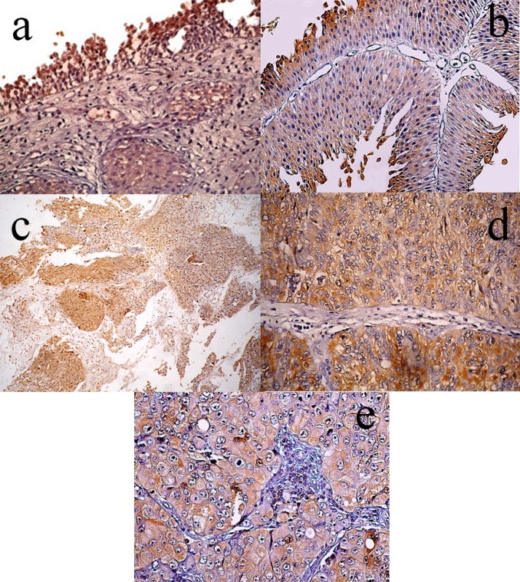
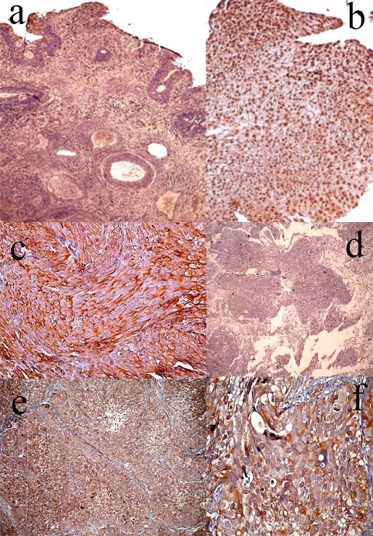

Figure 1: IHC expression of survivin. (a) Normal survivin immunostaining 7% in a chronic non specific cystitis (X100). (b) Altered survivin immunostaining 90% in a low grade papillary UC, showing diffuse nuclear predominance staining and moderate cytoplasmic staining pattern (X100).
(c) Altered survivin immunostaining 70% in a high grade papillary UC, showing diffuse cytoplasmic immunopositivity (X200). (d) Alterd survivin expression 70% in a low grade non-papillary UC, showing focal cytoplasmic and nuclear immunostaining (X100). (e & f) Altered survivin immunostaining 80% in a high grade non papillary UC, showing diffuse cytoplasmic staining (X100 & X400).

Figure 2: Caspase-3 immunoreactivity. (a) Caspase-3 normal “15%” cytoplasmic immunostaining in chronic cystitis with von brunn nests (X400). (b) Altered “70%” Caspase-3 immunostaining in a low grade papillary UC, showing diffuse cytoplasmic staining (X200). (c) Caspase-3 expression 70% in a low grade non papillary UC, showing nuclear and cytoplasmic staining (X100). (d) Caspase-3 expression 90% in a high grade papillary UC, showing diffuse cytoplasmic staining (X400).
(e) Caspase-3 immunostaining 70% in a high grade non papillary UC, showing diffuse cytoplasmic staining pattern (X400).

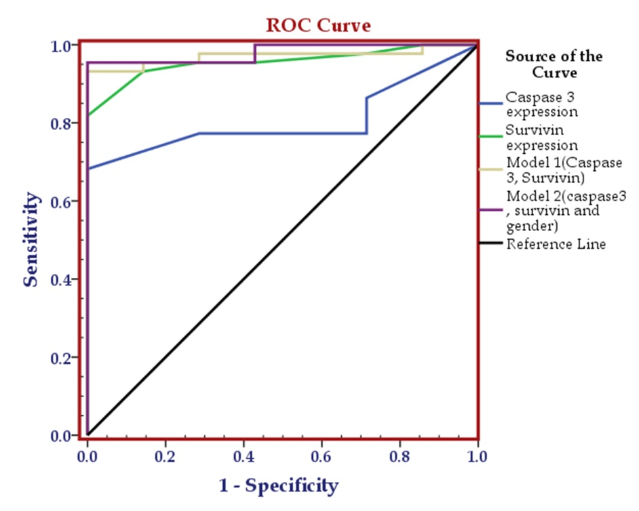
Figure 3: ROC curve comparing the performance of caspase-3 expression alone, survivin expression alone, Model one (caspase-3 and survivin expression) and Model two (caspase-3 immunoreactivity, survivin expression and gender) in diagnosis of urinary bladder cancer among studied sample.

Biography

Vivian Rouston was born in 1979. She obtained her MBBCh in 2004 and Masters in Pathology in 2015 from Faculty of Medicine Alexandria University. She was trained for histopathology and cytopathology at histopathology division of the Department of Pathology, St James's university hospital, the Leeds Teaching Hospitals, NHS Trust, United Kingdom. She is working as a histopathology specialist in a general hospital in Egypt.
Presenting author details
Full name: Vivian Gaber Daboos Rouston
Contact number:+971 554983344
Email id: v_dabous@hotmail.com
Category: (ePoster presentation)
Session name: Histopathology
Research interest: Histopathology and Immunohistochemistry

