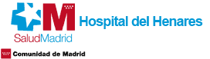

MACROCASSETES: TEACHING EXPIRIENCE IN SPAIN. PROFITABILITY, ADVANTAGES AND POSSIBLE LIMITATIONS

Authors: Laura del Barrio Prieto, Irene Beitia Rodriguez, Laura Martinez Codes, Mar Olmo Fernandez, Mª Jesús Lago Perez, Blanca Palomeque Castro.
INTRODUCTION
Macrocassettes are a very useful tool within the pathology laboratory. Currently, they are usually carry out exclusively in radical prostatectomies. We are pioneers in Spain in using them for all types of tissues. It is not usually known the adequate processing that allows the realization of good quality slides in any type of tissue. The fact that the pathologist can visualize complete structures or larger lesions in a single slide improves efficiency.
PURPOUSES
To present our experience for more than ten years in the fixation, processing, inclusion and cutting of numerous biopsies in macrocassettes (more than 4000), and show the advantages and disadvantages of the use of this technique. Currently we have launched a practical workshop for Pathology Technicians teaching these techniques. In this first edition of the workshop we have full occupation from the participants, and also we haver received numerous emails from profesional from outside Spain to get information to participate.
EQUIPMENT AND METHODS
For more than ten years we have made macrocassettes of all kinds of tissues (fetuses _{(Figure 1)}, bone, kidney, colon, breast, brain_{(Figure 2)}, etc ...) with fixings and different processing times, processing the macrocassettes separated from the routine biopsies (due to the time of permanence in each liquid), until obtaining optimal results in each type of tissue. We present our processing protocols and abundant iconography of the process and the results.
RESULTS AND CONCLUSSIONS
The use of macrocassettes facilitates the diagnosis by the pathologist to be able to visualize structures in a more complete way, provide more accurate tumor volumes and more appropiate assessment of surgical edges, automated immunohistochemistry can be performed, collecting from the flotation bath the area that is needed for diagnosis.
This technique increases the profitability in the daily work by decreasing the number of cassettes. It’s recommended to incorporate this technique to the routine only with a specific processor and qualified technicians in the handling of this type of cassettes.

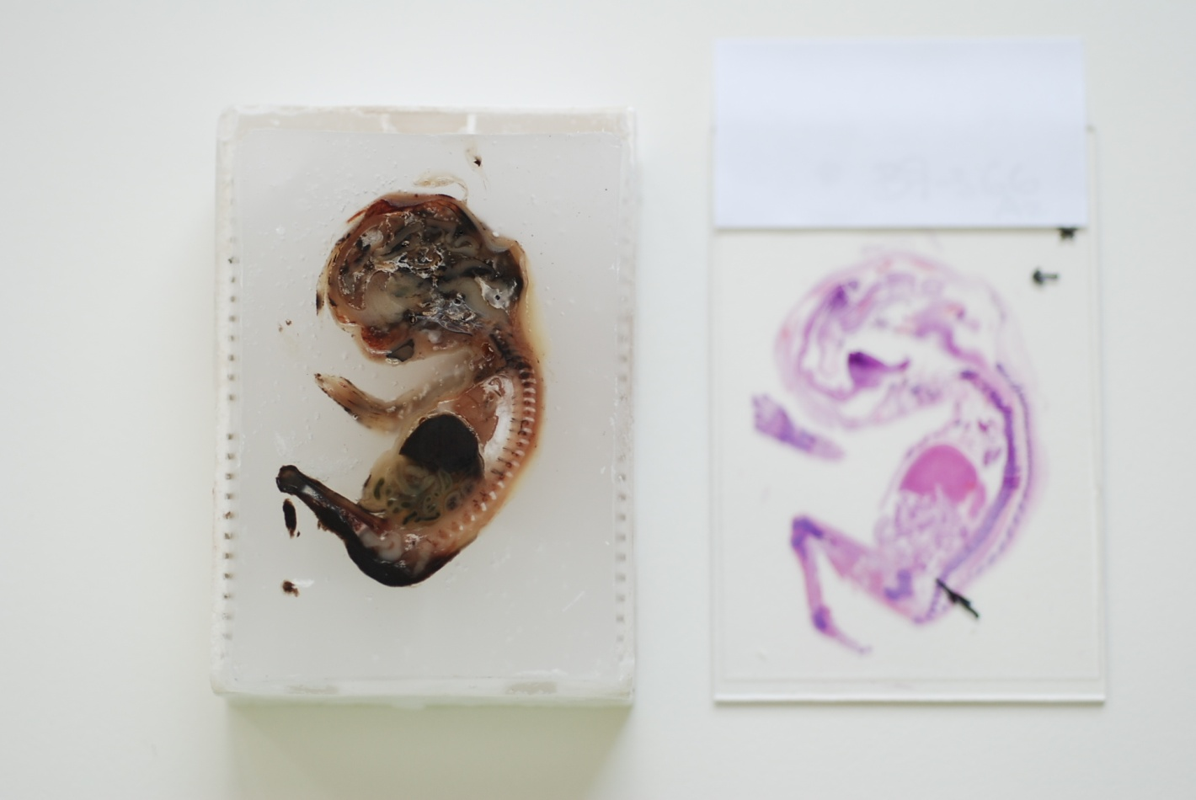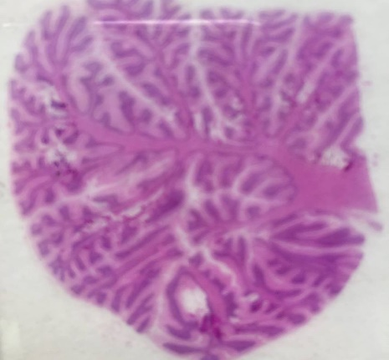
Figure 2: Complete cut of a brain structure
Figure1: Fetus 20 weeks,

BIOGRAPHY
We are a team of 6 people working on the Universitary Hospital del Henares in Madrid, with a experience that goes from 30 to 3 years of experience as technicians of pathology in Spain. We have presented numerous oral communications and posters in both national and international congresses on the management of biopsies in macrocassette.

PRESENTING AUTHOR DETAILS
Full name: Laura del Barrio Prieto
Contact number: +34 627208313
Email id: lauradbp@hotmail.com
Category: Oral presentation
Session name: Macrocassettes. Teaching experience in Spain. Profitability, advantage and possible limitations
Research interest: To present our experience for more than ten years in the fixation, processing, inclusion and cutting of numerous biopsies in macrocassettes (more than 4000), and show the advantages and disadvantages of the use of this technique. Currently we have launched a practical workshop for Pathology Technicians teaching these techniques. In this first edition of the workshop we have full occupation from the participants, and also we haver received numerous emails from profesional from outside Spain to get information to participate.

