Optimal cut-off value of D-dimer levels to predict in hospital mortality in severe cases of Covid-19
Dr NK Wira Suastika, Udayana University, Indonesia
Prof Dr K Suega, PhD, Udayana University, Indonesia
Dr W Losen A, PhD, Udayana University, Indonesia
Dr NM Renny AR, PhD, Udayana University, Indonesia

Abstract
Statement of the Problem: Corona virus disease 2019 (Covid-19) can cause coagulation parameters abnormalities such as an increase of D-dimer levels especially in severe cases. The purpose of this study is to determine the differences of D-dimer levels in severe cases of Covid-19 who survived and non-survived and determine the optimal cut-off value of D-dimer levels to predict in hospital mortality. Methodology & Theoretical Orientation: Data were obtained from confirmed Covid-19 patients at the Udayana University Hospital, Bali, Indonesia, who were treated from June to September 2020. The Mann-Whitney U test was used to determine differences D-dimer levels in surviving and non-surviving patients. The optimal cut-off value and area under the curve (AUC) of the D-dimer level in predicting mortality were obtained by the receiver operating characteristic curve (ROC) method. Findings: A total of 80 patients were recruited in this study. Levels of D-dimer were significantly higher in non-surviving patients (median 3.346 μg/ml; minimum – maximum: 0.939 – 50.000 μg/ml) compared to surviving patients (median 1.201 μg/ml; minimum – maximum: 0.302 – 29.425 μg/ml), p = 0.012. D-dimer levels higher than 1.500 μg/ml are the optimal cut-off value for predicting mortality in severe patients of Covid-19 with a sensitivity of 80.0%; specificity of 64.3%; and area under the curve of 0.754 (95% CI 0.586 - 0.921; p = 0.010). Conclusion & Significance: D-dimer levels can be used as a predictor of mortality in severe patients of Covid-19

Image
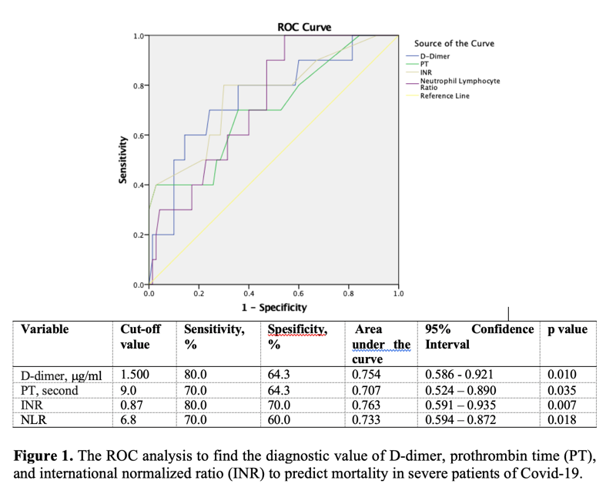
Recent Publications
- Tang N, Li D, Wang X, Sun Z (2020). Abnormal coagulation parameters are associated with poor prognosis in patients with novel coronavirus pneumonia. J Thromb Haemost 18(4): 844-7.
- Yu HH, Qin C, Chen M, Wang W, Tian DS (2020). D-dimer level is associated with the severity of COVID-19. Thromb Res 195: 219–25.
- Han H, Yang L, Liu R, et al (2020). Prominent changes in blood coagulation of patients with SARS-CoV-2 infection. Clin Chem Lab Med 58(7): 1116–20
- Thachil J, Tang N, Gando S, et al (2020). ISTH interim guidance on recognition and management of coagulopathy in COVID-19. J Thromb Haemost 18(5): 1023-6.
- Yu B, Li X, Chen J, et al (2020). Evaluation of variation in D-dimer levels among COVID-19 and bacterial pneumonia: a retrospective analysis. J Thromb Thrombolysis 50: 548-57.

Photograph

Biography
Dr NK Wira Suastika is a specialist in internal medicine and also a lecturer in the Division of Hematology and Medical Oncology, Department of Internal Medicine, Faculty of Medicine, Udayana University, Bali, Indonesia. Interested in studies in the field of thrombosis and hemostasis. Participate in the management of Covid-19 patients at Udayana University Hospital.
Email: wira.suastika@unud.ac.id

Notes/Comments:

