Primary results of abdominal aortic aneurysm screening in the at-risk residents in middle China
Dr Kun Li, Henan Provincial People’sHospital, China
Dr Shuiting Zhai*, Henan Provincial People’sHospital, China

Abstract (300 word limit)
There is a lack of information on the epidemiological data and risk factors associated with abdominal aortic aneurysm (AAA) in Chinese population. We reported the primary results from screening five-community population in Middle China for AAA. Methods: From March 2014 to October 2015, an AAA screening program was performed in three urban and two rural communities. These communities were randomly selected. All at-risk residents (a total of 6925) aged 40 years or older were invited to attend an ultrasound scan for AAA. At-risk population was defined as having a family history of first-degree relative diagnosed with AAA; or smoking and aged 55 years or older; or having a history of CAD, cerebrovascular disease, hypercholesterolemia, obesity (BMI ≧ 26 kg/m2) or hypertension. Results: The study investigated 5402 subjects and the mean age of them was 61.2 ± 10.4 years old. It included 2847 women aged 62.5 ± 10.4 years and 2555 men aged 59.7 ± 10.2 years. The mean maximum infrarenal aortic diameter (Max-IAD) was 15.0 ± 2.7 mm (from 4.1 to 51.5 mm). Eighteen people (aged 68.0 ± 10.4 years) with AAAs were detected (prevalence rate was 0.33%), and the prevalence rate in males was higher than in females (0.55% vs 0.14%, respectively, P = 0.009). Additionally, the screened subjects aged 55 to 75 years had a higher prevalence rate of AAA than other age groups (0.51% vs 0.11%, respectively, P = 0.016). Conclusion: Conclusion: The mean Max-IAD of the screened population in Middle China was apparently small by comparison with other reports. The result of low prevalence rate of AAA didn’t support routine screening in Chinese population. The at-risk males aged 55 to 75 years should be targeted for further screening

Image
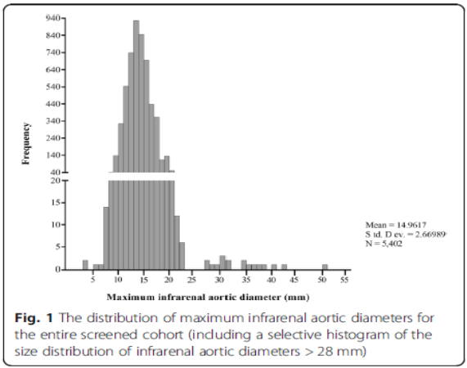
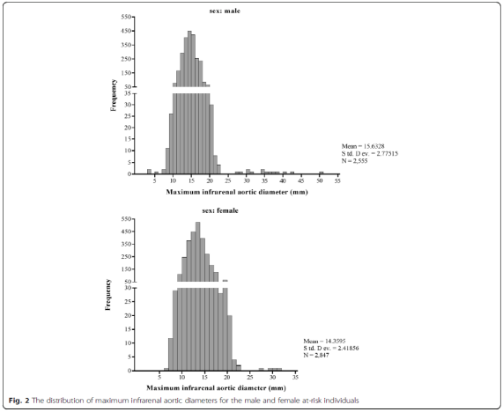
Recent Publications (minimum 5)
- Zhidong Zhang, Kai Liang, Gangqiang Zou, Xiaosan Chen, Shuaitao Shi, Guoquan Wang, Kewei Zhang, Kun Li, Shuiting Zhai*. Inhibition of miR-155 attenuates abdominal aortic aneurysm in mice by regulating macrophage-mediated inflammation[J]. Bioscience Reports, 2018:BSR20171432..
- Kun Li, Yu Zhou, Jia yuan Yang, Jian hua Zhu, Chang jian Liu, Shuiting Zhai*. In vitro biocompatibility evaluation of ePTFE graft with controlled release of heparin from mesoporous material. Applied Surface Science, 258,4041– 4047,2012.
- Yu Zhou , Kun Li , Jia Yuan Yang , Chen Xi Guan , Ying Wang , Chang Jian Liu , *and Jian Hua Zhu. Small-Caliber Vascular Prosthesis Prototype Based on Controlled Release of Heparin from Mesochannels and Its Enhanced Biocompatibility. small 2012, 8, No. 9, 1373–1383
- Shi S, Wang G, Zhang K, Zhang Z,Liang Kai, Kun Li, Weixiao Li, Shuiting Zhai*. Expression of S100β protein in patients with vascular dementia after basal ganglia hemorrhage and its clinical significance:[J]. Experimental & Therapeutic Medicine, 2017, 13(5):1917-1921.
5. Wang G, Zhai S*, Li T, et al. Mechanism and management of retrograde type A aortic dissection complicating TEVAR for type B aortic dissection[J]. Annals of Vascular Surgery, 2016, 32(6):111-118

Photograph


Biography (150 word limit)
Dr Li master the basic clinical theory of vascular and endovascular surgery, and knows recent hot issues and advanced state of the field. With good experiences working and training in Vascular and endovascular surgery department. From Oct15th,2015 to Feb28th,2016, He was trained as Observership in Department of Vascular Surgery, Iowa Methodist Hospital. From Mar1st 2016-Apr 30th 2016, He was trained as VISITING SCHOLAR in Department of Vascular Surgery, Cleveland Clinic.
Email: likun1331@gmail.com

Notes/Comments:

