Abstract Template
Abstract Title: Effect of Telephone Monitoring on Adherence to Treatment in Patients with Heart Failure
Diana Achury Saldaña , Luisa Fernanda Aponte, Nubia Roa Buitrago.
1 Associate Professor. Faculty of Nursing, (Pontificia Universidad Javeriana. Bogotá, Colombia)
2 Coordinating Nurse. Heart Failure Clinic. Hospital Universitario San Ignacio. Bogotá, Colombia
3 Cardiologist. Hospital Universitario Fundación Santa Fe de Bogotá. Hospital Universitario Mayor - Méderi. Bogotá, Colombia

Abstract

Objective. This work sought to determine the effect of telephone monitoring on levels of adherence to pharmacological and non-pharmacological treatment in patients attending a heart failure program in a tier IV health care institution. Method. Controlled clinical trial (n = 61) in which patients were randomized to telephone monitoring or to usual monitoring. To determine the effect of the intervention, three measurements were made of the adherence levels: prior to monitoring, at 12 months, and 6 months after finishing the monitoring. The Cochran-Armitage trend test was used, along with a multivariate analysis with a quantile mixed logistic model. Results. Patients with telephone monitoring tended to classify in levels of greater adherence than those from the control group (p < 0.0001). The multivariate model shows an association between the adherence scores and the telephone monitoring, which depend on time, percentiles studied, and the distribution. There was greater adherence with the intervention of the second visit in the distribution’s low quantiles (P10 and P25) and, in the third, in the highest quantiles (P50, P75, and P90). Variables, like male gender (P10 and P25), university schooling (P10 and P90), and presence of a caregiver (P90) were associated with higher adherence levels. Conclusions. Telephone monitoring becomes an effective intervention that promotes motivation, self-management, and assertive communication with patients, whenever it is carried out in standardized manner.

Key words: adherence, heart failure, monitoring studies; telenursing.

Professional Biography (100-150 words)

Diana Marcela Achury has completed his master degree in cardiovascular nursing at the age of 26 years from Universidad Nacional . She has been associate professor and journal editor since 2006 from Pontificia Universidad javeriana. Colombia. Also she is in charge form the international critical nursing net during five years. She has published more than 15 papers in reputed journals related with cardiovascular care and critical care and main author from two nursing academic books

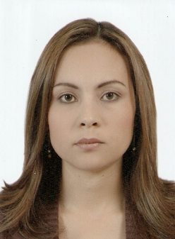
Paste your Photograph here

Email Id: dachury@javeriana.edu.co
dianaachury@yahoo.es

Any Comments:

