1Robotics evolution and future
Shukla Vinita; (2009) Advantages of robotics in assistive surgery.

Abstract

Robotic is in precision and micro-surgery. It involves minimally invasive surgery procedure by robots. Also, nanobots play a key role in the future and present of assistive surgery. The remote surgery is via internet and IoT based platform. In some cases there is medical intervention by robots. Surgery assistance is also provided by robots. For drug therapy and ocular disease nanobots are used. It is made of flat nickel part known as steerable surgeon. The working of nanobot is by external electromagnetic coils which produces magnetic field inside it. There are robotic system for professional care in hospital. This category of robotic caring is for ageing person. It includes monitoring, aid for nurses and physical activities in term of care provision and paramedic task. Robotic includes rehabilitation treatment hybrid assistive limb. Daily living activities. Also involves a great deal of robotic inclusion and interaction. Robotics is extending human capabilities rather than replacing human surgeon.Robotics plays a vital role in healthcare in hospitals. Future scope lies with the study of virtualisation.
Type: | Proceedings paper
Title: | Robotics evolution and future
Event:
Location: | London, United Kingdom.
Dates: | 09 October 2018 - 14 October 2018
Open access status: | not
DOI:
Publisher version:
Language: | English
Additional information: | in other works.
Keywords: | Robotics, robot, nanbots.
URI:

Robotics -Evolution and Future

Evolution of robotics:
The word “robotics” was invented by the master science fiction writer Issac Asimov in his movie classic robot stories which at the time of writing were unusual and told of robots which not only did not harm humans but actually helped them. It was in one of these stories called ‘Runaround’, which appeared in one of these stories called ‘Runaround’, which appeared in the March 1942 issue of ‘Astounding Science Fiction’, that Asimov first propounded the famous Three Laws of Robotics.
a)A robot may not injure a human being or through inaction allow a human being to come to harm.
b)A robot must obey the orders given to it by human beings except where those orders would violate the first Law.
c)A robot must protect it’s own existence, except where that would violate the First or Second Law.
Although it is only very recently that people have been able to specialist exclusively in the field of robotics, nevertheless research which we would now classify as robotics has been conducted for several decades under the different guises of such field as ‘artificial intelligence’(AI), computing and Control and Mechanical and Electrical Engg. The first mechanical and calculating machines were built in the seventeenth century by Pascal and later by Leibiz and the concept of programmable machinery followed soon after in 1720’s in the form of developments in France which eventually led to construction of looms in which the lifting of the correct thread to produce the required complex patterns in the cloth was controlled by a bond of punched cards, perfected by Jacquord in 1801.From 1823 Charles, Babbage was able to use his Mechanical different engine for the automatic computation of tables for navigation, insurance and astronomy. This first design was only capable of producing such tables rather than acting as a general purpose calculator. Babbage, however produced more sophisticated designs for Mechanical Computer which is called his ‘Analytical Engine’. However during the lifetime the mechanical tolerances were not good enough to actually construct work machines. In 1930, forty years later the first analog computer was constructed. In 1944 the first fully automatic digital computer was built by IBM, with 750,000 components and 500 miles of wiring.
In 1984 Nobert Weiner published Cybernetics or Control and Communication in Animal and the machine and so popularized the whole field of control (feed back) and communication theory, which has since consequently been termed Cybernetics.

Also, in 1984, the British built at Manchester University the first computer which actually stored its program of instruction. From early 1950’s onwards the electronic computer developed swiftly with substantial improvements in memory and overall system design, while in 1951 a general purpose digital program storage device was patented for controlling automatic machine tools.
In 1954, George Devol applied to patent a design for what is generally considered to be the first Industrial robot.
The future of advanced robotics for assisting in precision surgery. The paper will also have information regarding Internet of Robotics.
Future of Robotics
The future of Robotics lies in assistive surgery as it is extending human capabilities rather than replacing human surgeon. Robotics has good geometric accuracy, stable and untiring and can be designed for a wide range of scales. Robot may be sterilised. It is resistant to radiation and infection. The strength of robotics can use diverse sensors in control. It has it’s own set of limitation, poor judgement and limited dexterity hand and eye co-ordination. Robotics is restricted to simple procedures expensive technology in flux. It is also difficult to construct and debug.
As for the robot purely strengths are strong hand-eye coordination, dexterous (at human scale),flexible and adaptable, Can integrate extensive and diverse information, Able to use qualitative information good judgment, easy to instruct and debrief, limitations, limited dexterity outside natural scale, Prone to tremor and fatigue, limited geometric accuracy, limited ability to use quantitative information, large operating room space requirement limited sterility
and not susceptible to radiation and infection.
Future work is virtualisation i.e. Interaction of virtual machines like a robot with desktop application and server application. Batch management and workstation model block diagram. 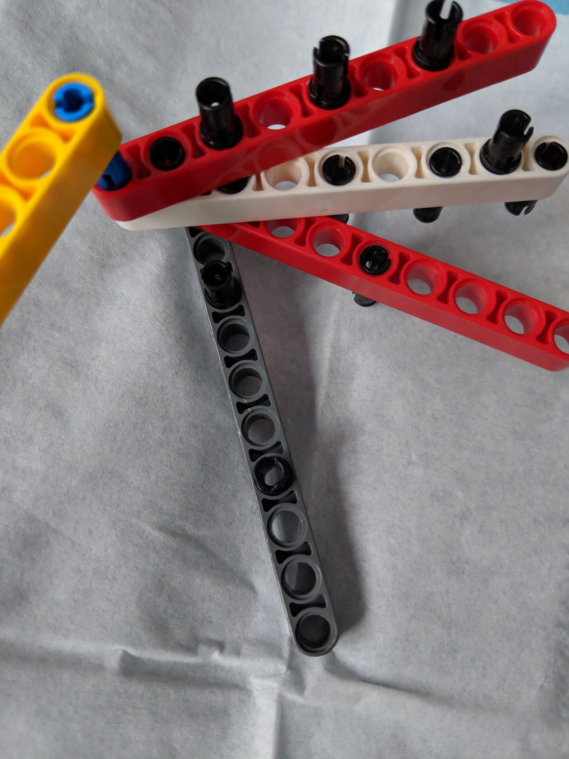Figure1: Robotic arm with legos.

