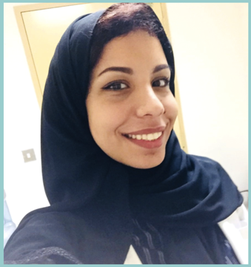

Unspoken Words: Overcoming Head and Neck Silencing Tumors at End of Life.
Noura Y. AlSalloum¹, Balaji P. Duraisamy², Sami A AlShammary²
¹Department of Family Medicine and Employee Health, King Fahad Medical City, Riyadh, Saudi Arabia. Email: nalsalloum@kfmc.med.sa
²Department of Palliative Care, King Fahad Medical City, Riyadh, Saudi Arabia. Emails: bduraisamy@kfmc.med.sa, saalshammary@kfmc.med.sa

Head and neck cancer (HNC) is prevalent worldwide to rank the 9th most common cancer globally ( Ferlay et al, 2013). HNC may impair speech with cancer progression and invasion, or may cause speech difficulties as a consequence post management. There was lack in data measuring the prevalence of speech difficulties in HNC patients nationally, but looking at data from the Saudi Cancer Incident Report in 2013, the following cancers (table1) may, but not necessarily, involve the oral cavity or impair speech with disease progression. This paper is about a HNC patient who had a speech difficulty. A 50-year-old male patient, “Ahmed”, had communication difficulties which arose as a result of squamous cell carcinoma of the skin of his left cheek; it had invaded his nasal and oral cavities leaving him with a speech difficulty. He also had hearing loss and a language difference barrier. In aims of improving his quality of communication, his basic needs list was cross-referenced with HNC patient communication needs from the literature and individualised for Ahmed’s use (figure 1). It was printed into a bigger A3 cardboard sheet and laminated in protective vinyl material, and he was provided with a white board marker. The vinyl covered sheet would be a more durable Augmentive and Alternative Communication (AAC) method for basic needs than the regular paper; it would be reusable, protected from fluids and can be disinfected, also the writing is provided in a big font for ease of reading (figure 2). We suggest the use of a standardized practical, inexpensive and reusable AAC method which was developed for this patient and can be used after validation for Arab patients with a similar presentation as did our patient.

Biography

Dr. AlSalloum graduated from King Saud University, Riyadh. Currently in her fourth year as a Family Medicine resident enjoying her training at King Fahad Medical City.

Keywords: communication, palliative, rotation, end of life, cancer, head and neck.

Desired presentation : _ Oral / Poster / _ either

Topic : Track 20: Healthcare and Cancers

Corresponding Author Details: Noura AlSalloum
dr.nalsalloum@gmail.com
King Fahad Medical City
Riyadh, Saudi Arabia
(00966) 556778847

