Early-stage Burkitt lymphoma remained in remission 7 years from diagnosis after one cycle of chemo-immunotherapy

Ali Al Sbihi, MD; Nouraldeen Manasrah, MD; Dahlia Sano, MD; Sarah Lonardo, MD
Department of Internal Medicine, Sinai-Grace Hospital/Detroit Medical Center, Wayne State School of Medicine, Detroit, MI

Abstract (300 word limit)

Background:

Burkitt Lymphoma (BL) is a rare, mature, fast-growing, and highly aggressive B-cell neoplasm. It is a type of Non-Hodgkin’s Lymphoma (NHL) which has a high proliferation rate with distinctive genetic changes in the C-MYC oncogene. It can rarely occur in adults in its sporadic form; approximately 1% of adult NHL in the United States.

Case Presentation:
A 63-year-old African American man presented with a painless mass in the right submandibular region. Physical examination showed 1-1.5 cm firm lymphadenopathy in the right submandibular, cervical, and supraclavicular regions. Biopsy showed dense atypical large lymphoid cells with a background of focal areas of starry sky appearance. Immunohistochemistry was BCL-6 and PAX5 positive and BCL-2 negative. FISH was positive for C-MYC translocation of chromosomes 8:14 suggestive of BL. PET-CT showed active lymphadenopathy in the right cervical, submandibular, and supraclavicular regions. The patient decided not to pursue therapy, but he presented to our clinic three months later due to mass enlargement. Repeat PET-CT showed increasing abnormalities in the abovementioned regions with two new abnormal cervical LNs. He was admitted and received part A of the hyperCVAD chemotherapy regimen. He also received rituximab and intrathecal prophylactic methotrexate before chemotherapy. Afterward, he decided to decline therapy due to concerns about side effects. After a year, repeat PET-CT showed near complete resolution of the lymphadenopathy. The patient had again chosen not to get further treatment based on the imaging findings and he lost follow-up for four years. On its most recent follow-up, his lymphoma continued to completely be in remission.

Discussion:

Our patient’s lymphoma remained in remission despite not completing the recommended treatment course. This could draw attention that probably a lower number of cycles can be curative in selected patients like our patient who was young, asymptomatic, and had early stage with normal-minimally elevated LDH.

Image
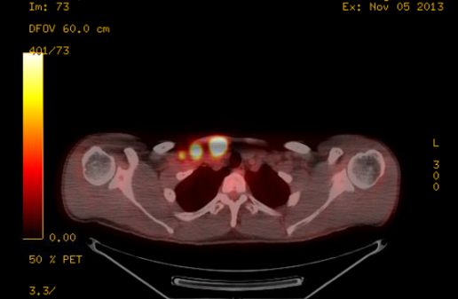
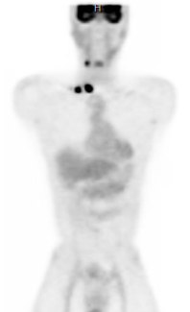

Recent Publications (minimum 5)
- Al Sbihi A, Manasrah N, Alqasem S, Abudalou M. Emphysematous endometritis in stage III endometrial cancer. BMJ Case Rep. 2021 Apr 22;14(4):e242371. doi: 10.1136/bcr-2021-242371. PMID: 33888481; PMCID: PMC8070862.
- Al Sbihi AF, Singh P, Manasrah N, Kandah E, Appel J. An HIV Associated Plasmablastic Lymphoma With Spontaneous Tumor Lysis Syndrome. Cureus. 2020 Aug 9;12(8):e9625. doi: 10.7759/cureus.9625. PMID: 32923226; PMCID: PMC7478934..
- Al Sbihi A, Manasrah N, Sano D, Lonardo S. Early-stage Burkitt lymphoma remained in remission 7 years from diagnosis after only one cycle of chemoimmunotherapy. BMJ Case Rep. 2021 Apr 20;14(4):e240925. doi: 10.1136/bcr-2020-240925. PMID: 33879463; PMCID: PMC8061862.
4. Al Sbihi AF, Manasrah N, Kosti J, Alhassan S. Coronavirus Disease 2019-Associated Bilateral Massive Pulmonary Emboli Caused Death in a Healthy 35-Year-Old Patient. Cureus. 2020 Sep 2;12(9):e10213. doi: 10.7759/cureus.10213. PMID: 33042659; PMCID: PMC7535868.
5. Abudalou M, Al Sbihi AF, Perepletchikov A, Stallwood C. Small Intestinal Adenocarcinoma in a Patient With Celiac Disease. Cureus. 2021 Jan 31;13(1):e13039. doi: 10.7759/cureus.13039. PMID: 33665060; PMCID: PMC7924906.

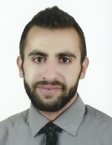
 Biography (150 word limit)

Dr. Ali Al Sbihi is a 28 year-old second year internal medicine resident at Wayne State University/Detroit Medical Center/Sinai Grace Hospital. I am interested in the cancer research projects, case series, and case reports. I write up any interesting cases that I encounter in my medical training. I am currently working on a big research project for paragangliomas treatment options.
Email: aalsbihi@dmc.org

Notes/Comments:
I hope that I will be accepted to present my case report about Burkitt lymphoma remission with one cycle of chemo-immunotherapy. My case report was recently published in the BMJ case repor

