Menstruation and Vestibular Migraine
Dr Eleni Zoe Gkoritsa MD, PhD, Independent Researcher, Tripoli , Greece

Abstract (300 word limit)

Statement of the problem: Vestibular migraine is one of the most common vestibular disorders affecting up to 1% of the general population. The diagnostic criteria for vestibular migraine have been jointly formulated by the Committee for Classification of Vestibular Disorders of the Bárány Society and the Migraine Classification Subcommittee of the International Headache Society (IHS) in the year 2012. This was necessary due to the heterogeneity of clinical manifestations of vestibular migraine in terms of duration, frequency, association with headache, and nature of the vestibular symptoms, together with the diversity in vestibular laboratory findings. Menstruation is among the triggering conditions of vestibular migraine as it is for migraine. The ovarian steroids modulate various neurotransmitter pathways associated with migraine activation. Although the pathomechanism of perimenopausal occurrence of migraine has been sufficiently clarified, regarding vestibular migraine, the association of vertiginous symptoms with the menstrual cycle and perimenopause, yet clinically documented, has been only partially elucidated. The purpose of this presentation is to summate the existing knowledge about vestibular migraine and report clinical examination and laboratory results in women of premenopausal and perimenopausal age. Methodology: A detailed history of headache and vertiginous symptoms was followed by a complete clinical and laboratory vestibular test battery. All women completed the Dizziness handicap inventory (DHI) questionnaire and their scores were noted. Findings: most women had only minor clinical and laboratory abnormalities on examination. However, they scored higher in the emotional and physical section of DHI compared to functional scores. Conclusion and Significance: Vestibular migraine associated to menstruation and perimenopause can cause significant emotional burden in women even though their functional performance is affected to a lesser extent. Reassurance and acute phase medication is enough to control about two thirds of patients. Nevertheless, a small but significant percentage will need prophylactic medication and psychological support.

Image 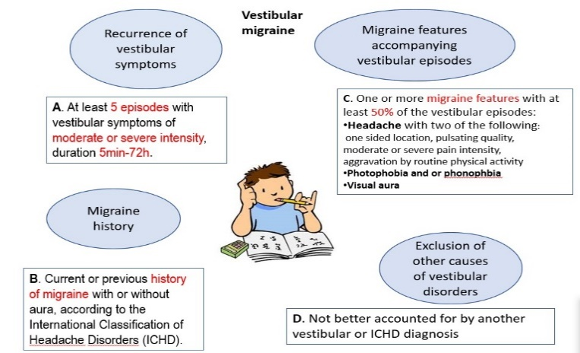
Diagnostic criteria for vestibular migraine
Recent Publications (minimum 5)
- Lempert,T et al.(2012) ‘Vestibular Migraine: Diagnostic Criteria’. Journal of Vestibular Research 22: 167 – 172.
- Balaban C (2011) / Migraine, vertigo and migrainous vertigo: Links between vestibular and pain mechanisms. Journal of Vestibular Research 21: 315–321
- Park JH, Viirre E (2010) Vestibular migraine may be an important cause of dizziness/vertigo in perimenopausal period Medical Hypotheses 75: 409–414.
- Chari DA, Liu YH (2021) Subjective Cognitive Symptoms and Dizziness Handicap Inventory (DHI) Performance in Patients with Vestibular Migraine and Menière's Disease. Otol Neurotol. 42(6):883-889.
- Mostardini, C., Nola, G (2014) EHMTI-0086. Pure mestrual vestibular migraine. J Headache Pain 15 (Suppl 1), D43.

Photograph

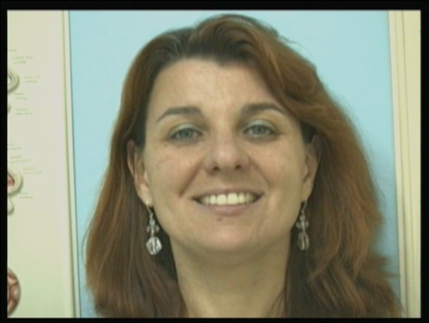Biography (150 word limit)
Dr. Eleni Zoe Gkoritsa MD, PhD is an Otorhinolaryngology Specialist and a Fellow of the European Board of Otorhinolaryngology Head and Neck Surgery since 2010. Her main focus of interest is Neuro-otology and in particular vestibular diseases. She has obtained her PhD title at the University of Athens Greece in 2006. She has had special training in Vestibular Rehabilitation and has obtained the title of “Diplôme Inter-universitaire sur la Rééducation Vestibulaire” from Université Paris VI in 2013. She is the author of ‘Handbook of Benign Paroxysmal Positional Vertigo, Diagnosis and Treatment”, Nova Publishers Inc, New York,2017. She has also co-authored a large number of papers in many scientific journals. She is currently working in her Private Practice in Tripoli Greece.
Email:zoilen@hotmail.com

Notes/Comments:

