Clinical presentation and symptoms according to the type of adenomyosis.
HAIMEUR Y., BOURDON M, M.D., SANTULLI P., M.D. PhD, CHAPRON C., M.D.PhD

ABSTRACT
PURPOSE. The aim of the study was to compare symptoms of each type of adenomyosis (focal form, diffuse form and the association of both forms).
METHODS. We conducted a prospective observational study at Cochin Hospital. We evaluated patients operated for benign gynecologic pathology who had a diagnosis of adenomyosis confirmed in MRI. They were divided in three groups: focal adenomyosis, diffuse adenomyosis and focal and diffuse adenomyosis.
RESULTS. 248 patients were included: 109 had an isolated focal form, 78 had a diffuse form and 61 had both forms. In the diffuse form group, patients were significatively older and suffered from more menorrhagia than patients in the focal form group, respectively [33,79± 5,17 vs. 33,01± 6,39 vs. 31,90± 4,59, p= 0,014], and (79.5% vs. 53.2% and 54.1%, p <0.001). Focal forms were more associated to severe gastrointestinal pain and to deep infiltrating endometriosis than diffuse forms, respectively [VAS= 5.28 ± 2.49 vs 5.55 ± 3.47 vs 4.00 ± 3.51, p=0,016] and (89% and 82% vs 30,8%). The primary infertility rate seemed to be superior in the isolated focal forms and in the focal and diffuse forms (25.1% and 22.9% vs. 9%, p=0.051).
CONCLUSION. Adenomyosis is a heterogeneous pathology that can be divided in 2 different profiles: focal adenomyosis and diffuse adenomyosis. These 2 forms seem to affect 2 specific populations but can also be associated.

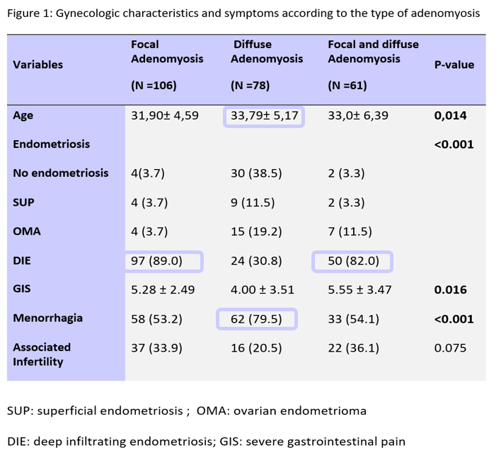
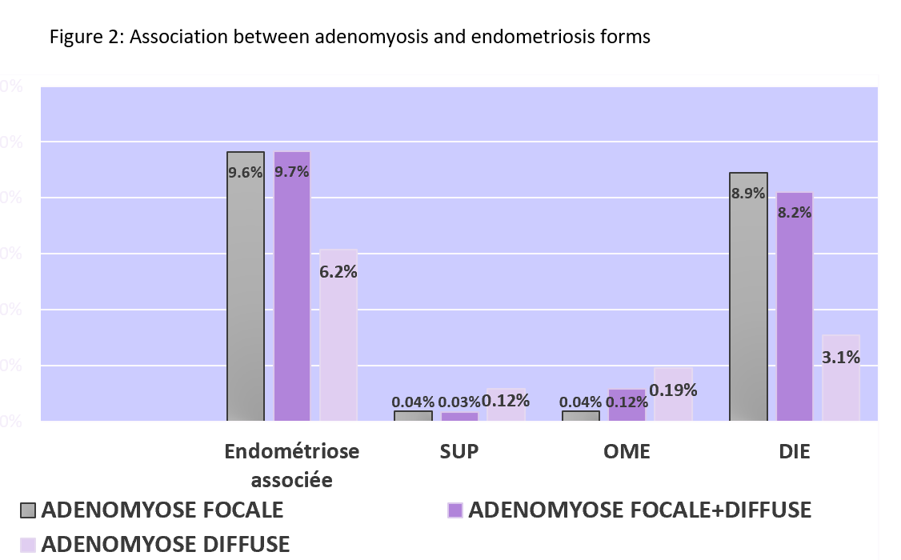
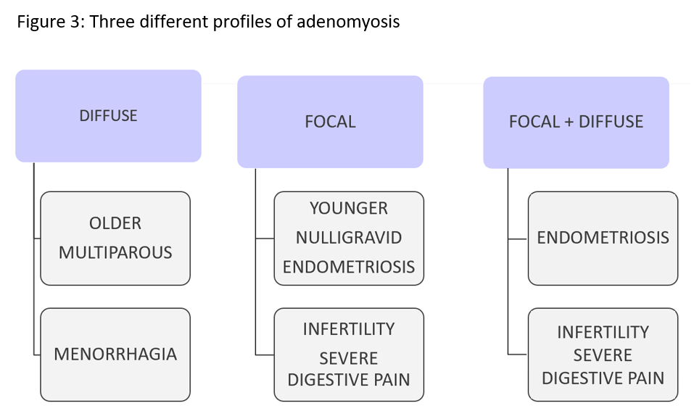

1. Exacoustos C, Morosetti G, Conway F, Camilli S, Martire FG, Lazzeri L, et al. New Sonographic Classification of Adenomyosis: Do Type and Degree of Adenomyosis Correlate to Severity of Symptoms? J Minim Invasive Gynecol. 7 oct 2019;
2. Chapron C, Tosti C, Marcellin L, Bourdon M, Lafay-Pillet M-C, Millischer A-E, et al. Relationship between the magnetic resonance imaging appearance of adenomyosis and endometriosis phenotypes. Hum Reprod Oxf Engl. 01 2017;32(7):1393‑401.
3. Barrier BF, Malinowski MJ, Dick EJ, Hubbard GB, Bates GW. Adenomyosis in the baboon is associated with primary infertility. Fertil Steril. oct 2004;82 Suppl 3:1091‑4.
4. Kishi Y, Suginami H, Kuramori R, Yabuta M, Suginami R, Taniguchi F. Four subtypes of adenomyosis assessed by magnetic resonance imaging and their specification. Am J Obstet Gynecol. août 2012;207(2):114.e1-7.

Email: yousrahaimeur@hotmail.fr

