Molar tubal ectopic pregnancy: report of 5 cases and literature review
M. Rahaoui, I. Benchiba, N. Mamouni, S. Errarhay, C. Bouchikhi, A. Banani
Department of Obstetrics and Gynecology 1, University Hospital Hassan 2, Fes, MOROCCO

Abstract
Gestational trophoblastic disease encompasses a range of pregnancy-related disorders, which present a broad spectrum of diseases ranging from benign precancerous lesions, partial and complete hydatidiform mole, malignant lesions, invasive moles, choriocarcinoma and placental-site trophoblastic tumor. The incidence of hydatidiform mole is 1 in 1000­2000 pregnancies. The molar tubal pregnancy is extremely rare with an incidence of approximately 1.5 per 1 000 000 births.
We related in our series 5 cases of a tubular hydatiform mole collected in Obstetrics and Gynecology Department 1 of the Teaching Hospital Hassan II, Fez - Morocco, for a period of 10 years from 2010 to 2019. 3 patients report an infertility history, with one secondary to polycystic ovary syndrome. The patients were submitted to gynecological emergencies for bleeding with pelvic pain, and in whom the dosage of β -hCG was positive with variable rates, and whose pelvic ultrasound performed was in favor of adnexal images with effusion. The ruptured EP was evoked in 4 cases hence the indications for exploratory laparotomy. One laparoscopic salpingectomy was performed for an unruptured ampullary EP. Surgical exploration revealed aspect of a ruptured tubal pregnancy appearance with in one case a vesicle appearance, with non-retainable tubes indicating salpingectomies with postoperative course was uneventful. The histopathological study mentioned the diagnosis of tubal hydatiform mole. The molar biological monitoring was satisfactory in all 5 cases.

Image
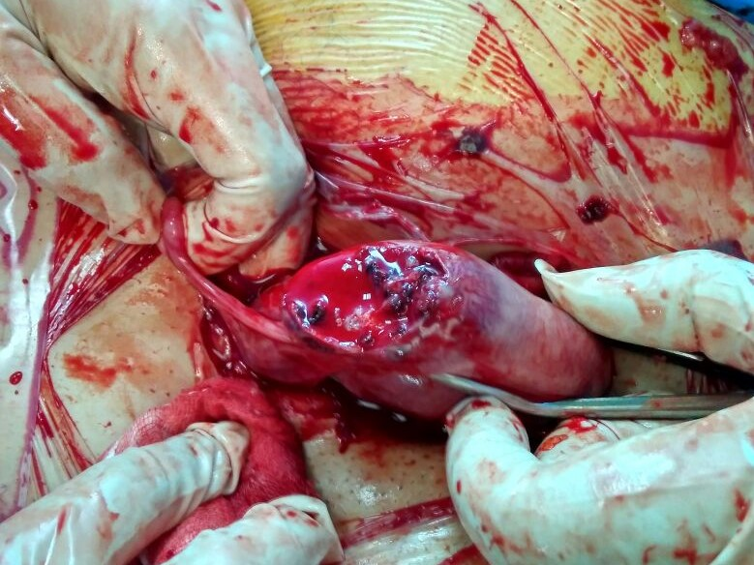 Figure: a ruptured tubal hydatidiform mole.
Recent Publications (minimum 5)
- A Siozos, A Siozos. A case of true tubal hydatidiform mole and literature review. BMJ Case Reports 2010; 10.1136/bcr.07.2009.2123
- Samaila et al. Ruptured tubal hydatidif. J Turkish-German Gynecol Assoc 2009; 10: 172-4
- Zhao T, Hou X, Su C, Wu Q. Tubal hydatidiform mole treated with salpingotomy: A case report. Clin Case Rep. 2019;7:653–655. 10.1002/ccr3.2037
- Centers for Disease Control and Prevention. Ectopic pregnancy— United States, 1990­92. MMWR Morb Mortal Wkly Rep 1995;44: 46–8.
- Gillespie AM, Lidbury EA, Tidy JA, Hancock BW. The clinical presentation, treatment, and outcome
Photograph


Email: rahaoui.mohamed@hotmail.com

Notes/Comments:

