Summary:
Objective: The presentation of these cases is intended to show the results of two treatments used for cervical ectopic pregnancy that are minimally invasive: One in the first trimester and another in the third trimester of pregnancy.

First case: A 34-year-old primiparous patient who came to the emergency room with abdominal pain and transvaginal bleeding and was 6 weeks pregnant. There, an endovaginal ultrasound was performed, which showed a sac without embryo and "incomplete abortion". She was admitted to performing uterine curettage and during the procedure, the empty uterine cavity was found, so a transoperative ultrasound was requested that demonstrated the gestational sac in the cervix, with a live embryo of 7 weeks. This patient was admitted to the hospital and was treated with methotrexate plus folic acid, monitoring the beta-fraction levels of chorionic gonadotrophin and ultrasound every 48 hours until its negativization and resorption.

Second case: Patient of 30 years. G2C1 who attended the consultation with abdominal pain and intermittent transvaginal bleeding for 4 months. She started her condition after interrupting her first-trimester pregnancy in a clinic where she was initially treated with medication and then with a curettage.
Upon examination, a 20-cm uterine fundus was found, and a fetal focus was heard. The ultrasound showed a pregnancy of 19.5 weeks with placenta previa and later in the service of maternal-fetal medicine the diagnosis of placenta accreta was established. In this case, the diagnosis of cervical pregnancy was made by magnetic resonance until week 37 and was resolved by cesarean section, achieving the birth of a live product.
Conclusions: Cervical ectopic pregnancy is rare and difficult to diagnose an entity whose incidence increases. It is possible to perform conservative medical treatments in first trimester pregnancies and some cases may come to term.
Images:
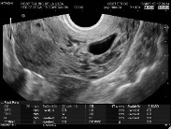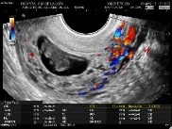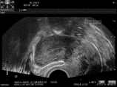
Figures1:Ultrasounds From a cervix-sac; 7-week live embryo in the cervix and its evolution until its disappearance.
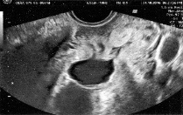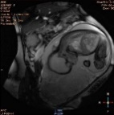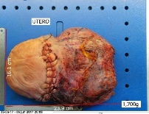
Figures 2: from six weeks of ultrasound to MRI of a 37-week fetus .

Recient publications:
1. Galia O. Tulandi T. A pragmatic and evidence based management of ectopic pregnancy. The journal of minimally invasivegynecology. Vol. 20. No. 4 Jul aug-2013.
2. Russel D. Jelsema. Zuidema L. First trimester diagnosed cervico isthmic pregnancy resulting in a term delivery. Obstetrics & gynecology Vol. 80 No.3 PART 2 September 1992.
3. Menahem P. David, Arieh Bergman,MD and Liane Delighdish,MD. Cervico isthmic pregnancy carried to term. Obstetrics & gynecology Vol. 6, No 2 August 1980 Case reports.
4. Begum S. Ferdous A. Sultata M.. Cervical pregnancy: A puzzling event. Chattagram man o Shisu Hospital medical CollageJournal. Vol. 13. Issue 2. May 2014.
5. http://www.comegic.org.mx/wp-content/uploads/2018/05/revista_comegic_2014-2015.pdf#page=8.
6. Dixit N . Venkatesan S. Cervical Pregnancy: An Uncommon Ectopic Pregnancy. Med J Armed Forces India, Apr, 64, ( 2), 2008: 183-184.
7.Vela G, Tulandi T. Cervical pregnancy: The importance of early diagnosis and treatment. The journal of minimally Invasive Gynecology (2007)14, 481-484.

