Non-medicated Childbirth in a Tertiary Medical Center:

A survey of Attitudes among Obstetricians
Dr. Ma. Kristina A. Quetulio, Dr. Joanna B. Rey-Matias and Dr. Gay Luz M. Talapian

Abstract

Non-medicated childbirth has positive empowering experience for the patients. However, according to studies only few patients undergo non-medicated childbirth. This was a qualitative study survey exploring the attitudes on non-medicated natural childbirth among obstetricians practicing at a tertiary medical center. Most of the participants believed that they were educated on non-medicated childbirth, however, less than half of the participants routinely discussed it to their patients and can convince to undergo non-medicated childbirth. Factors such as knowledge on alternative methods, demand of time, decision-making, availability of birth facilities, influence of birth companions and malpractice litigations, all contributed to obstetricians’ attitude on non-medicated childbirth.
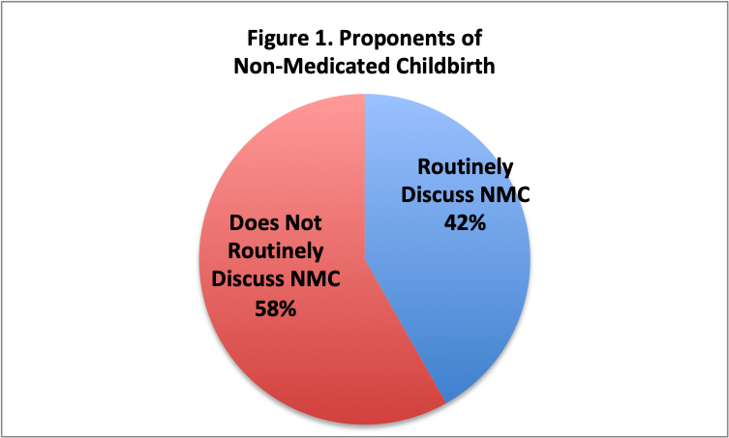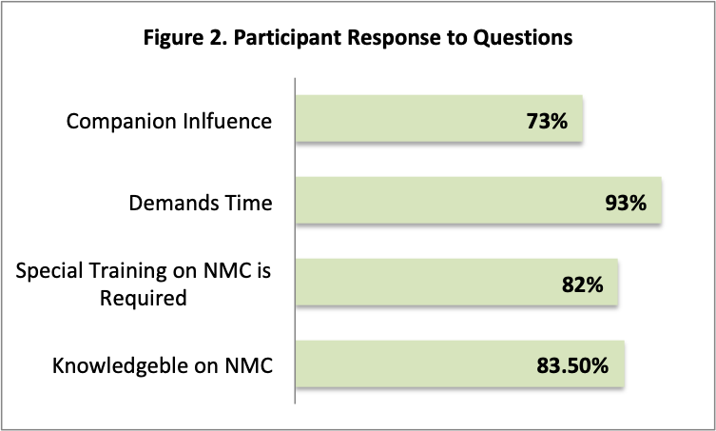

Recent Publications
- Kabakian-Khasholian, T., El-Nemer, A., & Bashour, H. (2015). Perceptions about labor companionship at public teaching hospitals in three Arab countries. International Journal of Gynecology & Obstetrics,129(3), 223-226. doi:10.1016/j.ijgo.2014.12.005
- Wagner, M. (2001). Fish cant see water: The need to humanize birth. International Journal of Gynecology & Obstetrics,75. doi:10.1016/s0020-7292(01)00519-7
- Behruzi, R., Hatem, M., Fraser, W., Goulet, L., Ii, M., & Misago, C. (2010). Facilitators and barriers in the humanization of childbirth practice in Japan. BMC Pregnancy and Childbirth,10(1). doi:10.1186/1471-2393-10-25
- Cook, K., & Loomis, C. (2012). The Impact of Choice and Control on Women’s Childbirth Experiences. The Journal of Perinatal Education,21(3), 158-168. doi:10.1891/1058-1243.21.3.158
- Hodnett, E. (2002). Pain and womens satisfaction with the experience of childbirth: A systematic review*1. American Journal of Obstetrics and Gynecology,186(5). doi:10.1067/mob.2002.121141

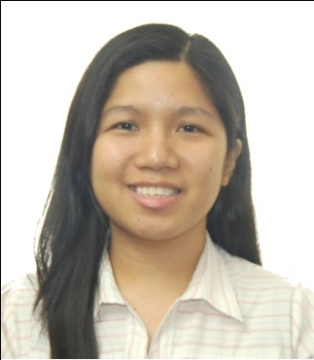
Dr. Ma. Kristina A. Quetulio has completed her degree in Medicine at the age of 25 years from the University of Santo Tomas Faculty of Medicine and Surgery, Manila and Residency Training in Obstetrics and Gynecology at St. Luke’s Medical Center, Quezon City. Dr. Quetulio is an advocate of
natural childbirth in her country. She believes that women has the autonomy and undergoing natural childbirth is empowering to them.

Email: mkaquetuliomd@yahoo.com

Notes/Comments:

For Oral or Poster Presentation

