Semen Analysis in African Laboratories: The Challenge of Precision and Clinical Interpretation.
Ezute, S Azuka1, Edith Cowan University, Perth Western Australia,
Philip Matson2, Peter Roberts3

Abstract

Background: Infertility affect 45 million couples worldwide and the number is still rising. The highest prevalence is seen in South Asia, Sub Sahara Africa, North Africa/Middle East and Eastern Europe. Semen analysis is the core screening test for male fecundity but has repeatedly being observed to show large technical variations due to difficulty in control of accuracy and precision.

Aim: This current opinion paper discusses the challenges faced by African laboratories in using the current reference ranges published by WHO and calls for inclusion of African subjects in the WHO reference range.

Method: The measurement of semen quality as a surrogate measure of male fecundity in clinical andrology laboratories must consider racial and geographical differences that exist in semen values. Although, the current WHO manual is the most robust of the series published since 1980, there were no African sites included in the study. There is need to verify international ranges for African men. However, African laboratories must demonstrate they are using methods of the day before data can be used for future revision of reference ranges.

Results: Cooper, T., Noonan, E., von Eckardstein, S., Auger, J., Baker, H., Behre, H., . . . Vogelsong, K. (2010). World Health Organization reference values for human semen characteristics. Human Reproduction Update, 16(3), 231-245. Elbardisi, H., Majzoub, A., Al Said, S., Al Rumaihi, K., El Ansari, W., Alattar, A., & Arafa, M. (2018). Geographical differences in semen characteristics of 13 892 infertile men. Arab Journal of Urology, 16(1), 3-9.

Conclusion: Racial difference exist in values obtained at semen analysis. Before the current international reference ranges published by WHO can be used, African laboratories must confirm the suitability for local African men. Standardized methods need to be used in African Laboratories before verification studies for African subjects can be done.

Recent Publications (minimum 5)
- Nweze EI and Ezute S (2010). Isolation and antifungal susceptibility of Exophiala dermatitidis isolates from human stool samples in Nigeria. Mycopathologia 169(3):201-6.
- Nweze EI Ezute S, Nweze CC Emeka, CC Ogbonna, Eze C (2012). Bacteria etiological agents causing respiratory tract infections in children and their resistance patterns to a panel of ten antibiotics 1(2) 18-23.
- Ezute SA, Matson P, Peter R (2019). Semen Analysis in African Laboratories: Is it Valid to Use the Reference Ranges from the WHO 5th Edition Manual for Clinical Interpretation? Journal of Reproductive Biotechnology and Fertility 8: 25- 29
Photograph

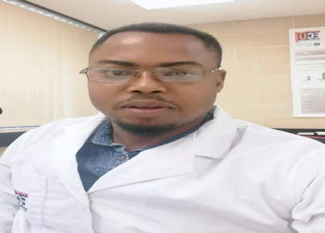Biography
Mr Ezute S Azuka studied bachelor’s in applied microbiology Ebonyi State University. He joined Chimos diagnostic laboratory in Enugu Nigeria after graduation in 2008, his work in the lab. resulted in two publications in 2010 and 2012 before joining pharmaceutical industry as a medical representative. He rose to the post of District Commercial and National product manager. His passion for clinical embryology and in vitro fertilization drove him to study graduate diploma in reproductive biology Monash University (2018) and now Masters in Assisted Reproduction Technology ECU Australia. He identified during his studies that there were no African subjects included in the research used in publishing the current WHO reference ranges for semen analysis, that resulted to the current opinion letter

Email: ezutesunday2015@yahoo.com

Notes/Comments:

