Polycystic Ovary syndrome (PCOS) and Genetic Predisposition
Nida Ajmal, Young researcher, BUITEMS, Pakistan

Abstract
Polycystic ovary syndrome (PCOS) is a heterogeneous condition which is related to an endocrine reproductive disorder of females. It affects females of 18–44 age. The persistent hormonal disbalance leads to the complexities such as numerous cysts, an irregular menstrual cycle that ultimately leads to infertility among females. Many candidate genes have been identified to be one of the causes of PCOS. Different studies have been carried out to find the genetic correlation of PCOS. It is essential to carry out such studies that identify the clear cause of PCOS and its genetic association and hormonal disbalance. This review has highlighted different genes and their correlation with PCOS that leads to hormonal disbalance. Yet not in-depth but an attempt to study the genetic predisposition of PCOS.

Image

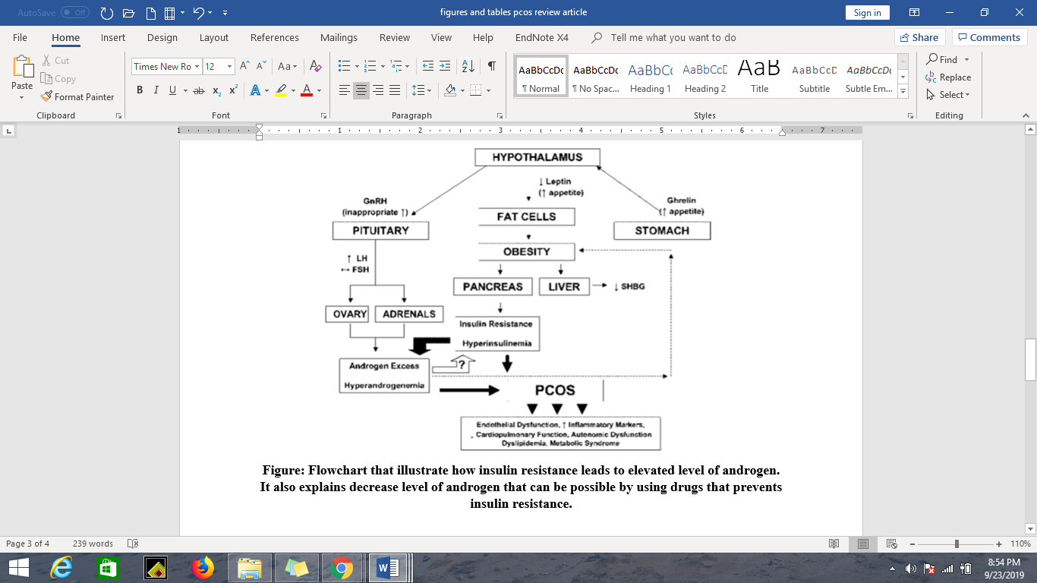

Recent Publications (minimum 5)
- Reddy R, Deepika M.L.N, Prasanna K.L, Someswar R.S (2015). Polycystic ovary syndrome: role of aromatose gene variants in South Indian women International Journal of Pharma and Bio Sciences 6(2): 1283-1296
- Helvaci N, Karabulut E, Demir AU, Yildiz BO (2017). Polycystic ovary syndrome and the risk of obstructive sleep apnea: a meta-analysis and review of the literature. Endocrine Connections, 6(437): 437–445
- Chen Y, Fang S.Y (2018). Potential genetic polymorphisms predicting polycystic ovary syndrome. Endocrine Connections 7: 187-195
- Rizwan S, Ghazanvi S, Rasheed N and Ullah MI. (2018). Association of FTO Common RS9939609 Polymorphism with Obesity and Polycystic Ovarian Syndrome in Pakistani Women J Med Res Biol Stud 1(101): 1-5
- Aesha Sh.B, Sabah H.K, Anas A.H (2017). The FSHR Polymorphisms Association with Polycystic Ovary Syndrome in Women of Erbil, Kurdistan in North of Iraq Ibn Al-Haitham Journal for Pure and Applied science

Photograph

Biography (150-word limit)
Nida has her expertise in the field of human molecular genetics. She has worked on the phylogenetic analysis and SNP’s identification. She has expertise in the teaching, research activities and in bringing out innovative research ideas. She belongs to one of the renowned universities BUITEMS, Quetta, Balochistan, Pakistan that provides an excellent platform for learning opportunities. A growing young researcher with full of enthusiasm and A purposeful individual with a strong will to achieve results.
Email: nidaajmal99@gmail.com

Notes/Comments:

