Early fallopian tube cancer found incidentally on the opposite side of an early ovarian cancer : A case report

Sungyob Kim M.D. Jeju national university, hospital South korea
Eunseo Shin M.D. Jeju national university, hospital
South korea

Background:
Primary fallopian tube cancer (FTC) accounts for about 0.14-1.8% of all malignancies. The most common symptoms of fallopian tube cancer is vaginal bleeding after menopause. However, symptoms are often ambiguous or absent. It is difficult to definitively diagnose it before surgery. Multiple primary cancers (MPC) mean two distinct cancers arising from two distinct organs. Synchronous multiple primary cancer is rare and very hard to distinguish from metastatic tumors.
Results
We present a 54-year-old, postmenopausal women with a right ovarian mass on health screenings. Transvaginal sonography showed a homogeneous 3 cm mass with solid nature in the right adnexa and a 3.6 × 3 cm size solid and well defined mass on the C-T. The CA 125 antigen level was normal. The patient underwent laparoscopic right oophorectomy. The right ovarian capsule was intact and the left fallopian tube was dilated like hydrosalpinx. There was no specific finding in the opposite ovary and other surrounding organs. In the final pathology, LOW-GRADE SEROUS CARCINOMA appeared in the right ovary.PET-CT was performed and focal FDG uptake was observed in the left adnexa area. We performed complete staging operation. The left salpinx was thickened from the previous operation, so frozen biopsy was performed during this operation and malignant findings were seen. The right ovary bed has no specific findings and showed benign on frozen biopsy. The final pathologic result was a high grade serous carcinoma localized only to the left fallopian tube. The malignant cells of tube were positive for CK, WT1 and weakly positive for PR, but negative for p53. The p53 staining is deficient and the Ki-67 labeling index is increased to 60%, which may support the diagnosis of tubal intraepithelial carcinoma. Histopathological and immunohistochemical examinations of both tumor were different.
Conclusion:
The prophylactic bilateral salpingectomy during gynecologic surgeries is now expected as the attempt to reduce the ovarian cancer. In our case, we also observed the appearance of the left tube such as hydrosalpinx at the time of the first operation.
However, there was no evidence of suspicious tubal cancer or abnormal levels of blood, such as CA 125, if ovarian cancer was not diagnosed. Therefore, evaluation of adnexa during surgery is important, and if there are abnormal findings, we should consider the possibility of fallopian tube cancer in menopausal women.
Although it is only one case, we think it is a good example to support prophylactic bilateral salpingectomy.
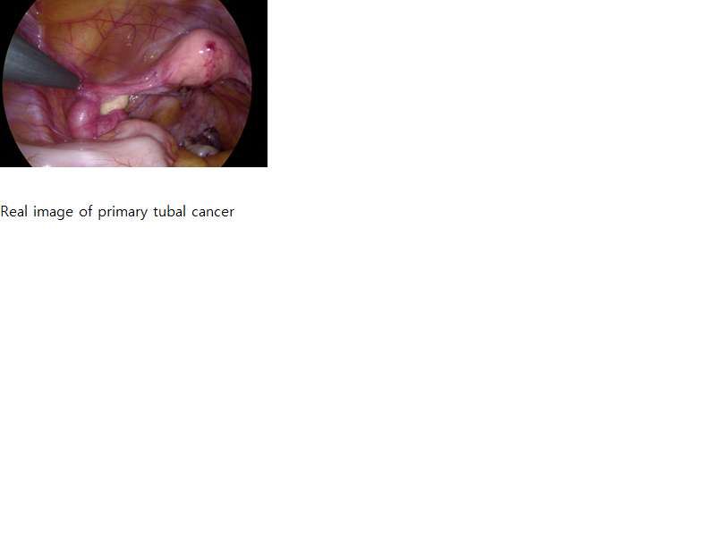
[1] Disaia Clinical Gynecologic Oncology 9th Edition. 400p
[2] Primary fallopian tube carcinoma : A case report and literature review
Meral Rexhepi, Elizabeta Trajkovaska, hysni Ismaili, Florin Besimi, Nagip Rufati
[3] Multiple primary cancer in the female genital system : Two rare case reports and a literature review.
Wei Chai, MD, Fengyan Gong, PhD, Wenlei Zhang, PhD, Yan Wen, PhD, Lifeng Cui, PhD.
[4] The performance and safety of bilateral salpingectomy for ovarian cancer prevention in the United States
[5] A case of bilateral primary fallopian tube carcinoma
Manisha sahu, Prakash k.sahoo, Mahesh C. Sahu, Rabindra N. Padhy
[6] Multiple primary cancer in the female genital system

Photograph


.
Email: obman2@naver.com

