Postoperative complications after extended pelvic resections for locally advanced gynecological cancers
Dr Bacalbasa, Nicolae PhD, CarolDavila University of Medicine and Pharmacy, Bucharest, Romania
Dr Balescu, Irina PhD Student, CarolDavila University of Medicine and Pharmacy, Bucharest, Romania

Abstract (300 word limit)
Statement of the Problem: Pelvic exenteration represents the only potential curative method for women diagnosed with locally advanced or relapsed gynecological malignancies, increasing therefore the chances to achieve a long term survival. However, a significant number of cases will not have the chance to benefit from this surgical procedure due to the fact that severe, life threatening complications develop.
Methodology & Theoretical Orientation: in the current paper we reviewed the early postoperative complications among 100 patients submitted to pelvic exenterations between 2019-2022. As expected, the most commonly encountered complications were represented by postoperative hemorrhage, pelvic abscesses and perineal herniations. Reoperation was needed in 18 cases; when it comes to empty pelvic syndrome and secondary perineal herniation, the rates of this complication were significantly diminished in cases in which pelvic prostheses were used. Conclusion & Significance: pelvic exenteration remains a demanding procedure associated with significant rates of perioperative morbidity. However, once the concept of pelvic prosthesis placement was implemented, an improvement regarding postoperative morbidity was observed.

Image
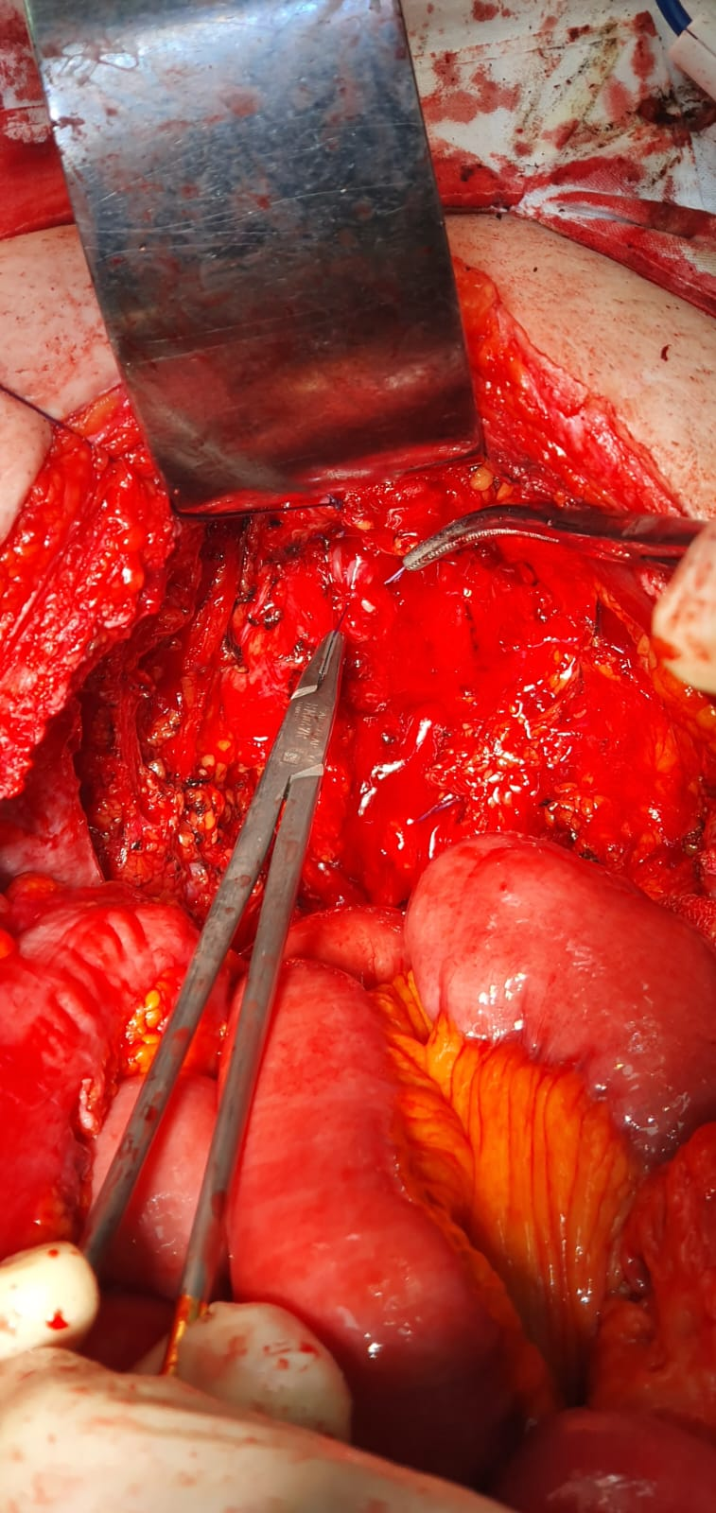

The final aspect after extended pelvic resection for relapsed endometrial cancer
Recent Publications (minimum 5)
- Bratu O, Marcu D, Anghel R, Spinu D, Iorga L, Balescu I, Bacalbasa N, Diaconu C, Savu C, Savu C, Cherciu A (2021). Tumoral markers in bladder cancer (Review) ETM 22(1):773.
- Bacalbasa N, Balescu I (2015). Pelvic exenteration--reconsidering the procedure. J Med Life 8(2):146-9
- Bacalbasa N, Balescu I, Vilcu M, Dima S, Brezean I (2020). Risk Factors for Postoperative Complications After Vulvar Surgery. In Vivo 34(1):447-451.
- Gheorghe M, Cozlea AL, Kiss SL, Stanca M, Căpîlna ME, Bacalbașa N, Moldovan AA (2021). Primary pelvic exenteration: Our experience with 23 patients from a single institution. ETM22(4):1060.
- Bacalbasa N, Balescu I, Cretoiu D, Halmaciu I, Dimitriu M, Socea B, Diaconu C, Iliescu L, Savu C, Savu C, Filipescu A, Stoica C, Stiru O (2021). Determination of whether HIPEC is beneficial in patients with synchronous peritoneal and liver metastases from colorectal cancer (Review). ETM 22(5):1267

Photograph


Biography (150 word limit)
My name is Nicolae Bacalbasa and I was born on April, 02, 1979 in Bucharest. After graduating the courses of the „Carol Davila” University if Medicine and Pharmacy, Bucharest, Romania and completing my doctoral and postdoctoral research in the field of oncogynecology I continued to focus my studies in the field of surgical oncology and gynecologic oncology as well as in the field of hepato-bilio-pancreatic surgery . My current position is of consultatnt visceral surgeon in „Fundeni Clinical Institute” Bucharest Romania and Assistant professor - Obstetrics and Gynecology - "Dr. I. Cantacuzino" Clinical Hospital, "Carol Davila" University of Medicine and Pharmacy, Bucharest, Romania.
Email: nicolaebacalbasa@gmail.com

