Effects of deep tissue massage on pain and comfort after cesarean
Asst. Prof. Dr. Esra GÜNEY, TURKEY
Assoc. Prof. Tuba UCAR, PhD, TURKEY

Abstract
Statement of the Problem: In this study, it was aimed to determine the effect of deep tissue massage (DTM) applied by midwife on pain and comfort after cesarean section. Methodology & Theoretical Orientation: This study was designed as a randomized controlled trial conducted with experimental and control groups. The data were collected using a personal information form, visual analogue scale (VAS), the Postpartum Comfort Questionnaire (PPCQ). DTM was applied to participants in the experimental group twice (at the 10th and 22nd h) after cesarean. No applications were performed in the control group. Findings: According to the measurements, the mean VAS score of the mother in the experimental group was lower than that of the control group (17.51 ± 6.15, 56.16 ± 9.53; respectively) and PPCQ total and sub-dimension mean scores were found to be statistically significant in favor of the experimental group (p < 0.001). Conclusion & Significance: It was indicated that DTM application decreased the levels of pain and increased the comfort levels of the women who had cesarean sections.

Image
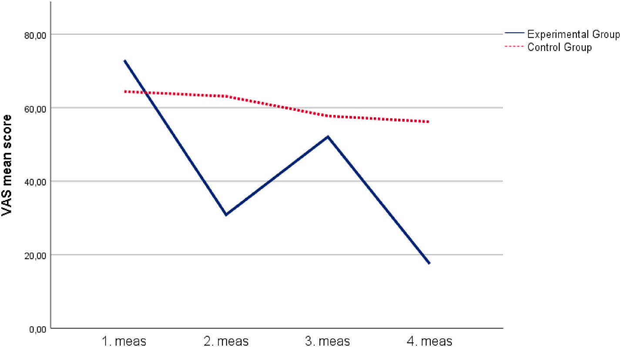

VAS scale score curve in the measurements of the women in the experimental and control groups (n = 162).
Recent Publications (minimum 5)
- Güney E, Uçar T. (2021) Effects of deep tissue massage on pain and comfort after cesarean: A randomized controlled trial. Complementary Therapies in Clinical Practice, 43, 101320.
- Uçar T, Güney E, Cesur B, Yurtsal ZB. (2018) The scale for body image concerns during pregnancy: development and validation. Perspectives in Psychiatric Care 54(3): 416-421. doi: 10.1111/ppc.12287.
- Guney E, Ucar T. (2019) Effect of fetal movement counting on the maternal antenatal attachment. Japan Journal of Nursing Science 16(1): 71-79. doi:10.1111/jjns.12214
- Ucar T, Aksoy Derya Y, Barut S, Guney E, Sabanci E, Unver H. (2018) Opinions of labor professionals about Vaginal Birth after Cesarean in Turkey. International Journal of Caring Sciences 11(2): 1043-1049.
- Uçar T, Güney E, Bal Z. (2018) Psychosocial aspects of gynecologic cancer. Sakarya Medical Journal. 8(4):678-685. doi:10.31832/smj.435160
Photograph

Biography
Esra GÜNEY has a PhD in midwifery from Inonu University. She is working as a fulltime Assistant Professor at midwifery department in İnönü University Faculty of Health Sciences.
Email: esra.guney@inonu.edu.tr

Notes/Comments:

