Green and Sustainable Catalysis in Supercritical Media
Thomas E. Müller

Thomas Ernst Müller, Carbon Sources and Conversion, Faculty of Mechanical Engineering, (Ruhr-University Bochum, D)

At present, the value chains of our economy are built to a large extent on the extensive use of fossil carbon resources. Progressive depletion of the resources together with increasing impact of human activity on the environment calls, however, for a fundamental reassessment. At the heart of the upcoming transformation of raw material and energy supply is a switch to renewable carbon sources and progressive closure of anthropogenic carbon cycles (Figure 1).

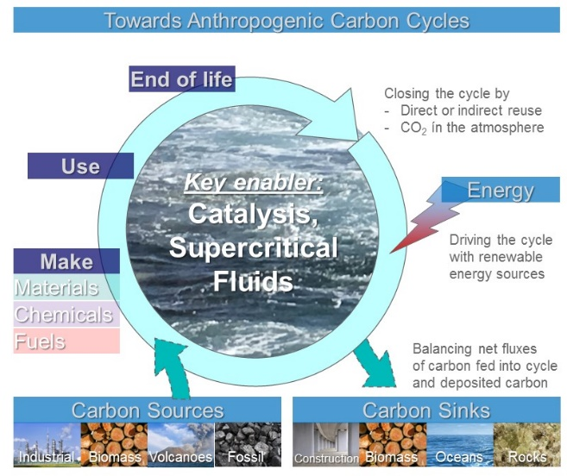
Figure 1: Closure of carbon cycles in the upcoming transformation of the raw material supply in the chemical industry and the energy sector.

To attain this goal, new carbon sources as well as novel sustainable conversion technologies will have to be implemented. Green Chemistry, based on new catalysts and alternative reaction media, will be a key enabler to effect this transformation. One option is provided by the increased use of near critical and supercritical fluids as reaction media. Carbon dioxide that is evolving as alternative carbon feedstock is thereby of particular interest.

Supercritical fluids combine specific properties of liquids and gases that are at the base for effective catalytic transformations. Thus, diffusion coefficients are significantly higher than in the liquid state giving rise to enhanced mass transfer. The absence of a gas-liquid phase boundary avoids diffusion limitations, when reagents and/or products pass over phase boundaries during chemical transformations in multiphase systems. The low interface stress of supercritical fluids enhances rapid solubilization of product molecules that are adsorbed at the surface of heterogeneous catalysts. The typically high heat transfer rates in supercritical media facilitates temperature control. Further, the pronounced change in dissolution capacity at or near the supercritical point, renders supercritical fluids solvents of choice, when chemical conversion and processing steps shall be combined in intensified processes.

Consequently, catalysis in combination with the use of supercritical fluids will be a key enabler for the upcoming transformation of the raw material supply in the chemical industry and the energy sector. The introduction of new technologies, such as advanced Fischer-Tropsch technologies based on CO₂ as feedstock, and challenging feedstock, such as lignin, will lead to new value-chains of the manufacturing industry. In this context, an enhanced use of supercritical fluids as reaction medium and likewise as reactants is to be anticipated.

Keywords—Supercritical Media, Renewable Energy, Carbon Dioxide, Fischer-Tropsch Synthesis

Professional Biography

Prof. Dr. Thomas E. Müller (MRSC) is full professor at Ruhr-Universität Bochum. After having studied chemistry at LMU München and ETH Zürich, he pursued his PhD project at ICL London followed by research positions at University of Sussex and TU Munich and visiting professor positions at NUS Singapore and University of Tokyo. He then worked for 12 years for Bayer MaterialScience, later Covestro in process development. In parallel, he was head of CAT Catalytic Center, a joint venture of Covestro with RWTH Aachen University. In 2018, he moved back to academia accepting a teaching position at RFH Köln and, since March 2019, is incumbent of the chair Carbon Sources and Conversion at Ruhr-Universität Bochum. His research interests are centred around establishing new process chains for efficient use of carbon.

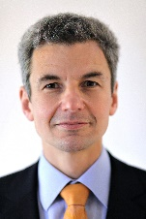
Email Id: mueller@ls-csc.rub.de

