Sustainable Smart Buildings

Ayush Srivastava, Technische Universität Berlin, Germany

Abstract
The general paper aim is to draw an overall picture of the current research and potential future aspect of Smart Buildings.
Structures (Such as houses, residential and commercial, industry etc.) building all around the globe expend a lot of vitality, which is pretty much 33% of the aggregate essential vitality assets (Pervez HameedShaikh, 2014). Consequently, this has demonstrated a rising vitality request sooner rather than later. Sustainable smart building has the advantage of automation system that manage the energy, environment, connectivity and communication with user. Buildings such as new or refurbished buildings, the smart manner is to build to look at multidisciplinary and integrated manner, as well as feedback from end user (Tang, 2012). The sustainable smart building manages the building issues of building mechanization as a type of innovative insight and the investigation of those advances technologies coordinated into the building envelope and that enhance its performance and making it more sustainable (Vattano, 2014). Sustainable smart building mainly based on building envelop, building control system, renewable energy generation, energy optimization and energy management system (Evins, 2013).

Bibliography

Image
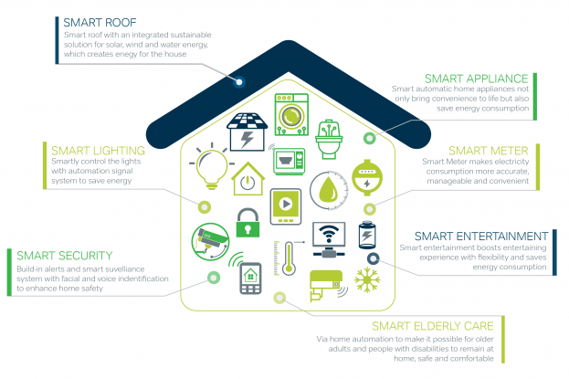
Figure: http://www.jtm2m.com/blog/internet-of-things-in-the-smart-home/
Smart home system consists of switches and sensors that are connected with central hub which is then controlled with a user interface that is controlled either with a wall-mounted terminal, mobile phone software, tablet computer or a web interface using internet cloud services (solution).
Final overview is to present what building is a smart and which essential hardware components are the necessary to make a sustainable smart building for the future.

Bibliography
Evins, R. (2013). A review of computational optimisation methods applied to sustainable building design. Retrieved 09 04, 2018, from https://www.sciencedirect.com/science/article/pii/S1364032113000920
Pervez HameedShaikh, P. (2014, 03 27). A review on optimized control systems for building energy and comfort management of smart sustainable buildings. Retrieved 09 05, 2018, from https://www.sciencedirect.com/science/article/pii/S1364032114001889
solution, M. (n.d.). Internet of Things in the Smart Home. Retrieved 09 05, 2018, from http://www.jtm2m.com/blog/internet-of-things-in-the-smart-home/
Tang, D. T. (2012). sustainable buildings:smart, green and people-friendly. Sustainability and Environmental Management. CEM OCCASIONAL PAPER SERIES. Retrieved 09 05, 2018, from https://www.ucem.ac.uk/wp-content/uploads/2016/01/SustainableBuildings_OP_FINAL_web.pdf
Vattano, S. (2014). Smart Buildings for A Sustainable Development. DAVID PUBLISHING. Retrieved 09 02, 2018, from http://www.academia.edu/9734998/Smart_Buildings_for_A_Sustainable_Development

