Solar Wi-Fi Eco Bin
Luciano Guido-Founder & CEO Solar outdoor media, Dheepika Tamilselvam-Project Engineer

AbstraAbstract  Though there are many awareness and promotions on recycling units, there’s still a void in the marketplace for attractive, sanitary and safe recycling and refuse centers. Today people need sustainability in every product, we at Solar Outdoor Media UG made a green initiation to promote recycling and a healthy community connection with cities and their people in an eco-friendly way. Solar Wi-Fi Eco Bin is a recycling and refuse center that measures approximately 4’ by 6’ and it features a solar powered advertising media space on all four sides of the BIN, making it so appealing to companies and entities that employ them. The solar panel on top powers internal batteries which automatically illuminate all the side panels in the night, making the Solar Wi-Fi Eco Bin a lucrative opportunity. It is also enabled with a built-in WIFI extender that creates an internet hotspot for consumers, and 4 USB ports for mobile devices. Solar Wi-Fi Eco Bin is a smart, eco-friendly and economical product which creates a recycling center that gives the consumers/ customers mobile charging and Wi-Fi, and allows for the operator to make money. It’s an appealing product for municipalities, hospitals, educational facilities, public recreation areas, sports arenas and entertainment venues. We are also planning to connect this system on grid (Hybrid System) i.e. once the battery is fully charged excess solar power not required can be exported to the grid via meter. When the solar system is not in use, and if the battery is drained then it start drawing power from the grid. Hybrid systems are also able to charge the batteries using cheap off-peak electricity (usually after midnight to 6am). Thus making our Solar Wi-Fi Eco Bin more green and sustainable. | Image  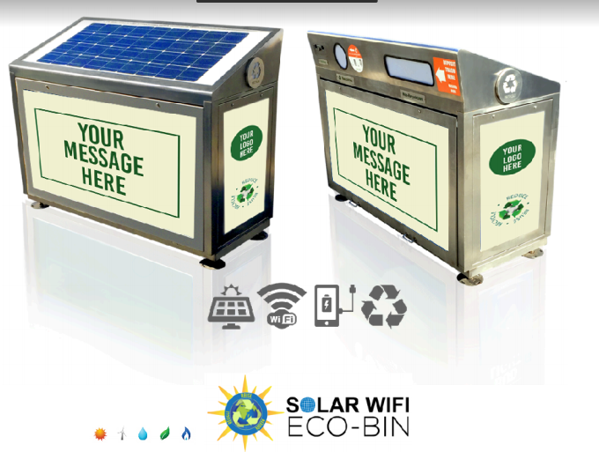  Publications  Pu  - Patent right - Combined trash and recyclables bin with solar powered led illuminated display panels.  - Listed as one of the 1000 solutions to make difference in solar impulse foundation.

 | Mr. Luciano Guido  Founder & CEO of Solar Outdoor Media UG  He has over 15 years of experience in Renewable Energy and Private Investment Banking experience, equipped with a strong leadership background in building advisory, substantial experience in advising clients on mergers and acquisitions, corporate restructuring and other strategic business initiatives. He is a strategic planner and guides clients in their business development.  Email: Luciano@solaroutdoormedia.com , Ph: +49-178-854-9073
 | Ms. Dheepika Tamilselvam  Project Engineer at Solar Outdoor Media UG  Engineer with an experience in renewable energy projects, mechanical engineering, solar thermal energy and storage system.  Email: dheepikat.t@solarwifiecobin.com , Ph: +49-15214441156

