Simultaneous oil extraction and transesterification of high acidity rapeseed oil

Miglė Šantaraitė, RN PhD,
Aleksandras Stulginskis University,
Kaunas r., Lithuania

Abstract

Simultaneous extraction and transesterification of high-acidity (3 mgKOH/g) rapeseed oil, using a mineral diesel (as an extraction solvent) and methanol mixture, have been investigated aiming to obtain a mixture of mineral diesel and biodiesel fuel which can currently be used as fuel. Mineral diesel and rapeseed oil ratio in mixture was 9:1 (w/w). Effectiveness of different biocatalysts – lipases (Lipozyme RM IM, Lipozyme TL IM, Novozym 435, Lipozyme 435, Lipolase 100L, Lecitase Ultra, Resinase A 2X, Palatase 20000L, Lipozyme CALB, Liopozyme TL 100L, Lipex 100L), suitable for in-situ processes, was studied and the most effective was selected. The conversion of rapeseed oil to biodiesel fuel was evaluated in the presence of a lipase from Lipozyme TL IM (Thermomyces lanuginosus). We aimed to extract the maximum amount of rapeseed oil, as well as to fully convert the oil to methyl esters. At the optimal conditions the 99.9% of the rapeseed oil was extracted from rapeseed. The maximum methyl esters yield was 98.99% (degree of transesterification more than 96.5%) after 5h of reaction. The quantities of monoglycerides (0.38%), diglycerides (0.06%) and triglycerides (0.00%) remaining in the product comply with the requirements of standard for biodiesel fuel. It was found that the optimum conditions for simultaneous oil extraction and transesterification using methanol and lipase – Lipozyme TL IM were the following: molar ratio of methanol to oil – 5:1, amount of lipase preparation Lipozyme TL IM - 7%, duration of reaction – 5h, temperature – 23 ±2°C.

Image

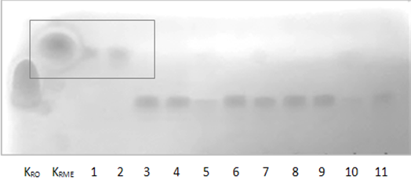

Figure 1: The efficiency of lipases in the synthesis for the simultaneous process (in-situ) of oil extraction from ground oilseeds and transesterification. RO – rapeseed oil, RME – rapeseed methyl esters, 1 – Lipozyme RM IM, 2 – Lipozyme TL IM, 3 – Novozym 435, 4 – Lipozyme 435, 5 – Lipolase 100L, 6 – Lecitase Ultra, 7 – Resinase A 2X, 8 – Palatase 20000L, 9 – Lipozyme CALB, 10 – Liopozyme TL 100L, 11 – Lipex 100L.

Image

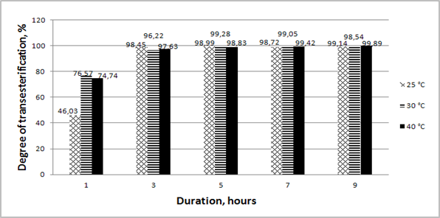

Figure 2: Dependence of the degree of transesterification on the reaction time and temperature, when molar methanol to oil ratio – 5:1, lipase concentration – 7%.

Recent Publications
- Hernández-Martín E, Otero C (2008) Different enzyme requirements for the synthesis of biodiesel: Novozym® 435 and Lipozyme® TL IM. Bioresource Technology 99:277-286.
- Sim JH, Kamaruddin AH, Subhash Bhatia S (2010) Biodiesel (FAME) Productivity, Catalytic Efficiency and Thermal Stability of Lipozyme TL IM for Crude Palm Oil Transesterification with Methanol. Journal of the American Oil Chemists' Society 87: 1027–1034.
- Xu Y, Nordblad M, Nielsen PM, Brask J, Woodley JM (2011) In situ visualization and effect of glycerol in lipase-catalyzed ethanolysis of rapeseed oil. Journal of Molecular Catalysis. B, Enzymatic 72: 213-219.
- Gog A, Roman M, Toşa M, Paizs C, Irimie FD (2012) Biodiesel production using enzymatic transesterification – Current state and perspectives. Renewable Energy 39:10-16.
- Guldhe A, Singh B, Mutanda T, Permaul K, Bux F (2015) Advances in synthesis of biodiesel via enzyme catalysis: Novel and sustainable approaches. Renewable and Sustainable Energy Reviews 41: 1447-1464.



Biography
Miglė šantaraitė graduated from Master's degree in environmental engineering field at Kaunas University of Technology in 2015. Her field of study was renewable (solar, wind and geothermal) energy. Today she is PhD student at the field of technology science, environmental engineering in Aleksandras Stulginskis University. Her field of study relates to the biodiesel fuel production and evaluation of physical and environmental properties of product obtained.

Email: m.santaraite@gmail.com

