Advances in Finite Volume and Lattice Boltzmann Method Simulation of Melting in Latent Heat Thermal Energy Storage Systems

Yuwen Zhang, University of Missouri, Columbia, MO, USA

Abstract
Modeling and numerical simulation for solid-liquid phase-change problem has become an active area in the last several decades due to its wide applications in energy systems as well as thermal manufacturing, building systems, and in thermal energy storage systems. Phase-change thermal energy storage systems can store thermal energy while being subjected to heat input, and then release it to the environment over a long period of time. Therefore, they are especially suitable for space applications involving pulsed power loads, such as a large amount of heat rejection from a power cycle in a short period of time. Advances in numerical simulation of natural convection controlled melting for latent heat thermal energy storage system has been systematically investigated by our group. An interfacial tracking model is developed to simulate melting in an enclosure with presence of natural convection. It obtains the melting front location by calculating energy balance at solid-liquid interface and is a simple and convenient method to solve the solid-liquid phase-change problem. It combines the advantages of the both deforming and fixed grids methods and can handle natural convection-controlled melting and solidification problems. Melting in porous media within a rectangular enclosure with presence of natural convection is also simulated using the interfacial tracking method. Convection in the liquid region is modeled using the Navier-Stokes equation with Darcy’s term and Forchheimer’s extension. A hybrid lattice Boltzmann and finite volume model is proposed to solve the natural convection controlled melting problem. Lattice Boltzmann method (LBM) is applied to solve the velocity field while the temperature field is obtained by the finite volume method (FVM). Three-dimensional melting problems are investigated numerically with Lattice Boltzmann method (LBM). Multiple-Relaxation-Time (MRT) models are employed to simplify the collision term in LBM and temperature and velocity fields are solved with double distribution functions, respectively.

Image
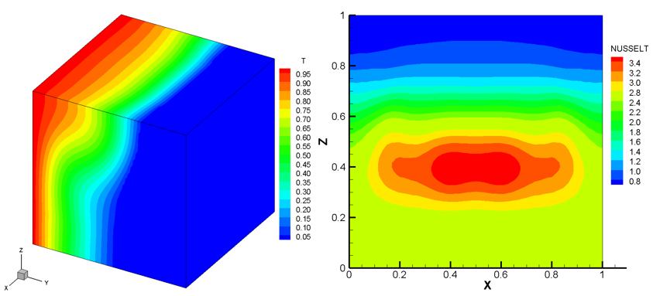

Temperature field and Nusselt number for 3-D melting problem
Recent Publications
- Mao Y, Afrin N, Chen JK, and Zhang Y (2018) Numerical Simulation of Complex Flow and Heat Transfer Induced by Localized Laser Heating on a Urethane-Coated Substrate, Numer. Heat Transfer 73: 63-77
- Mao Y, Zhang B, Chen CL and Zhang Y (2017) Hybrid Atomistic-Continuum Simulation of Nanostructured Defects-Induced Bubble Growth, J. Heat Transfer 139:104503
- Mohammadian SK and Zhang Y (2017) Cumulative Effects of Using Pin Fin Heat Sink and Porous Metal Foam on Thermal Management of Lithium-ion Batteries, Appl. Therm. Eng. 118:375-384
- Ji P and Zhang Y (2017) Electron-Phonon Coupled Heat Transfer and Thermal Response Induced by Femtosecond Laser Heating of Gold, J. Heat Transfer 139:052001
- Rassoulinejad-Mousavi SM, Mao Y and Zhang Y (2016), Evaluation of Copper, Aluminum and Nickel Interatomic Potentials on Predicting the Elastic Properties, J. Appl. Phys. 119:245102

Biography
Yuwen Zhang is a James C. Dowell Professor in the Mechanical and Aerospace Engineering Department, which he chaired from 2013 to 2017. He was a recipient of the Young Investigator Award from the Office of Naval Research in 2002. He is a fellow of the American Association for the Advancement of Science (AAAS), a fellow of the American Society of Mechanical Engineers (ASME) and an associate fellow of American Institute of Aeronautics and Astronautics (AIAA). Zhang received the 2010 MU Chancellor’s Award for Outstanding Research and Creative Activity. His research lies in the areas of multiscale and multiphase heat and mass transfer, ultrafast and ultra-intense laser-mater interaction, and sustainable and renewable energy. His research has resulted in more than 285 journal papers and more than 165 conference papers, and he has published five books. He is an editorial board member for over 10 international journals.
Email: zhangyu@missouri.edu

