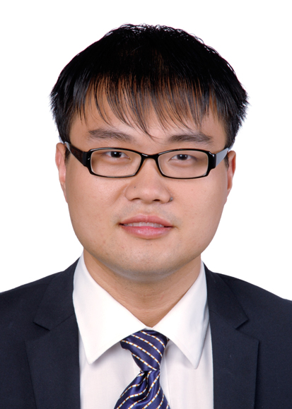 Chitin Based Functional Materials Constructed via NaOH/urea Aqueous Solution

Bo Duan, Lina Zhang
College of Chemistry and Molecular Sciences, Wuhan University, Wuhan 430072, China

Abstract
A series of functional chitin materials with physical regeneration method from the NaOH/urea solvent system have been developed. Due to the physical process was applied in the fabrication of chitin materials, the natural function of the chitin was maintained. The chitin chains in the NaOH/urea aqueous solution rapidly self-aggregated in parallel to form nanofibers with diameter about 25 nm, which then formed weaved microspheres. Based on the adsorption of the chitin for the metal ions and the templates function of the nanofibrous structure, the nanofibrous chitin microspheres were applied as matrix to deposit hydroxyapatite with different morpholog. The hydroxyapatite/nanofibrous chitin microspheres significantly enhanced the bone cell adhesion and proliferation on the chitin microspheres, indicating the great potential in bone tissue engineering. Ag-Fe₃O₄ nanocomposites also could be bounded on the chitin micropsheres through the acetyl amino groups to obtain the magnetic chitin microsphere with high catalysis activity. Moreover, the chitin film and sponge with gas barrier and oil/water separation were successfully fabricated. These chitin based material would find wide application in oxygen resistant packaging, oil/water separation, highly efficient catalysis and tissue engineering field. These basic researches provided scientific evidence and academic value for construction of materials with highly added value from the least exploited resource chitin, and are in accordance with sustainability. Therefore, this thesis exhibits scientific significance and application prospect. The NaOH and chitin formed a hydrogen-bonded complex that was surrounded by the urea hydrates to form a sheath-like structure, leading to the good dissolution of chitin, and the chain conformation of chitin was a stiff chain.

Biography
Bo Duan (male) is an associate Professor at College of Chemistry and Molecular Sciences, Wuhan University. He has completed her B.S in Organic Chemistry and PhD in Polymer Chemistry and Physics by Wuhan University in 2015, and then Postdoctoral at Stowers Institute for Medical Research in USA. He focused on the exploitation of the chitin based materials. He has published 25 papers in the international journals, including Angew. Chem. Int. Ed; Prog Polym Sci; Nano Energy; Green Chem; Biomacromolecules, et al.

Presenting author details
Full name: Bo Duan
Session name/ number: xxxxx
Category:
Email: bo_duan@whu.edu.cn
Contact number: +86-27-87216311

