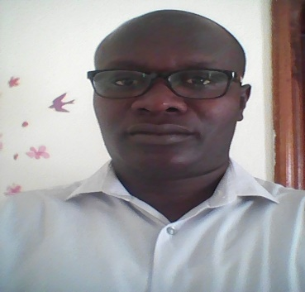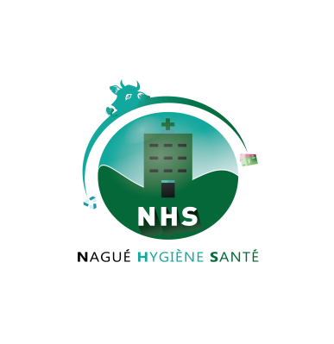
Title: Bio-Hazardous waste damages in agriculture area (Saint Louis of SENEGAL)
Cheikh Saya SOW
Nagué Hygiène Santé (NHS)

Abstract
Senegal, like the underdeveloped countries, is faced with the problems of waste management in general and bio-hazardous waste in particular.
Saint Louis is one of the fourteen administrative regions of Senegal. Consisting of 19,044km² (7,353mi²), the region is limited on the north by the Senegal River, on the west by the Atlantic Ocean, in the south and the east by other regions of the country.
Saint Louis is the main agricultural area of the country due Senegal River and the extent of managed cultivated areas. There are approximately nine hundred thousand (900 000) inhabitants.

Its medical infrastructure includes 2 hospital, 5 public health centers, 1 analysis laboratory and private health facilities.
All these together produce an enormous quantity of bio-hazardous wastes but unfortunately there is not a single Bio-Hazardous Waste Treatment unit in the entire region.
The only mode of treatment that exists in Saint Louis is burning.
The consequences of improper disposal of untreated biohazardous wastes are harmful to both the environment and to humans. Contagious diseases like hepatitis B or poisoning are both two of the possible consequences in humans, and small children are especially vulnerable. In the natural environment both soil and water, whether rivers or oceans, can be contaminated, causing harmful consequences to flora, fauna and the food supply.
Same phenomenon is noted in the other regions of the country.
In this context, it becomes urgent that Saint-Louis and the other regions of Senegal benefit from a standardized and permanently funded Bio-hazardous Waste Treatment Unit that complies with international standards.

To do this there must be private initiatives supported by the state and development partners.
Biohazardous waste places destruction

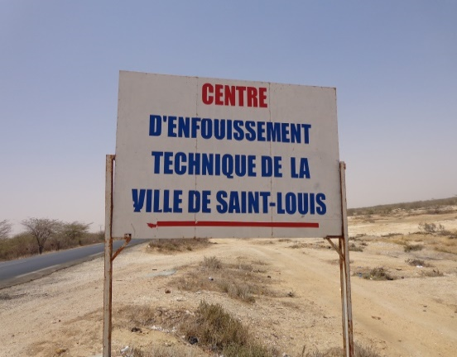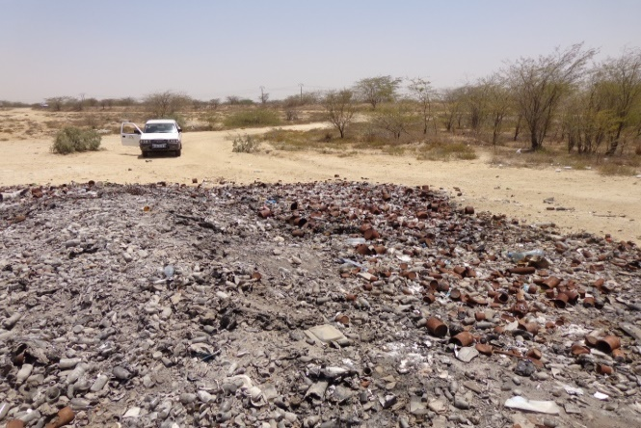

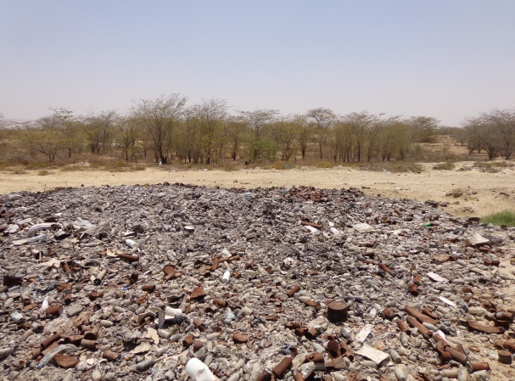

- Bibliography
- M. Ndiaye, L. El Metghari, M.M. Soumah, M.L. Sow. Biomedical waste management in five hospitals in Dakar, Senegal.

- Regional Disease Surveillance Systems Enhancement Project (REDISSE – SENEGAL)

- Biography:
Cheikh Saya Sow is an engineer Hygiene Quality Safety Environment; he studied to the Polytechnic College of Cheikh Anta Diop University of Dakar. He has besides a University Degree in Quality Management of Pierre et Marie Curie University (Paris VI). He was the Quality Responsible of BRC EPLS which leads research projects centered on diseases connected to water (Bilharziasises, Malaria) in Senegal River Valley.
Currently he has set up a company that offers services in Management of Bio-hazardous waste and Hygiene in general named NHS (Nagué Hygiène Santé).

Presenting author details

Full name: Cheikh Saya Sow
Session name/ Number: Waste Management / 30
Category: Oral
Email id: cheikhsaya@gmail.com / nague.hs@gmail.com
Contact number: 00221 78 309 20 77

