Experimental Data of Designing an Optimal System for Storage, Collection and Transfer of Household Waste in the GIS Environment, A Case Study of Tehran, IRAN

Mohammad Hadi Dehghani

Tehran University of Medical Sciences, School of Public Health, Department of Environmental Health Engineering, Tehran, IRAN

Abstract
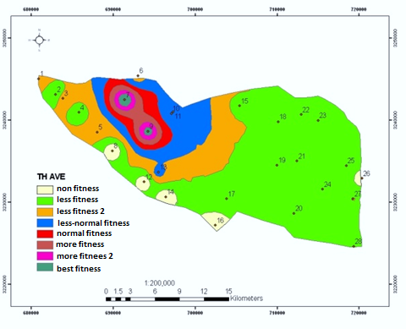
This study was conducted to correctly manage the system of storage, collection and transfer of wastes in district 22, Tehran. After reviewing existing methods, an optimal system was designed in the GIS environment and appropriate solutions were suggested. Analytical Hierarchy Process (AHP) method was used. After extracting result criteria, these criteria were provided to 15 experts and managers by means of a Delphi questionnaire. Screening of the criteria was done using the criterion importance graph; a necessary condition to apply criteria and sub-criteria, is having at least half the numerical value of each vertical and horizontal vector. The results of the study showed that the most important criterion associated with the selection of waste transfer station is "distance from residential houses" with a final weight of 0.341. "Suitable traffic conditions" and "lack of noise pollution" are the next important criteria with weights of 0.259 and 0.118, respectively. Finally, "non-destruction of recreational facilities" was chosen as the least important (weight of 0.03). Transfer in this district is also 100% mechanized. At the district level, there are 10 garbage trucks, of which 7 collect during night and 3 during day. Given per capita of the district, it takes about 10 minutes to collect each ton of waste. In general, in order to investigate and plan specific methods in the study district, using Geographic Information System, the location of reservoirs in residential and commercial districts has been determined and suggested with a coefficient of 0.75.

Fig. Prioritization of optimal locating criteria for the urban waste transfer station.

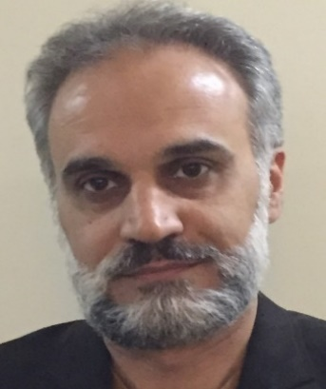

Professor Dr. Mohammad Hadi Dehghani (PhD) is a Full Professor at the Tehran University of Medical Sciences (TUMS), School of Public Health, Department of Environmental Health Engineering, Tehran, IRAN. His scientific research interests include the Environmental Science. He is the author of various research studies published at national and international journals, conference proceedings and Head of several research project at the TUMS. He has authored 8 books and more than 150 full papers published in peer- reviewed journals. He is an editorial board member and reviewer in many internal and international journals and is member of several international science committees around the world. He has supervisor and advisor PhD and MSc theses at the TUMS.

