Abstract Title: De-constructing and re-constructing advanced imaging data through creative visual digital experimentation. To generate new methods and scope to help influence how scientific image data can be disseminated and communicated.
Berry, J.

Name: Berry, J.
Affiliation: Birmingham City University
Abstract (not more than 300 words)

Abstract (upto 300 words)
This project is situated within contemporary visual arts and communication, drawing upon the knowledge of the discipline as practitioner and academic. Mapping out important aspects of this research investigation as it unfolds while working in the field and in the studio. It is a ‘multi-dimensional zone of considerable complexity’ (Kemp, 2016:217) originating from experiencing science in action.
It has its roots in a collaboration of over 10 years with the School of Life Sciences, Nottingham University and their project Advanced imaging and Microscopy. This led to further collaborations with a wider network of six internationally renowned research laboratories in the field of bio science. The four core case studies emerging from this investigation are:
- COMPARE, The Cell Signalling and Pharmacology Group and a minor study at the Molecular and the Cellular Biology Group, School of Life Sciences, Queens Medial School, University of Nottingham.
- COMPARE, Cardio Vascular Sciences, Medical and Dental Schools, Birmingham University
- Core Research Laboratories Imaging and Analysis Centre, Natural History Museum (NHM), London,
- The Centre for Cellular Imaging (CCI) Sahlgrenska Academy Gothenburg University, Chalmers University and the Biofilms, Research Centre for Bio-interfaces, Malmo University.

The researcher has collected primary raw scientific image data from passive observation and active participation from a wide range of advanced imaging and microscopy experiments. Acquiring an inside view of many aspects of laboratory work and imaging experiments. Subject matter focuses on natural phenomena, skin and cells.
This research investigates how art created from pure scientific image data from observed scientific imaging experiments can be used as a creative device to enable how this data can be visually communicated. New insights into the application, use and analysis of advanced imaging technology and data is presented.

Professional Biography (100-150 words)
Exhibiting regularly throughout the Country and Internationally with pieces in the Victoria & Albert Museum (V&A), Arts Council England (ACE) Collections, Nottingham University Medical School and Zeiss Microscopy Labs, Munich, Germany. From the year 2000 attaining cumulative money applications totalling £203K. Awarded by ACE, Wellcome Trust, AHRC, AHRB, ESPRC, local authorities, Arts for Health and global companies. High quality outputs from research include: Light it Up: Brains, Psychosis, Neuroimaging & Us a collaboration with the Neuro Transational Imaging Department, Nottingham University to create Brain Container, Blackpool Illuminations. Hijacking Natural Systems funded by Wellcome Trust, ACE, Derby City Council and Derby Museum & Arts Gallery. This was a highly successful project nominated by Nottingham University for The Times Higher Education Award and cited by the Wellcome Trust as an exemplar of a successful Arts and Engagement project. Artwork from this project was featured in the BBC4 TV series The Beauty of Anatomy presented by Dr Adam Rutherford. Residencies include Florence Trust, London, Natural History Museum, London. Public commissions include Millfield Sculpture Commission, Derbyshire Moorlands, Sheffield Galleries and Museums Trust, New Shetland Museum & Archives and Blackpool Illuminations.

Recent Publications (up to 5)
- Book chapter: Visualization of Scientific Image Data as Art Data for a book titled Big Data in the Arts and Humanities, Theory and Art Big Data: Arts and Humanities, published by TAYLOR & FRANCIS Books, Inc. (March 2018)
- Art made from live scientific images to help and influence how Art made from live scientific images to help and influence how they are visually communicated and distributed. Ref P116, Cumulus Hong Kong Design for Everything. ISBN: 978-978-0077-0 (print), ISBN: 978-978-0078-7 (Online), ISBN: 978-978-0079-4 (APP).
- Varoom Mag digital magazine: http://theaoi.com/varoom-mag/article/v31-varoomlab-visionaries-scientific-images/ (November 2016)
Exhibition
- The Centre of Membrane Proteins and Receptors (COMPARE) Compare Conference April 2018. Formal launch of COMPARE, Medical School, Queen’s Medical Centre, Nottingham.
Keynote speaker: Professor Brian Kobilka, 2012 Nobel Prize in Chemistry, Stanford, USA.

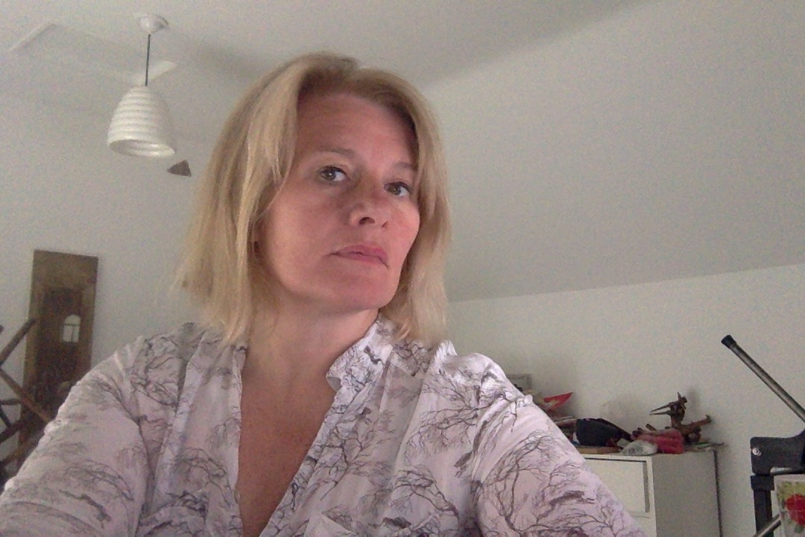

Email Id: Email ID: j.berry@bcu.ac.uk

