Graphene-Stoichiometric Lithium Niobate Hybrid Structures for Surface Acoustic Wave Sensors
Narek Margaryan¹, Ninel Kokanyan^{2,3} ,Edvard Kokanyane^{4,5}
¹ National Polytechnic University of Armenia, Department of Physics, Yerevan, Armenia
²Université de Lorraine, Laboratoire Matériaux Optiques, Photonique et Systèmes, Metz, F-57070, France
³Laboratoire Matériaux Optiques, Photonique et Systèmes, CentraleSupélec, Université Paris-Saclay, Metz, F-57070, France
⁴ Armenian State Pedagogical University after Kh. Abovyan, 17 Tigran Mets Ave., Yerevan, 0010, Armenia
⁵ Institute for Physical Research, National Academy of Sciences of Armenia, Ashtarak-2, 0203, Armenia
Carbon nanostructures and especially graphene are under general attention of international science society due to their unique physical properties and huge application potential [1]. Production of such nanostructures by the most optimal methods is the goal of many studies. The methods based on exfoliation deserve special attention, among other methods [2]. In our research large scale fractal graphene layers are obtained by complex method of liquid phase exfoliation and self- organization. Atomic force microscopy (AFM) is used to study the surface properties of formed layers and to assess their thickness. Raman scattering spectra were used for structural analysis and assessment of the level of defects (Fig. 1). The influence of twisting deformation between layers on Raman spectra is discussed [3].
The optical absorption spectra for these layers indicate the presence of an exciton transition along the M-point of symmetry of the Brillouin zone. These spectra of are affected by dielectric confinement [4] effect (Fig. 2).
In addition, the graphene / LiNbO3 structure is discused as a potential structure for surface acoustic wave (SAW) sensors.
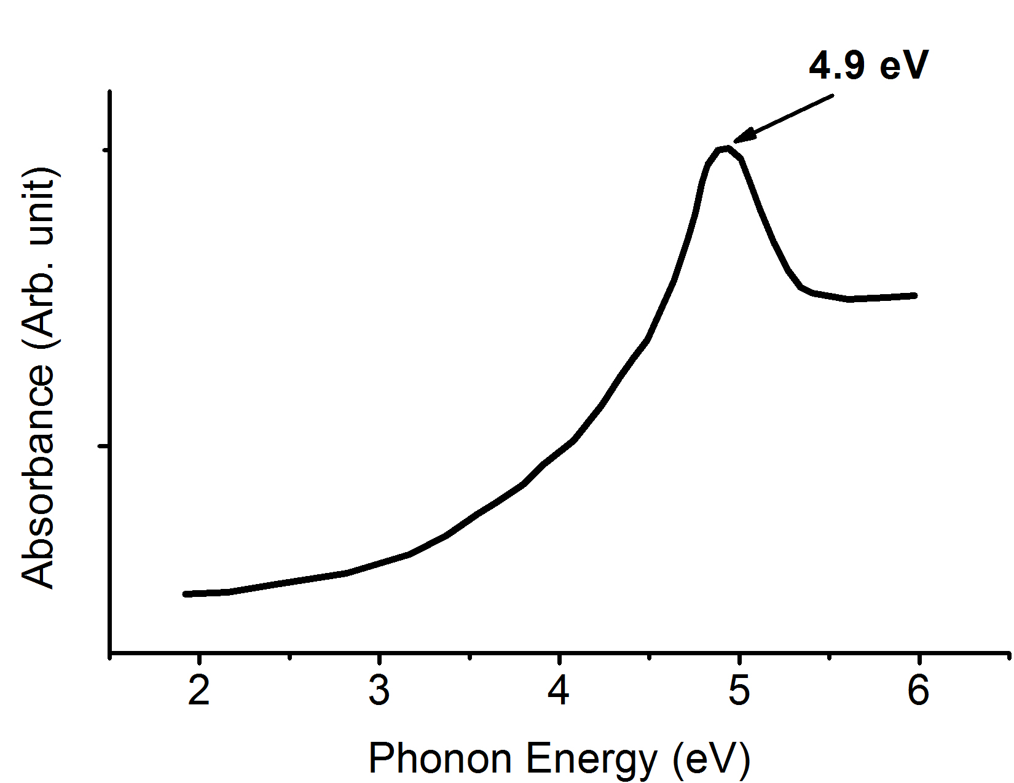
Fig. 2: Optical absorption spectra of obtained graphene affected by dielectric confinement.

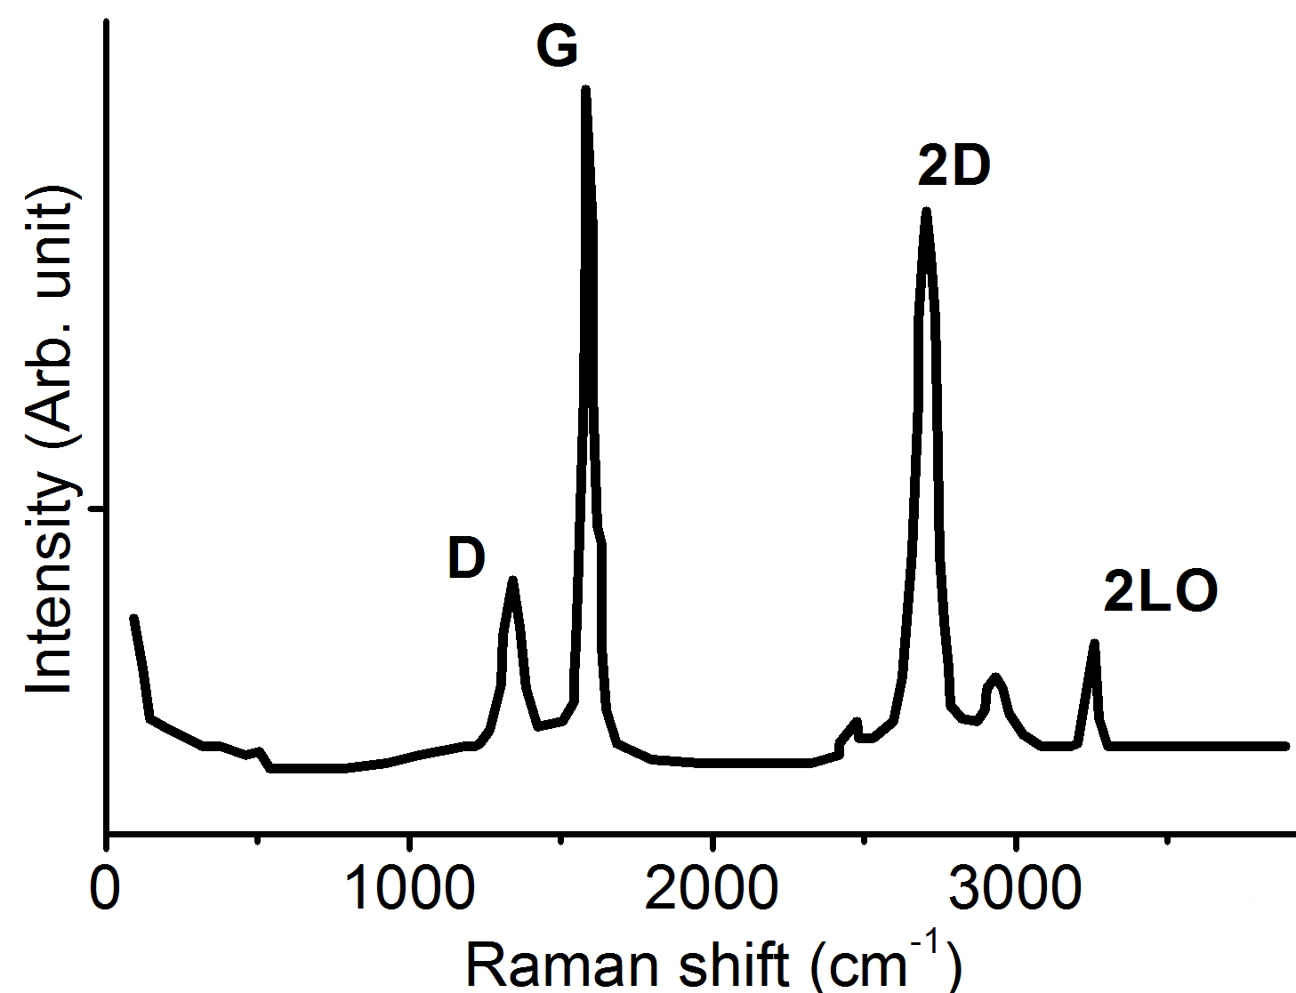
Fig2 1: Figure illustrating the Raman spectra of few-layer graphene.

References
- Bouchloukh, W., Jouenne, B. (2012) Characterization of biofilms formation in urinary catheters, Amer. J. Infect. Control., In Press.
- Montoneri F., Montoneri, E., Boffa, V., Sharts, O. (2011), Protein helical structure enhancement in fluorinated-phosphonate nanoporous silica glasses characterized by circular dichroism spectroscopy, Int. J. Nanotech., 8, 471-491.
- Margaryan N, Kokanyan N, Kokanyan E. (2018). Low- Temperature Synthesis and Characteristics of Fractal Graphene Layers. Journal of Saudi Chemical Society (2019) 23, 13–20.
- Aharonyan K., Margaryan N. Dielectric confinement influenced screened Coulomb potential for a semiconductor quantum wire. Journal of Physics Conference Series 672(1): (2016)012009.

Keywords—Graphene, AFM, Raman, Excitonic Absorption.

Professional Biography (100-150 words)

In 2017 he has completed his PhD at the age of 30 years from National polytechnic University of Armenia. He is a senior researcher and associate professor at the National Polytechnic University of Armenia. He has published more than 20 papers in peer reviewed journals and has participated in 7 international conferences with oral presentations.



Email Id: narekmargaryan@yandex.ru

