A complementary computer analysis of the porous structure of activated carbons obtained from waste material of biomass origin

Mirosław Kwiatkowski¹, Dimitrios Kalderis²
AGH University of Science and Technology, Poland
Technological and Educational Institute of Crete, Greece

Abstract:
This paper presents the results of the computer analysis of the porous structure of activated carbons produced from biomass waste, namely eucalyptus, wood chips, pruning waste and deinking sludge rice husk. The structural analysis was carried out using the BET, the t-Plot, the NLDFT and the LBET methods, which yielded not only complementary information on the adsorptive properties of producing activated carbon from these materials, but also information on the usefulness of the structural analysis methods in question for the research into an effect of the technology of carbonaceous adsorbent production. The research pointed to a correlation between the results produced using different methods, i.e. the BET, the t-plot, the NLDFT and the LBET, testifying to the validity of the assumptions behind the tests and of the mathematical apparatus behind these methods.

Keywords: Adsorption, Numerical Methods, Micropores, Activation.

Acknowledgments: The research was led within the subvention from the Polish Ministry of Science and Higher Education for the AGH University of Science and Technology in Krakow.

Professional Biography:
Dr. hab. eng. Mirosław Kwiatkowski in 2004 obtained Ph.D. degree at the AGH University of Science and Technology in Kraków (Poland), and in 2018 D.Sc. degree at the Wrocław University of Technology (Poland). In addition, he obtained a certificate of completion of postgraduate studies: Professional Research and Development Project Manager at the Krakow University of Agriculture (Poland), Research and Development Project Manager at the University of Economics and Innovation in Lublin (Poland), and Electrical Energy Markets at the AGH University of Science and Technology in Krakow (Poland). His published work includes more than 45 papers in reputable international journals and 90 conference proceedings. He is the editor in chief of The International Journal of System Modeling and Simulation (United Arab Emirates), an associate editor of Micro & Nano Letters Journal (United Kingdom) and a member of the organizing committees international conferences. Dr. hab. eng. Mirosław Kwiatkowski is also a reviewer in a most reputable scientific journals.
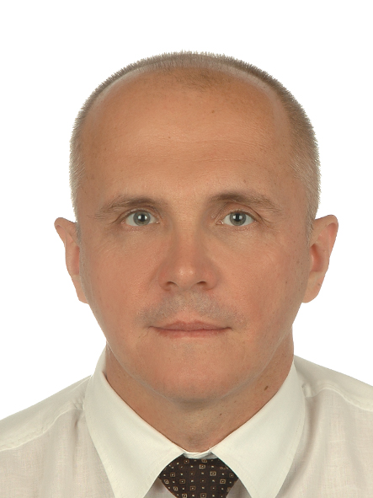
Email Id: kwiatkow@agh.edu.pl

